**The Genetic Code**

**Section I**

**A 24 codon table and the “exponent 2/3 series (ES**

**Section II**

**Comparisons with simpler numeral series**

**Section III**

**Transformations beteen number base-systems**

**Åsa Wohlin**

**2015-03-23**

**www.u5d.net**

**CONTENT *Page***

###### Introduction: A 5-dimensional Numeral Series… 3

##### A background model 6

1. Amino acids and codon bases: Why this coding system? 7

**Section I: A 24 codon table and the “exponent 2/3 series (ES)**

1a. Abbreviations – ways of writing 9

1b. Table on 24 codons and 20 + 4 amino acid side chains 10

2. Table on amino acids and codons: First observations 11

3. The exponent 2/3 number series (ES) 13

4. Mass division on atom kinds and on other bases than codons 21

5. The two 12-groups of amino acids – details 25

6. Backbone chains 31

7. N-Z-divisions and H-atoms 34

8. Geometries 37

9. Glycolysis – Citrate cycle: Cpodon grouped amino acids 42

on the basis of their origin

10. The coding bases – some annotations 47

11.  Transmitters and the ES-chain 51

Table 3: Survey of mass sums derived from the ES-series 52

**Section II: Comparisons with simpler numeral series**

12. Simpler numeral series: comparisons with the ES-series.

Some first notes 55

13. The 2x2-chain 57

14. Halved orbitals as a superposed chain 66

15. x1 – The triplet series. ⎯ The x4-series 69

16. An x3 series 73

**Section III: Transformations between number base-systems**

17. Transformations beteen number-base systems (nb-x) 81

18. More on totals and other notable transformations 91

19. P – phosphorous groups – Coenzymes – Nucleotides 101

Met AUG - tRNA-end ACC

20. Additions to files 17-18 107

21. I. The triplet series. – II. An alternative series 112

22 Other substances 120

Discussion 120

References 122

## **The Genetic code: Section I**

**A 24 codon table and**

**the ”exponent” 2/3 series (ES)**

#### **Åsa Wohlin**

**www.u5d.net**

**2015-03-23**

CONTENT *Page*

###### Introduction: A 5-dimensional Numeral Series… 3

##### A background model 6

1. Amino acids and codon bases: Why this coding system? 7

1a. Abbreviations – ways of writing 9

1b. Table on 24 codons and 20 + 4 amino acid side chains 10

2. Table on amino acids and codons: First observations 11

3. The exponent 2/3 number series (ES) 13

4. Mass division on atom kinds and on other bases than codons 21

5. The two 12-groups of amino acids – details 25

6. Backbone chains 31

7. N-Z-divisions and H-atoms 34

8. Geometries 37

9. Glycolysis – Citrate cycle: Cpodon grouped amino acids 42

on the basis of their origin

10. The coding bases – some annotations 47

11.  Transmitters and the ES-chain 51

Table 3: Survey of mass sums derived from the ES-series 52

A 5-dimensional Numeral Series behind the Genetic Code

**Introduction**

DNA is built of 4 bases G-C-T-A. When DNA is copied to RNA, the T-base is replaced by the U-base. Different triplets as "codons" of these 4 bases G-C-U-A in RNA-chains encode for the 20 "classical" amino acids that united in long strings make up all proteins. The coding system is nearly universal throughout biological life.   
  **Why this coding system?** It's a fundamental question. A suggested view is presented in **file 0** (right column) to start with.

Since the construction of DNA was discovered in 1950th, one big, old question has been if the distribution of codons to amino acids are "a frozen hazard" or may reveal some hidden logic. Hundreds of articles have been published on the subject in **PubMed** during decades with different approaches and theories (one **review here** and a selection of such articles besides references in the text is found in **References**), but there is still no commonly accepted answer to the question.

The 5-dimensional model, shortly presented on the site **here**, led to the thought that if it had any relevance, it could appear in some form on superposed levels, not least in a "main stream" development towards life and the genetic code. Here results from this research.

As said above: In spite of an immense lot of research and new knowledge during last decades there is no consensus on how to interpret the genetic code and the system for protein synthesis but a lot of quite different hypothetical aspects and approaches. To really get the faintest idea or intuitive guess on the development of a cell - and life, it's proposed here as necessary to start from general assumptions as the following ones, some of them surely shared by many, others more controversial.

a. The enormous complexity of the cell and its metabolism must be understood as an **internal differentiation**, through opposite forces, which implies starting from some kind of (partly) enclosed "unit", defined by a centre and an substantiated "anti-center" as a partly penetrable circumference. (This could perhaps in a first stage be some kind of metal shell - analogous to later Me-skeletons of unicellular organisms; metals representing anticenter in relation to non-metals, the main structure-building elements of life.)

b. Next, about **forces**, it must be assumed that all forces recognized at the level of physics (probably redefined in the future) appear **on the biochemical level** too, in one or another form, not just the electromagnetic one. (Naturally also aspects from quantum mechanics.)

c. Further, about **dimensional conceptions** on the biochemical level: To get the slightest intuitive comprehension of the biochemical complexity, it seems quite necessary to extend the dimensional analysis to higher dimension degrees (d-degrees). It would imply that aspects on structure in simple 3D-terms were integrated with other biochemical gradients of differentkinds - binding and polarizing ones - as 4-dimensional vector fields, into some unified, multidimensional analysis.

It's surely also time to leave the concept of dimensions defined only in terms of "independent" variables (already questioned in physics) and adopt a view where dimensions are deeply integrated and interdependant in dynamical processes.

d. The character of the genetic code as **an information system** should be closer analysed: Is it a reference system between connected complementary forms, a memory system and **/** or a parallel development of the same structural kind on different levels, where underlying level becomes the "memory" ... or is seen as "representing" the superposed one - or the inverse. Perhaps it's only part in a more general system of references connected with concepts as inversions, resonances, conjugates, complementary units - and relations between different, dependent d-degrees?

e. Then, about **mass**, mostly disregarded when the genetic code is discussed. Mass is a property not yet understood by physicists. That shouldn't be taken as a reason for regarding mass as an unimportant property for the emergence of life. Sooner, it would be extremely astonishing if not all atomic properties played essential roles at the creation.   
   The ***main objection*** to reevaluate mass is surely such experiences which seem to show that some unusual isotopes don't change the studied metabolism in an established cell milieu of today.  
   Smaller changes of isotopes may be possible to neglect in properties as structures and volumes of molecules, (even if they theoretically should influence gradients in mass fields, if this term is allowed),  
   However, does such facts necessarily contradict a presumption that mass of common isotopes had a decisive importance at first configurations of elementary biomolecules?   
   It is reasonable to assume that mass is a property of higher d-degree, representing a deeper level, than charge. (The physicists' application of the gravity concept into microcosm and quantum mechanics could be mentioned here.) If so, it would agree with dimensional views that the deeper mass level was decisive for elementary structures, while the more superficial level of charge, expressed in electron shells, becomes the relevant level in processes, in metabolism as characterized by more of released kinetic energy.   
   Further, in research to find shortened ways to predict destinations and functions of proteins, mass is used as one factor besides polarity with obviously good results [1].   
   About counting on ordinary isotopes, the overwhelmingly most common ones, it could also be reason for reminding of the carbon-nitrogen cycle in the sun, where it is the 3 alpha carbon and 4 alpha oxygen that make up the start and end of the fusion: 4 protons (H) giving an alpha-particles (4He).   
   Some more about this matter in concluding remarks.

f. Looking for an eventual **guiding principle** behind emergence of the code, where could it be found? If it isn't regarded as an invention from heaven, it's unavoidable to look for the guiding principle somewhere else, most naturally expressed in the singular atoms themselves.   
   Hence, we could suspect that the atoms themselves - with their underlying relations in the fusion processes - should serve as microcodes for cellular life and the principles guiding it. Those principles should probably be found in their internal configurations, also deeper in their nuclei and on a higher level in their spectral lines?

g. Finally, about **numbers** in general, it's hard to see why numeral series as such should be regarded as special exceptions when appearing in Nature. Different elements are regarded as characterized by numbers of units (u) and on a molecular level by protons equivalent with electrons and their relation to the "octet rule". Since all matter - as well as radiation - is quantified, it shouldn't be too strange to find underlying arithmetical relations behind the structuring principles in the genetic code.   
   Most scientists in the field may perhaps feel inconvenient with this idea, regarding it too abstract for any practical work. However, since pure mathematics has led to deeper understanding of nature on the level of physics and astronomy, why shouldn't it in biochemistry?   
   In fact, such number series could be compared with structure drawings for buildings, revealing mutual relations between later, stepwise materialized structures. Or perhaps more resemble the principal scheme for the working processes, the logistics? Just the way of Nature to organize itself.   
   After all, the numeral series behind the periodic system didn't "exist" - in any recognizable form - in the first materialized Universe after Big Bang.

Rather few contributions to interpretation of the genetic code have paid attention to number regularities as it seems (among references chiefly [2 and 3] but also in one aspect [4]). Recently, according to reference [5], it has been shown that the human genome as a whole single strand is of a fractal kind regarding frequency of codons.   
   Since long ago it's observed that features of Fibonacci number series and the golden section appear in Nature. (Below it's shown that such series show up also in mass analysis of the genetic code.)  
   There are more general and recognized numeral series: One very simple example is the valences of the central structuring elements in the genetic code: P - C - N - O - H with valences 5 - 4 - 3 - 2 - 1. (A suggestion here is that numbers also could refer to d-degrees or to dimensional steps, presumably as fractals, with the same patterns reappearing on different levels of evolution.)  
   Another essential example is the 2x2-series (x = 5 - 0), 50 - 32- 18 - 8 - 2, behind the periodic system, with intervals defining number of electrons in the different orbitals, the orbitals p, d, f also occupying increasing d-degrees in their orientation. It's natural to assume that the arrangement of electron shells have correspondences in the atomic nuclei, responsible for most of the atomic mass.  
   A third example is the formulas for spectral lines of hydrogen, where differences between inverted squares of integers as n = 1, 2, 3, 4 and m = 2,3,4, 3,4,5 etc. times a constant give the wavelengths.   
   Quotients between wavelengths (n = 2, m = 5, 4, 3) in the Balmer series times 102 happen to give the mass numbers of U- and A-bases too (112 and 135) and approximately the G-base (151,2), which could awake some suspicions...* (Quotients as a kind of phase waves? Alleged not to carry any information!)

**Fig 1-1:** *From Balmer series for spectral lines of hydrogen*:

  (C-base eventually later developed to give two pairs?  
  Last  term in c. = 1**/**9,  x 1000, = 111,1. C-base = 111 )

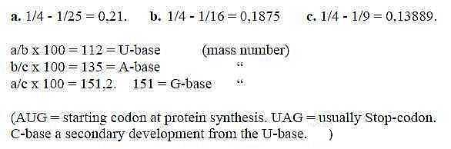

**A background model**

The actual background behind this research was a very elementary 5-dimensional model or conceptual structure, suggested by the author for interpretations in theoretical physics.   
   (See **Physics.**)  
  
Shortly: the model, with some redefinitions of the concept dimension and the 4th d-degree implies a development from a 5-dimnsional "entirety" through polarization steps towards lower degrees 5 →> 4 →>3... with debranched degrees being translated to external motions or meeting "the other way around", see figure below.A reason to mention the background model, however primitive it may be, and include the figure, is that some of the found arithmetical patterns below reflect features of this model.

**Fig 1.2** *A dimension chain:*

Each d-degree is supposed to be defined by the complementary poles or partial structures through polarization of the next higher one. First polarization into centre - anti-center (0 - 00) is regarded as defining d-degree 4 as vector fields, divergent / convergent, these fields through polarization transformed into 3D etc. Mass (with Space as complementary "pole"), is assumed to be defined in d-degree step 3-2, as a 3-dimensional property in its relation to Charge when this is analysed as 2-dimensional. (Level of analysis optional.) The 5th d-degree may ultimately be regarded as transformed into pure motions or kinetic energy through polarization of 1-dimensional structures in a step 1→ 0/00, the "d-degree 0/00 of motions".   
   The thought was that such a model, if of any value, also should reveal itself in some form in sciences of superposed levels, not least in a "main stream" development towards life and the genetic code. This with the general hypothesis that similar patterns or principles reappear on all superposed levels of higher complexity.

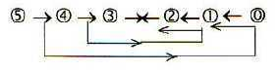

**0. Amino acids and codon bases.   
Why this coding system ?**

**A main question:**  
Why genes, why this coding system between RNA and proteins?

It's suggested here that the relation between codon triplets of bases and amino acids could be illustrated (note just illustrated) as in the table 0 below. Other classes of substances are marked as well in the pattern, i. e.. their main structural properties, showing on their close relationships.

The hexagonal pattern - as in graphite - can be regarded either as a pattern of hexagons, sharing edges with one another - or as consisting of atomic points, centers with 3 radii.   
   Virtual 4th valence pointing upwards from the plane, as towards next layer in a crashed or sliced diamond.

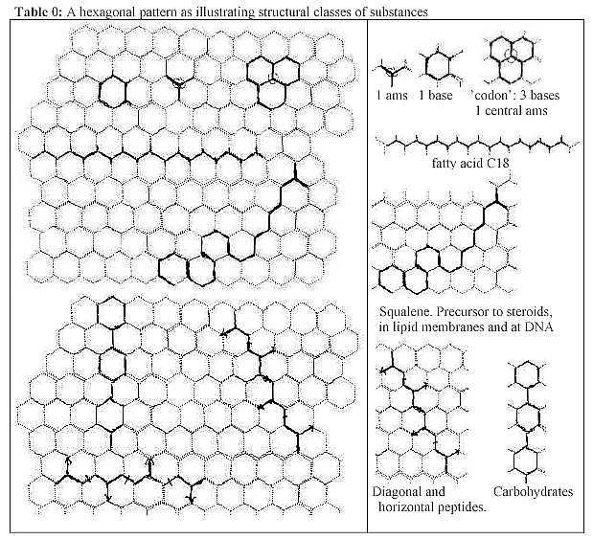

In this illustration the relation **bases - amino acids** shows up to be only a question of complementary "aspects", a fundamental one on the whole pattern.   
   One property of these aspects is the polarity between circular and radial structures. Another is the center - anticenter polarity with regard to the carbon atoms: in amino acids a central C-atom of tetrahedrons, in hexagon rings decentralized, anti-centric atoms.

A third, also fundamental, aspect is the physical polarity between mass (atomic structure) versus space as antimatter, which may appear when regarding the whole pattern as structures of **fatty acids**. It means "semipermeable" membranes, another essential condition for life. At a certain temperature they also form hexagonal patterns (*Lindahl et al 1967*).

The mentioned polarities correspond to the complementary "poles" or "partial structures" in the proposed, dimensional background model and follows from polarizations of dimension degrees 5 - 4 - 3.

Codon bases - amino acids:  
Each "3-radii-center" gets defined by 3 hexagons - as do amino acids through a codon triplet.  
   Each coding base gets synthesized to an essential degree of amino acids, the simplest one, Gly, being a kind of displaced center, an intermediate bridge between the two rings in purine bases G and A from Inosine (Hypoxantine). The amino acid Asp gives about half the rings of pyrimidine bases U and C.  
   (A hexagon ring of the bases include 4 C, 2 N, corresponding to 2 N-C-C-parts in bound backbone chains of amino acids.)

How could anything that only would be two different aspects, get translated to existing processes in a cell?   
   If departing from the illustration in the figure above, it seems necessary to imagine that the two opposite "aspects" on such a pattern - in some way* - get polarized into separate types of units, substantiated and saturated to structural classes of molecules in interaction with present substituents as N, O, H (nitrogen, oxygen and hydrogen). Further that the long range of intricate processes develops "the other way around" to recombine to the sense of a "reference system". This within - or on? - demarcating layers of fatty acids.

* The idea of a crashed diamond leads to the thought of different substances created from the different pathways and diffraction of light in the crystal.

Resevations:  
The figure doesn't include pentagon rings, e.g. the extra three edges in purine bases or ribose molecules, not differences in angles of valences etc. With the figure above it's not the intention to assert that this was 'the way it happened'.   
   Yet, it may illustrate the close relations between substances and the underlying two aspects on the whole structure: a pattern of rings or a pattern of centers with 3 radii - and a virtual 4th for differentiated growth of side chains (R) of ams?

**Abbreviations - ways of writing**

**Ams** = amino acids (ama = amino acid)   
**00 =** infinity sign **(∞**).

20 ams --> 24 codons: i.e. 4 ams with double codons:  
Arg 1, 2: codons CG + AG-A/G;   
Ser 1, 2: codons UC + AG-U/C;   
Leu 1, 2: codons CU + UU-A/G; and   
Ileu 1, 2: codons AU-A +AU-U/C, only differing in third base

3rd bases in the codons:  
  
Codons with where A or G in 3rd place makes no difference, written A/G,  
where Uor C in 3rd position makes no difference = U/C.

Parts of an amino acid:

R = R-chain(s) = the "radical chain" of amino acids = "side" chains  
   = the differing part of ams not taking part in the peptide binding.   
B = B-chain(s) = "ground chain" =  
   = the similar parts of ams which through condensation combines to peptide       chains.

                      R   
                       |  
B:         H2N-CH-COOH

Sums:   
  
All sums refer to mass number A where not anything else is mentioned.  
They refer to R-chains where not anything else is denounced.

Codon groups, way of writing:  
G1 - C1 - U1 - A1 = ams-groups coded by G-C-U-A respectively as first base.  
G2 - C2 - U2 - A2 =        "                             "                "          as second base.

Codon types, used denominations:

"Cross-codons" = GU-UG-AC-CA     
"Form-codons"  = GA-UC-AG-CU     
"Pair-codons"    = GG-UU-AA-CC     
"RNA-codons"  = GC-UA-AU-CG         6 ams in each group.

**/\** = sign for inversion of numbers

A-numbers for the RNA-DNA-bases with including +1 for the bond to ribose:

G = 151, A = 135, U = 112, C = 111…sum 509, + T 126 = 635.

# Table I, 24 codons

Table 1: *Codons and A-, N-, Z-numderzs of 20 + 4 amino acids*

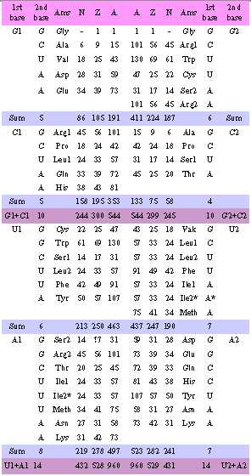

*Ile, AU-codon, only differing in type of 3rd base

**Observe that Lys and the two Arg are charged according to the reference P..Karlssn 1976. 2. Table on amino acids and codons. - First observations**

The investigation started in the 1980th - without prejudices - with a table of 20 + 4 codons (Table I) with and A-, N- and Z-numbers of side-chains (R) of the coded amino acids (ams), 4 ams having two different codons. Most common isotopes were used.  
   Hence, codons where the choice of purine bases U and C in 3rd position or of pyrimidine bases A and G in 3rd position makes no difference was counted as one and the same, as when 3rd base makes no difference at all (called "2-base-coded", generally in the literature called "degenerated"). The 4 ams with double codons are Arg CG + AG-A/G, Ser UC + AG-U/C, Leu CU + UU-A/G and Ileu AU-U/C + AUA, only differing in 3rd base *type*.   
  
In these files all numbers will refer to atomic mass (nucleon number) and to side-chains (R) of ams where nothing else is mentioned.

**2.1. First observations:**

First to notice is that the mass sums of the two main groups with G+C-codons and U+A-codons become the same in 1st and 2nd base order, 544 and 960.   
    It implies that mass sums of ams with mixed codons changing position between the groups are the same, 385 (Table 2). These groups showed astonishing regularities, which seemed to support the hypothesis that mass distribution of ams on different codons wasn't a random one. Note the approximately equal sums horizontally and vertically, Table 2:

**Table 2:** Mixed codons 12 amino acids, sum 385*:*

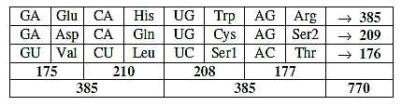

The table is closer studied in file The two 12-groups of ams.

It led to a division of the 24 codons in 2 main groups of 12 ams, the other = 2 times

367, (Table 3), which doesn't show the same regularity as the other:

Table 3: Non-mixed codons. 12 amino acids, sum 734:   
This way of counting and organizing codons seems deviating from most other research.

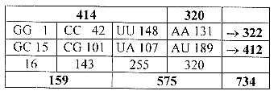

We get 4 subgroups of codons, here called Form-, Cross-, Pair- and RNA-codons:

Form-coded:  GA, AG, UC, CU, 6 ams, sum 352  
Cross-coded: GU, UG, CA, AC, 6 ams, sum 418...2 x 385 = 770  
    These two in Table 2.

Pair-coded:    GG, CC, UU, AA, 6 ams, sum 322  
RNA-coded:  GC, CG, UA, AU, 6 ams, sum 412...2 x 367 = 734  
    These two in Table 4.

Note in Table 3:  
G1 + A1, 175 + 177 = 352, give the same mass as the Form-coded ams,   
U1 + C1, 208 + 210 = 418, give the same mass as the Cross-coded ams.

Before going on with the analysis, two annotations:

**Survey of totals:**With mass in unbound backbone chains (B, B-chains) à 74 A, - 1 in the four ams Arg1 and 2, Lys and Pro. and mass 56 in bound ams, this gives following survey of totals:

24 ams: R: 1504, B unbound 1772, sum 3276 A,  
24 ams: R: 1504, B bound 1344, sum 2848 A.  
N-Z: R: 828 Z, 676 N, R+B: 1516 N, 1760 Z, unbound ams.

**2.2. Simple variations of the elementary number chain 5-4-3-2-1-0:**  
There are some simple variations of the elementary number chain (5-4-3-2-1-0), closer dealt with in files in section II, files 12-16, that more or less approximately give the division between some main codon groups of ams, G+C and U+A, but also other more detailed ones.   
   Hypothetically such simpler chains on integers 5→0 with exponents 4, 1, 3, 2 could underlie the more developed and differentiated chain in this section, precede this in a perhaps "inflationary" evolution of the code or represent underlying levels? Here only a couple of examples:   
   Reading the simple chain as triplets 543+432+321+210 gives 543 (G-C-group -1, U-A-group 960 +3,

**Fig 2-1:** *The triplet series 543 - 432 etc.*

Sum 1506 = total of 20 + 4 ams R, +2.

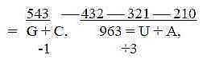

With exponent 4 the main division 544 - 960 (+2) derives from first three numbers 54-44-34 plus/minus 3rd number 81: G-C-group 544 = 625 - 81, U-A-group 960 (+2) = 625 + 256 + 81.  
  
With exponent 2 in the 2x2-chain behind the periodic system, times a factor 16, several different codon-groups of ams appear (+/-1), the main division showed in figure. 2-2:

**Fig. 2-2**: *Relations to 2x2-series, 34-26-60 times a factor 16****:***

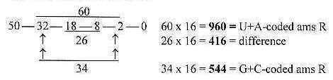

Total sum of the chain, 110, times 16 = 1760, the total Z of the 24 ams (R+B).  
   See further file “Simpler number chains” about the 2x2-chain.

3.  The exponent 2/3 number series (ES)

**ES-chain and main codon domains of ams:**

The elementary number series 5 to 0 with exponent 2/3 times 102 shows up to highly correlate with mass distribution on codon domains of ams, both the division on codons G+C — U+A (544 and 960), the 12-groups of ams from tables 2 and 3 (770 and 734), codon type pairs as G+A — C+U and individual codon groups, especially the G- and C-groups.

**3.1. Total mass and codon groups G+C and U+A:**

The series 52/3 - 42/3 - 32/3 - 22/3 - 12/3 - 0, times 100, gives the abbreviated numbers 292 - 252 - 208 - 159 - 100 - 0. Marking these numbers 5' - 4' etc. we have that 2 times 5' + 4' + 3' give mass sum of the 24 ams R = 2 x 752.

**Fig 3-1:** *The ES-chain:*

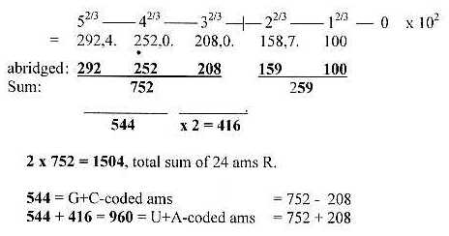

To repeat the way of writing:  
G1, C2, etc. refer to mass sums of side-chains (R) of ams coded by G as 1st base and those coded by C as 2nd base respectively etc.

G+C or U+A refers to the sums of coded ams (R), equal in 1st and 2nd base order.

G + C = 292 + 252 = 544  
U + A = 292 + 252 + 2 x 208.= 960

**3.2. Number of ams, correlating with the elementary numbers 5 - 4 - 3:**

**Fig 3-2:** *Number of ams:*

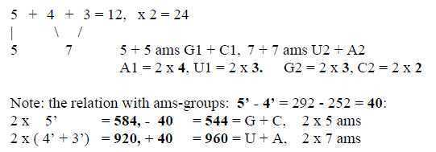

The individual and pairs of codon groups are given through minus**/**plus lower numbers or intervals in the series, reminding of the principle view of debranched degrees meeting "the other way around" in **the background model**:  
   

**Fig 3-3:** *A dimension chain, the loop version of the model:*



(For a very short description of the model, see **here**.)

**3.3. Mixed and not-mixed codons, 12-groups 770 and 734:**  
The two 12-groups of ams presented in **tables 2 and 3** are given directly in a simple way, groups 544 and 208, -/+ 159 times 2:  
  
**Fig 3-4:** *The two 12-groups 770 and 734:*

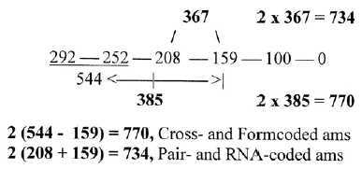

  U- and A-groups in 734-group = **2 x 208 + 159** = **575**,   
  G- and C-groups in 734-group = **159**

(575 also = 3' + 2' + 1' = 467, + interval 3' - 1' = 108. UU + AU + AA = 467 +1, Tyr UA = 108 -1.)

GG + GC + CC (Gly + Ala + Pro) = interval **59, -1**,   
CG (Arg) = end interval **100, +1**.  
  
**Arg can transform to Pro** leaving its end-group CN3H5 = **59**.

[In the background model the last step 1→ 0 is interpreted as a step from d-degree 1 into motions. It has been told that Arginine is especially rich in the tails of sperms. However, number 101 appears also in other contexts.]

See further details in file **The two 12-groups of ams.**

It may be added already here (see further file **Mass division on atom kinds...**)

Mass of C-atoms in 770-group = 444 = 544 - 100  
Mass of C-atoms in 734-group = 516 = 416 + 100,

**Cross- + RNA-codons:** ams = 418 + 412 = 830 = **2 x 416, -2**  
**Form- + Pair-codons:**   ams = 352 + 322 = 674 = **2(544 - 208),** +2

Adding bound B-chains to these codon *type* groups, we get sums approximately equivalent (~) with the division in R- and B-chains:

  Cross   RNA    Form    Pair  
    418     412      352      322 R  
+  336     336      336      336 B  
    754     748      688      658  
=      1502                1346  
     ~ R -2              ~ B +2

[In the sum of cross- plus pair-coded ams with R = 740, the close to equal division between U+G-codons and C+A-codons (the keto-/amino polarity) should be noted::

UU + GG + UG + GU = **370 -1**

CC + AA + CA + AC = **370 + 1** See Short files, 17.9, 3.

370 equivalent with 5 B-chins unbound à 74 A.

370 = 367 +3, the other 2 codon-groups 2 x 382 = 2 x 385 - 3 ]

**3.4. Purine - pyrimidine base pair groups, G+A and C+U:**Base pair group divided in purine and pyrimidine kinds are shown below. It should be noted that we can regard the whole chain included through number 934 as 2 x 467:   
  
**Fig 3-5:** *Base pair groups C+U, G + A:*

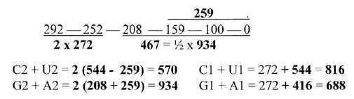

A division of number 544 (5’ + 4’), gives the purine and pyrimidine codon pairs from G+C, U+A:

Or: G1 + A1 = **960** **-  272** = 688  
      C1 + U1 = **544** **+ 272** = 816

Halving of 3', number 208, distributed inwards - "backwards" to 292 and 252  gives both a division on codon groups and on atom kinds, see **file 04.**

**3.5. Parents of the codon bases with mass 292 distributed to following numbers:**

**Number 292** (52/3 x 102) is the sum of Orotate (**156**) and Hypoxanthine (**136**), the parents to the pyrimidine and purine bases U, C and G, A. Just a coincidence?  
    Transferred to following two numbers in the ES-chain, times 2, happen to give the codon domain sums of ams in 1st base order, curiously enough:

**Fig 3-6:**

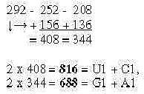

Remains to explain how this rather remarkable, simple derivations of mass numbers could be interpreted in terms of biological processes.

**3.6. Single code base groups:**

**3.6.1. *Minus/plus lower numbers:***G- and C-groups illustrate remarkably a similar -/+ operation of lower numbers in the chain:

**Fig 3-7:** *G-C-groups and numbers 100 - 159:*

G1 = 292 - **101** = 191,        C21) = 292 - **159** = 133  
 C1 = 252 + **101** = 353.        G21) = 252 + **159** = 411

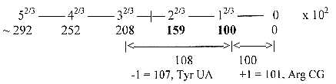

1) Note the changed order from 1st to 2nd base.

U22) = **544** -  **107** = 437        U1 = 252 + 208, **+3**  
A22)= **416** + **107** = 523        A1 = 208 + 292,  **-3**

2) Or: U2 = 544 – 208 = 336, + 101 , A2 = 416 + 208 = 624, - 101

**U1 and A1 groups** are less clear in derivations from the ES-chain than the G-C-groups;  
an alternative view with "polarization" of 544 in +/- 272:

U1 = G1 (191)        1  + **272** = 463  
A1 = C1 (353) + 416  - **272** = 497

U1 and A1 mass sums of ams may naturally be indirectly derived exactly though operations from G1+A-group 688, - G1, U1+C1-group 816, - C1.

Another way to write the derivations:

G1 = **5' - 1'**, -1        A1 = (**5' + 4'**) - (**3' - 2'**), +2 = 497  
C1 = **4' + 1'**, +1      U1 = ( **2 x 3'**) + (**3' - 2'**), - 2 = 463  
C2 = **5' - 2'**             U2 = (**5' + 4'**) - (**3' - 1'**), +1 = 437  
G2 = **4' + 2'**            A2 = ( **2 x 3'**) + (**3' - 1'**), -1 = 523

About Tyr 107 and Arg 101: Since Tyr derives from Phe, UU-coded, we could eventually regard Tyr as an expression for the step U2 →.A2. Arg, which gets its end-group from the G-base, eventually from an G1-code?)  
   In the same way A1 = 544 - 47, U1 = 416 + 47: 47 = mass of Cys R with UG-codon, as if from Meth AUG-codon - but Cys generally is regarded as derived from Ser.  
  
   With interval 3' - 1' -1 = 107 and 2' - 1' = 59 +1 (see below), the difference become 47.

(In the background model last step 1 to 0 represent the step to the d-degree of motions. Cf. that Arginine is said to be especially rich in the tails of sperms! However, number 101 appears also in other contexts.)

**3.6.2. *Interval 59 and 44:.***

Interval in step 2 - 1 in the ES-chain, -**/**+ 1 = 58 and 60, gives the difference between code-base groups in 1st and 2nd base order:

C2 = G1 -  58 U1 = A2 -  60  
G2 = C1 + 58 A1 = U2 + 60

(Interval 59 in step 2' —1' may be associated with main contributions from outside into the citrate cycle: acetyl(-Coa) + OH, 59 (60) in the step from oxaloacetate 132 to citrate 192. Corresponding step 4'→> 3' in the ES-chain = 44 ~ CO2, the preceding contribution in the cycle, with pyruvate giving malate.

252 ---|---208 -- 159 --|-- 100  
 44 <— 15 —> 59  
 COO -  CH3              (See more about **glycolysis-citrate cycle**.)

Notes.

*Notes 1.Number 544*Number 544 may be regarded as divided in three ways: 292 -- 252, 336 -- 208 and in interval 544 - 367 = 177 and 367.

C2 = 177 -  44 (the 2nd interval 4' - 3',  
G2 = 367 + 44

All four 2nd base groups (-/+1) from the interval 44:

544 -  367, - 44  = 133 = C2-coded ams  
208 + 159, + 44 = 411 = G2-coded ams  
272 + 208, - 44  = 436 = U2-coded ams - 1  
272 + 208, + 44 = 524 = A2-coded ams +1

*Note 2. -/+ Tyr from C1 to U1 ?*

C1 = 252 + 208  (= 460), - 107 (~Tyr) = 353.  
U1 = 252 + ½ x 208 + !07 (~Tyr) = 463

*Note 3: G1-group 191 divided after 2nd base:*

GG + GA = **133** = 5' - 2'; GU + GC = **58** = 2' - 1', -1.

**3.6.3. *Divisions within single base groups in 2nd base order:***

**In G2 + C2:**  
1st base G or A: sum of ams = **193**, **~ G1 +2** (GG + AG = 133; GC + AC = 60.).   
1st base U or C: sum of ams = **351**, **~ C1 - 2** (CG + UG = 278; CC + UC = 73)

**In U2 + A2:**  
1st base G2 or A2: sum of ams = **495, ~ A1 + 2**. (GU + AU = 232; GA + AA = 263.)  
1st base C2 or U2: sum of ams = **465, ~ U1 + 2** (CU + CA = 210; UU + UA = 255.)

Number of ams in single base groups with odd number of ams::  
Odd numbers of ams Even numbers of ams   
    G1, 5 ams 2nd base G, A: 3 ams, 2nd base C, U: 2 ams.  
    C1: 5 ams. 2nd base G, A: 3 ams, 2nd base C, U: 2 ams... division 3 -/2   
    U2: 7 ams: 1st base G, A: 4 ams, 1st base C, U: 3 ams  
    A2: 7 ams: 1st base G, A: 4 ams, 1st base C, U: 3 ams... division 4 - 3.  
    (*Thanks to Tyr without partner*)

**3.6.4. *Two sets of the single base groups in 1st and 2nd base order:***

5'  2 x 292 = **584**,                - 100 = **484** = C1 + C2 - 2  
4'  2 x 252 = **504**                 +100 = **604** = G1 + G2 + 2   
3'  2 x 208 = 416 **+ 584**        - 100 =   **900** = U1 + U2 (U1+U2 from the C-groups)  
3'  2 x 208 = 416 **+ 504**        +100 = **1020** = A1 + A2 (A1+A2 from the G-groups)

**3.7. 3rd base groups:**  
Number 292 as the sum of Hypoxanthine and Orotate, the parents to the code-bases from which these bases get synthesized, are connected with differentiation of codons in 3rd base: A**/**G (+A or G) or U**/**C, implying a connection too with 1st base in the anti-codons in tRNAs.   
   Mass sum of ams with differentiated codons in 3rd base = 1169 = 4 x 292 +1. It shows up to be divided nearly equal. (Also a coincidence!?)  
  
   G1 + A1: **584**          = 2 x 292  
   C1 + U1: **584 +1**.    = 2 x 292 +1  
  
All ams with indifferent 3rd base = **335 = 544 - 208 = 336, -1**   
(336 if Pro CC before ring closed.)   
  
ES-chain with intervals in steps 5' - 4' - 3':

**292** --- (40) --- **252** --(44) -- **208**

**4 x 292 +1** = sum of ams with differentiating 3rds base in codons.  
  
       **4 x 40** = **160, - 1** = 159 = "2-base-coded" ams in the 12.group of non-mixed codons   
       **4 x 44** = **176** = "2-base-coded" ams in the group with mixed-codons.

In 2nd bsse, ams with differentiating 3rd bse divide: :  
 **4 x 208** = **832** = **G2 + A2.**   
                                       G2: 1 x 208 + 101, A2: 3 x 208 - 101.  
 **4 x   84** = **336, +1** = **C2 + U2**   
                                       C2: 0 + U2: 337

We get 8 ams in each group  
8 ams with 3rd base A/G or A or G = **638** (3 ams only one choice: AUG, AUA, UGG),  
8 ams with 3rd base U/C                 = **531**  
8 ams with indifferent 3rd base  = **335**

Numbers 638 and 531 may eventually be derived in this way:  
   A/G-coded ams: 272 + 367 = 639,- 1 = (½ x 5' + 3' + 2') -1  
   U/C-coded ams: 272 + 259 = 531      = (½ x 5' + 2' + 1')

**3.8. Some extra annotations to base pair groups:**  
**3.8.1. *84 - interval 292 - 208 = 5’ - 3’:***

U+A: 960, - **84**  = **876** = C1 + A2   
G+C: 544, + **84** = **628** = G1 + U2. (C1 + 84 = U2)  
  
C2 + U2 = 570, **+ 84** = **654** = G1 + U1 = C2 + A2 - 2   
G2 + A2 = 934, **- 84**  = **850** = C1 + A1 = G2 + U2 +2

In general terms these number operations as +**/**- 84 (5' ↔ 3') could express a process outwards - inwards: “5 → 4 → 3 → ← 3← 4 ← 5”.   
 **3.8.2. *Examples of similarities in N and Z between base pair groups:***

N-number:       G1 + U1 = 299         = 299 = A2 + C2   
                       G2 + U2 = 377         = 377 = A1 + C1  
Z-number:        G1 + U1 = 355   +2  = 357 = A2 + C2  
                       G2 + U2 = 471   +2   = 473 = A1 + C1   
  
Crosswise addition N-Z between G2-C2-groups, U2-A2-groups gives the same numbers as Cross- plus Form-coded ams = 770, RNA- plus Pair-coded ams = 734:

G2: N + C2: Z = 262, → **734** ← 472 = U2: N + A2: Z.    Interval 208 +2.  
G2: Z + C2: N = 282. → **770** ← 488 = U2: Z + A2: N.    Interval 208 - 2.

**3.8.3. *Displacements 220 and 26 between groups in 1st and 2nd position:***  
G1 to G2 and C1 to C2: +/- 220 = 2 x 110 and A1 to A2: -/+ 26  
(See further file 7 and file **13** about N-Z-division.) U1 to U2

It may be noted here that   
G+C = **544**, **+ 26** = **570** = C2 + U2,   
                                      (G2 411 + 26 = U2 437. C2 133 + 26 ~ 159, - 26 = 107.)  
U+A = **960**, **-  26** = **934** = A2 + G2.   
  
U+A = 960, -  110 = **850** = C1 + A1 (~ U --> C); 960 - 220 = 740

= Cross + Pair coded ams  
G+C = 544, + 110 = **654** = G1 + U1 (~ C --> U); 544 + 220 = 764

= Form + RNA-coded ams.

**3.9. Some general annotations:**

**3.9.1. *Number 146:***- Half the number 292 = 146 is the mass of **α-ketoglutarate**, from which Glu (147 A) derives directly with a central role for amination of the amino acids

**-** 146* happens also to be the number of base-pairs in DNA winded around the **histones** in chromosomes. Why this curiously exact number? \**(Later in Wikipedia changed to 147.)*

**-**  292 is also the mass of **P-P-ribose** part of bases in the form of coenzymes.  
   (Ribose 150 + two H3PO4 (98, x 2), - 3 x H2O).

- Another feature is that G- and C-coded ams "come first" in the ES-chain as connected with the numbers 5'- 4'. This agrees with what scientist have found in experiments where ams appear in liquids. There are also indications of a pressure towards more A-T-rich DNA during evolution according to the scientists, as in agreement with steps 5' → 4' →3' in the ES-chain, ams with A-U-codons including number 2 x 3'.

- P-ribose groups in nucleotides:  
 The P-ribose-groups in chain binding = 195 uncharged, 194 charged (64 or 63 + 131):

584, 2 x 292 in the ES-chain → 3 x 195 (-1).

Could this number from the ES-chain perhaps be one aspect on the cause for triplets of the bases in codons?

A suggestion by Copley et al (2005) is that ams could have been synthesized at the inner OH-group of ribose in a string of nucleotides. In the illustration to this hypothesis a P-P-¨ribose group binds to two nucleotides.(P-ribose + bases). The whole ES-chain could somehow illustrate the mass numbers where the synthesis of ams should appear in the middle step :

***Fig. 3-8:*** Copley-figure numbers ***in*** *ES****:***

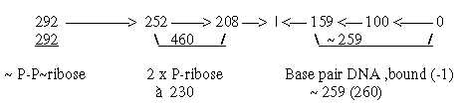

(P-P-ribose: 2 x 98 + 150, - 3 x 18 =292, P-ribose: 98 + 150, - 18)   
    Yet, here is counted with ribose in RNA, not deoxyribose, but with base pairs in DNA with the T-base instead of the U-base. Bonds (-18) to the bases also neglected or somehow occurring in the middle step. (Cf. 385 - 367 = 18. 544 - 159, 208 + 159).

3.9.2. *Testing of the ES-chain?*a) Only e.g. heavy water or other deviating isotope of C, N or O in the type of Miller    experiment. Does it change the reactions in any way?   
b) Construct a peptide with atomic masses in accordance with the ES-chain, e. g .:  
    Glu,Glu,Lys,Glu - His,Gln,Leu,Pro - Trp,Cys,Ser - Ala,Gly,Pro - Arg ?  
(In a liquid of Miller type, with small variations in pH. Does it have any effect?

# **4.  Mass division on atom kinds and on other bases than codons**

**4.1.. Mass division on kinds of atoms:**

First to observe is the fact the mass division on C-atoms versus other atoms is the same as between U+A-coded ams and G+C-coded ones:

C-atoms, 80     = **960**N + O + S + H = **544**

The division on codon grouped ams of the "substituents", N, O, S, H = 544:

G1 + A1: **292**  
C1 + U1: **252**

Mass of C-atoms in 12-group 770 = 444 = **544 -  100**  
Mass of C-atoms in 12-group 734 = 516 = **416 + 100**,

H-atoms: 252 - 100 = 152 = 4' - 1'  
N+O+S-atoms: 292 + 100 = 392 = 5' + 1'

The division between N-atoms and S+O+H-atoms could perhaps be noted too:

Atoms in R: **C + N** = 3 x 376, ½ (5' + 4' + 3'). **O + S + H** = 376

10 O + 2 S + 152 H = **376** = 1/2 x 752  
                                                    |- 2 x 208  
12 N = **168**                       = 1/2 x 336 (544 - 208).  
80 C + 12 N = 1128 = **3 x 376**

**4.2. The division of C-atoms on codon groups Purine - Pyrimidine pairs:**

Simultaneously on codon groups:

**G1 + A1: 33 C** = 292 + **½** x 208 **= 396**  
**C1 + U1: 47 C** = 460 + **½** x 208 = **564**

When one of the two 208-groups is divided on first numbers 292 - 252, we get the relations between mass division on **atom kinds** and on **codon groups of ams** shown below:  
**Fig 4-1:** Division of atom kinds and ams groups, halving 208

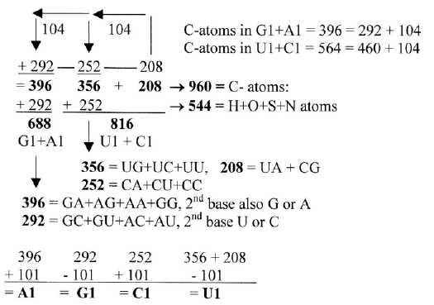

In table 4 below we find number 104 as the difference between groups G1 +C1 and U1 + A1. With number 416 uncounted, the sums get equally divided vertically and horizontally.  
   The arrangement could perhaps reveal a symmetric phase in step 5'- 4' along two axes (544) in opposite directions: C-atoms to**/**from "substitutes", before a stage 3' (416).

**Table 4:** Mass of C-atoms in G+C = mass of other atoms in U+A

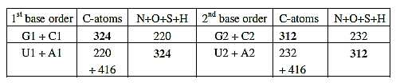

**The domain groups** of ams along the third polarity between bases, the keto-**/**amino types, shows in 2nd base order a mass division on atom kinds with strong regularity:

C-atoms: G2 + U2 = **576 = 3 x 192** (292 - 100). Other atoms = **272**  
               C2 + A2 = **384 = 2 x 192** (292 - 100). Other atoms = **272**  
  
Cf. in B-chains unbound: C = 576, O = 2 x 384; N = 336 (544 - 208), H 96 - 4.

***This number 192*** appears in many sums in the genetic code. Why?   
In the ES-chain = 5' - 1', the interval 292 -- 100. (I's the mass of citrate, isocitrate, however not an explanation. It's 3 times 64, 6 times 2^5.).

1536 - 1344 - 1152 - 960 - 768 - 576 - 384 - 192  
   8        7        6        5       4       3       2       1  x 192

1536 = sum of all C-atoms in 24 ams, R + B.  
1344 = sum of 24 bound B-chains (24 x 56)  
960 = U+A-coded ams  
768 +2 = ams with mixed codons, 2 x 384  
576 -1 = U+A-group in non-mixed codons  
192 -1 = G1-coded ams

**4.3. C-atoms in R-chains of ams as basis for mass division:**

**4.3.1. *Division of ams after number of C in the ES-series:***

This division doesn't concern codon distribution but seems related to the ES-series and number 584, 2 x 292, with certain assumptions. (Here C for carbon.)  
   Phe and Tyr are synthesized as 3C- plus 4C-molecules, Trp as 3C + 4C + 5C - 1C. Trp gets its B-chain from Ser, shares codon with Cys and can brake down to Ala, hence here regarded as "meeting the other way around", added to the l C group.   
**Fig 4-2:** *Cn: 4C, 7C, 3C +0C, 2C, 1C + 9C*

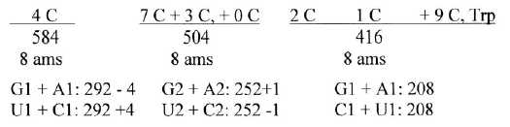

4 C: Arg1, Arg2, Lys, His = 356, + Leu1, Leu2, Ile1, Ile2 = 228.  
7 C: Phe + Tyr = 198;   
3 C: Glu, Gln, Val, Meth, Pro = 305;    0 C = Gly = 1;   
2 C = Asp, Asn, Thr = 162;   
1 C: Ala, Ser1, Ser 2, Cys = 124;   
9 C: Trp = 130.

**4**.**3.2. *Number of C-atoms in codon groups of ams as halvings:***

We may also note that number of C-atoms are approximately distributed on codon groups as 2/3 - 1/3 in two steps

   53 C in U1+A1-coded ams (+1 in A2 + U2), ~ 2**/**3 x 81  
   27 C in G1+C1-coded ams (- 1 in G2 + C2), ~ 1**/**3 x 81  
    ↓→18 in C1, 19 in G2, ~ 2**/**3 x 27  
             9 in G1,   7 in C2, ~ 1**/**3 x 27

**4.4. End atoms of R-chains as basis for mass division:**

- Ams with end atoms CHx plus Gly (H) = 420.  
- Ams with end atoms O, OH, S and no N = sum 468   
- N in end-groups or in rings (Trp and His), including Gln and Asn = 616.

420 + 468 = **2 (544 - 100)  = 888**   
616  = **2 (208 + 100)**.= **616**\*

*(2 Arg charged = 200 +2, rest 416 - 2)

Note that all N-contenting ams but Trp derive from the citrate cycle.  
(Another division: ams more or less polar: 468 + 616 = 2 x 544 - 4. Non polar ams, the CHx-group = 2 x 208 + 4.)

**4.5.  81 - 47, a division of number 128 and number of atoms:**

There are 128 C-atoms in the R- + B-chains of the 24 ams 128 = 544 - 416.  
  
His 81 and Cys 47 (mass of R-chains) cooperate in an enzyme to break fructose at the start of the glycolysis.

The number of atoms in R-chains are exactly twice the total number of C-atoms in R+B-chains in groups G + C and U + A:  
  
   G1+C1: **R+B = 47 C** → all atoms in **R =   94**; (G2 + C2 46 and 91)   
   U1+A1: **R+B = 81 C** → all atoms in **R = 162;** (U2 + A2 82 and 165)

**Fig**. **4-3, *81-47***

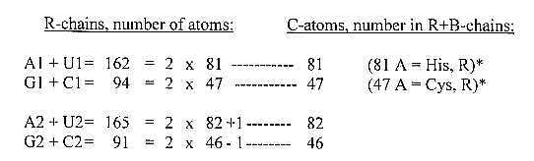

Which skeleton doubles its projection in its radical part? The human body in the brain!?   
  
   U1 + A1-coded ams: 81 C = entire number of C-atoms in R-chains +1  
   G1 + C1-coded ams: 47 = entire number of C-atoms in B-chains - 1

Minus **/** plus 81 and 47 gives also from the codon groups of ams from 544 and 416:  
½ x 544 -  81 = G1, 191  
½ x 544 + 81 = C1, 353  
544 - 81 = U1, 463.     544 - 47 = A1, 497  
416 + 81 = A1, 497     416 + 47 = U1, 463....difference 34 = 81 - 47.

Why this division of number 128?

**Fig. 4-4**, *60-26-34, cf. 13-2 in file 13*

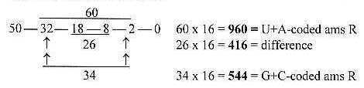

94 + 34 = 128, 47 + 34 = 81

**4.6. A similar "perpendicular" relation between number of C and H  
in the same codon groups:**

   C + H: total in U+A-coded ams R = **152**, ~ number of H in all R-chains  
   C + H: total in G+C-coded ams R =   **80**, ~ number of C in all R-chains.  
(See figures in “17 short files, file 02.)

**5.  The two 12-groups of amino acids - details**

with additional aspects

**5.i. 12-group 770:  
  
Table 2:***12-group 770:*



Division of **385** in **176 -/+1** and **209 -/+1** in table 2 appears in the ES-chain as interval 177 and number 208 = 3', the sums of columns U1 and A1. (-/+2 gives G1 + C1.)

**a) Individual codon groups** are closely related to intervals in the chain:  
  
**Fig 5-1:** *Mass of ams on individual codons in the ES-chain:*

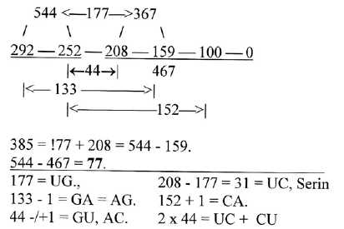

UG: Trp + Cys,   
GA Glu + Asp,  AG Arg + Ser,   
GU Val, AC Thr,   
CA His + Gln, UC Ser, CU Leu.

Note: 544 divided in a third way, 177 and 367:

C2 = 133 = **177 - 44**, G2 = 411 = **367 + 44**.

**b) Factor 77** times 5 divided 3-2 is a remarkable feature in the 770-group of ams, table 5. In the ES-chain 77 is the interval 544 - 467, i. e.,. the whole chain divided in step 4' — 3'.

**Table 5:** *Factor 77:*

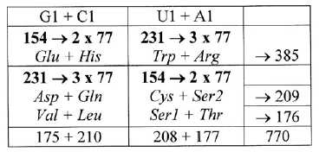

**Factor 11:** It's suggested here that this factor 77 and factor 11 characterizing this group is derived from a deeper, more elementary level, a double-directed chain:

**Mirror-codons**, 1st and 2nd bases, code for masses of ams that all are dividable by factor 11:  
   UG + GU = **11 x 20**, CA + AC = **11 x 18**, GA + AG = **11 x 24**, UC + CU = **11 x 8**.

A support for the suggestion of a two-way direction of the chain on this level is also that **4 →3 gives 43 + 34 = 77**: the division of sums 231 in the table: 3 x 43 = **129,** 3 x 34 = **102**, +/-1 gives Trp (130) and Arg (101). +/-2 gives Asp + Gln (131) and Val + Leu (100).    (Cf. perhaps in 734-group: 2 x 54 = 108 = Tyr +1, 2 x 45 = 90 = Phe -1.)

Factor 11 appears in the individual sums (-/+1), sum 132 in several pairs, GA, AG, also AU as Meth + one Ileu, besides in 88 -/+1 and UG 176 +1, CA 154 -1. (Biochemically it's perhaps natural to search for it's root in the CO2-molecule, 44A?)

(It may be mentioned that halved numbers in the ES-chain x 10, with the inverted exponent 3**/**2, as 14,63/2, 12,63/2 etc. if abbreviated downwards to integers, give the chain 55 - 44 - 33 - 22 - 11.   
    Such a chain with increasing factor 1 to 5 as the following one gives the sum 385:  
  
   1 x 55 + 2 x 44 + 3 x 33 + 4 x 22 + 5 x 11 = 55 - 88 - 99 - 88 - 55 = 385:   
  
Odd steps = 209 = 11 x 19,, even steps 176 = 11 x 2 x 8..   
(55 + 99 = 154, 2 x 88 + 55 = 231.).

**Factors 5 and 7** in 385 as 11 x 35 appear as the elementary numbers 5 and 4 + 3 in the basic series, also the numbers of ams in Gl, C1 and U2, A2 groups. (More about number 35 in the file **here**.)   
  
**Factors 27 and 8:** We observe that the sum of ams with differentiating 3rd base is 385 + 209 = 594, 2 x 11 x **27**. The last row = 2 x 1 x **8**.   
   For mor about these factors **3^3** and **2^3**, see **file 14**.

**c) 3rd bases** are with one exception A or G in the row 1 of tables above with heavier ams, U or C in the lighter row 2. Exception is the CA-pair His - Gln, possibly connected with the fact that His is the only ams not derived from stations in Glycolysis - Citrate cycle but from the A-base. His can brake down to the end station α-ketoglutarate, origin for Glu and Gln. It may express a turn of direction regarding 3rd base, since U/C-coded ams generally derives from an earlier station than the A/G-coded, sharing first two bases - as along an axis Orotate <—> Hypoxanthine. Cf. U-base from Orotate and all U1-U2-coded ams from glycolysis.  
  
**d) The equivalence** between groups G1 + A1 with Form-coded ams and U1 + C1 with the Cross-coded ams follows from the one between pairs in row 3, both 88: Val +Thr and Leu + Ser. If the CU-codon sometimes gets translated as Ser as it's said, it could perhaps depend on this UC-CU-group as decided by number 88 and reflect the suggested underlying two-way direction in an elementary chain.

**e) N-Z-division** in 770-group shows up to be the same -**/**+1 as between Form- and Cross-coded ams: 2 x 176 - 1 = 351 and 2 x 209 +1 = 419.   
   In the the other 12-group 734 the same concerns the A-U-group: N = U1-coded +1, Z = A1-coded -1. This is one among several examples of similar number divisions within different basis of mass divisions as along different coordinate axes. It makes the table of mixed codons almost 3-dimensional.  
    For another example of an "orthogonal" table, see for instance **file 10** about number of atoms in codon bases.   
  
**Fig**. from "17 short files", 02-12

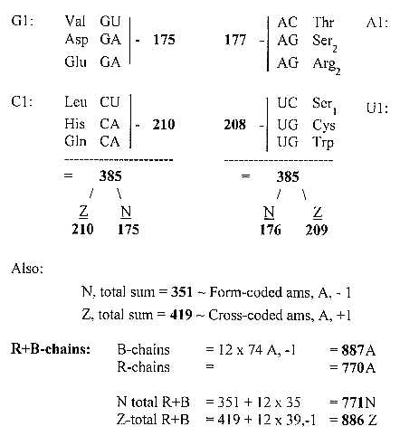

**f) There are three main divisions****of number*****752****,* 5' + 4' + 3':  
  
   752 = 292 - 460 in step 5'-4',   
   752 = 544 - 208 in step 4'-3', and   
   752 = 336 - 416, (544 - 208) - (2 x 208).   
  
The third division (+/-1) combines codon type groups in pairs across the two groups 770 and 734:   
  
   336 +1, x 2 = **674** = Form- + Pair-coded ams, 352 + 322  
   416 - 1, x 2 = **830** = Cross + RNA-coded ams, 418 + 412

**5.2. 12-group 734:**

**Table 3:** *12-group 734*



In this more irregular group it's the G+C-group versus U+A-group that appears as the main division, shown below. (The division in RNA- and Pair-coded deviates with -/+ 4 from 2 x 208 and 2 x 159.)

**Fig 5-2:** *Twelve-group 734:*

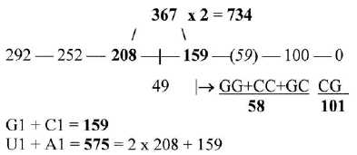

**N-Z-division** in the U+A-group:

N = 256 ~U1-coded ams +1  
Z = 319 = A1-coded ams -1.

(The similar scheme as among mixed codon groups

U1 = **255** = 208 + 49 -2, A1 = **320** = 2 x 159 + 2.   
  
Cf. an eventual displacement of **Cys 47** from an A1-codon (Meth AUG?) to an U1-codon:  
         A1 = 497 = 544 - 47,   
         U1 = 463 = 416 + 47.  
It could support the thought of a displacement of Cys that we simultaneously, in the 12-group 734 A+U-coded ams = 575 have:  
         U1 = 255 = 208 + 47   
         A1 = 320 = 367 -  47

[Regarding the two 12-groups of ams 770 and 734 as **752 +/- 18**, we can the division of the 734-group in G1 + A1 = 752 - 416 = **336**, C1 + U1 = **416 - 18**.(One reason perhaps why Pro, CC, has a tendency to get hydroxylated, yet only + O, 16 A?. Adding 2 H2O gives the sum 770 as in the other 12-group. Lys, AA-coded, in this 734-group has the same tendency.]

**Some individual mass numbers of ams** approximately connected with the 12-group of non-mixed codons 734:

133 - 59 = 74, +/-1 Meth 75, Lys 73  
59 -1, -2 = Asn 58, Ile1, Ile2, Leu2 = 57  
252 - 159 = 93, -2 = Phe  
208 - 100, -1 = Tyr  
44, - 2 = Pro. 44 - 59 = 15 = Ala. 100 +1 = Arg. + Gly 1.]

**Asp and Ala** are often regarded as typical for ams (a figure shown in **file 06**)..

   Asp, R+B unbound = 133 = 5' - 2' in the ES-chain. R = 2' - 1'.  
   The difference as secondary interval defines the normal value 74 of B-chains.  
      Ala 15 becomes the secondary interval between intervals 4' - 3' and 2' - 1' = 44 --59,  
   bridging over the middle step 3' - 2'. Cf. that Ala may derive from Pyruvate or from    oxaloacetate.

**[Of the 24 individual mass numbers  of ams** R, at lest 16 gather around number or intervals in the ES-chain:

4 around 73 with sum 292 +1,  
4 around interval 44 with sum 177 (544 - 367),   
6 at interval 59 -1,-2 with the two sets of Ile and Leu,  
2 at 100 (+1) with two Arg.   ]

**5.3. A special operation, amino acid masses with exponent 2/3:**   
  
If the mass numbers of R-chains of ams separately are "compressed" through exponent 2**/**3 (e.g. Trp 1302/3 = 25,66,), their codon grouped sums give approximate numbers at the middle of the ES-chain as shown in figure 5-3 below.   
    If not haphazard, it could hypothetically imply that the individualization of ams, if not occur, at least is connected with the middle of the chain. (Cf. an added dimensional aspect in end discussion.)

**Fig 5-3:** *Individually 'compressed' ams with exponent 2/3*

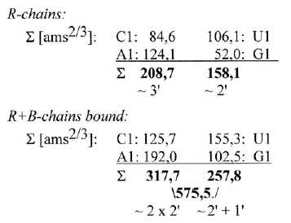

Note the keto-amino polarity: C1 plus A1- groups 208,7., U1- plus G1-groups 158,2. Sum 366,8. ~ 367 = 3' + 2'.

**5.4. Transformations between number-base systems (nb-x):**  
To forestall later files:

             nb-10   nb-8  
 G-base  151 = 227  
 C-base  111 = 157...Sum **384**. Transformed together = **386**.

U-base  112 = 160  
A-base  135 = 207...Sum **367**

Here we have the central numbers of the two 12-groups. And two times the 4 bases transformed together (1018) gives 1772, exactly the sum of the unbound backbone chains (B-chains). These curious facts led to the investigations in files “**Transformations”,** such transformations eventually part of the reference system.

See also about these numbers file “**Geometries and special arithmetic operations**”   
and file “**Halved orbitals numbers”** in section II.

**5.5. The weightt series of ams:**

Mass in ordder of heavines: A division ~ 2/3 around the middle = 600 ⎯ 904.

Gly → Asp = 14 aa, 1-15-31-31-42-43-45-47-57-57-57-57-58-59, sum 6**00**

Gln → Trp = 10 aa, 72-73-73-75-81-91-101-101-107-130, sum 904

**6.  Backbone chains**

**6.1 The square root of π**

√π,  x  10^3 = 1772.45 ~ 24 B-chains unbound  
             .          
√π x10^3     = 56.05 ~ one B-chain bound  
              .  
√56 56 56    = 752.101 ~ half the R-chains

If these operations have any sense, it remains for more advanced mathematicians to explain.  
 What kind of geometry could correspond to the square root of π ?  
 **6.2. Backbone parts of ams and the ES-chain:**

The similar parts of ams, the backbone (B) part, make up a separate coordinate axis, not governed by codons. It gives a good reason not to include them when studying differentiation of R-chains. The B-chains appear in the ES-chain in groups of 6 (cf. the 4 codon type groups?).  
                                   R  
                                    **|**   
B-chains:    (H)NH2—CH—COO(H)   = 74 A. Times 6 = 444.  
  
Minus 1 H in the 4 ams Arg1,2 and Lys (charged), plus Pro gives 443.  
Total sum 1776 - 4H = 1772.

Groups and condensations to bound B-chains are shown in figure 6-1:

**Fig 6-1***: Condensation of B-chains in groups of six:*

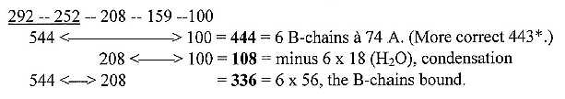

The division of the 6 unbound B-chains (444) in two intervals around the middle of the ES-chain supports the recognition of B-chains in this chain and connects R-chains with the middle step  
   Interval 544 to 367 = 177 = 6 x 29,5, the NH2(+H)-CH-part of a B-chain, and 367 to 100 = 267 = 6 x 44,5, the COO(H)-part of this chain as illustrated below. The decimal 0,5 may illustrate the displacement of H in COOH to N-group, charging both ends of B-chains. After condensation there is balance 28-28 between the groups, times 6 = 168 - 168.

**Fig 6-2:** *Division of interval 444 as 6 B-chains*

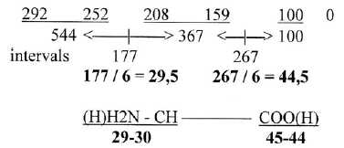

(Interval 292 to 208, 5' - 3', = 84 = 1,5 x 56, the bound B-chain. 111, 1/4 of 444 = 1,5 x 74, the unbound B-chain. Perhaps an aspect on why peptide bonds go on as if always a half was lacking?)   
  
The number of B-chains from the exponent series was grouped in 6: Two of the number series giving the R-chains with the operation below are not enough for the B-chains:   
    544 + 208, x 2 = 1504 = 24 R-chains  
    544 - 208, x 2  =   672 = 12 B-chains bound

Should the first three steps in the exponent series eventually be read both forward and backwards, (as in the “triplet series 5-4-3 + 3-4-5 = 888, x 2 = 24 unbound B-chains à 74 A)? Eventually connected in some way with the opposite directions of R-chains in proteins? More about this triplet series in **file II: 15.**

It's often said that **Asp -** or **Ala** - constitute the elementary form of an ams.   
    Whole mass of Asp R+B = 133 = interval 292 <—>159 in the ES-chain, its R-chain 59 is following interval, 159 - 100, figure 6-3.   
    Number 74 for B-chains becomes a secondary interval as Ala, R 15, the secondary interval 44 - 59. (Cf. that origin of Ala can be both Pyruvate in glycolysis (2 x 44) and Oxaloacetate (132) in citrate cycle.

**Fig 6-3:** *Asp-Ala, R-chains 59, 15*

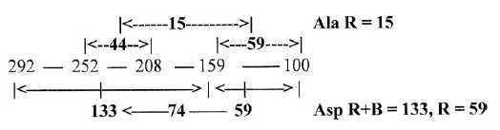

**6.3. The inverted A-base  
  
A-base 135, /\ = 740740740...x10x:** (Sign **/\** here for inversion.)  
At the protein synthesis it is the A-base as AMP that binds to B-chains of ams and transports them to tRNAs. Square of this number 1/135 gives the "factor chain"

1 x 54 = 54               ---> √ 54-86-96-84-50 = 74074,074074074...  
2 x 43 = 86  
3 x 32 = 96               370 / 5 = 74. Corresponding "factor chain" inwards = 235   
4 x 21 = 84               = 5 x 47: 47 = R-chain of Cys which binds protein strings to more  
5 x 10 = 50              complex structures.  
Sum     370  
       ~ 5 x 74

The **inverted number of the C-base, 111** A, times 2, gives 18 (~ H2O) as periodic number, 180180180...and with one 10-power of displacement (x1**/**10) it gives the difference* to inverted A-base 560560560... as period, the bound B-chains à 56.  
   It looks like a connection with the common **A-C-C-ends of tRNAs** at which the ams get attached, an intricate relation between mass of codon bases and ams where inversions appear as resonances in a complementary field? Only random associations?

*(Inversion of the G-base as bound (15 0A) to the period 66666..x10x gives a difference to the inverted A-base that only is a displacement of one 10-power in the period 740740... as if guiding the move of tRNAs between positions on ribosomes?)

**Another association** **about ACC-ends of tRNAs**:  
Sums of ams (R) with A- and C-contenting codons in 1st and/or 2nd position:

A = **888+1** = AA + AU + AG + AC + GA + CA + UA  
C = **444** = CC + CG + CA + CU + GC + AC + UC,

These sums happen to approximate numbers for groups of B-chains. A- plus two C-groups gives about the sum of 24 B-chains à 74 A. If the ACC-ends of tRNAs eventually should be part of a reference system, it seems surely very intricate.

**Keto-/amino polarity between bases:**Peptide bonds when O- and N-groups meet from two ams remind of the keto-**/**amino polarity between the bases U + G versus A + C. Two groups of codons divided by this polarity give sums of ams R = 370, 5 x 74, -**/**+1 (Pair- + Cross-coded):

**UU + GG + UG + GU = 370 - 1   
AA + CC + AC + CA  = 370 + 1**.

370, corresponding to 5 B-chains à 74 A

**6.4. Atoms in backbone chains:**

**Unbound B-chains:**  
    C 48 = 576 = 3 x 192  
    O 48 = 768 = 4 x 192 …(Note C+ O ~1344, sum of bound B-chains.)  
    N 24 = 336   
    H = 96, (-4 H in Arg1, Arg2, Lys (charged) and in Pro)

*

**7.  N-Z-divisions and H-atoms**

**7.1. Number 26 and total N and Z derived from the ES-chain:**  
Number of H-atoms is of course an essential result of and expression for structures of ams. Total N- and Z-sums without H = 2 x 676 = 2 x 262. (Cf. **file 13,** about the 2x^2-chain behind the periodic system: 26 as 18 + 8 in the middle of this chain and 26 as factor in total sum R+B of ams, 3276 = 26 x 126.)   
   N-Z-sums derived from the ES-chain (?):

**Z** = 2 x 544 -  259 = 829, - 1 = **828**,   
**N** = 2 x 208 + 259 = 675, +1 = **676**.

**7.2. N-Z-division similar to division between codon groups of ams:**  
In Table 1 it could be noted that N- and Z-sums didn't change more than one single unit (u) between main groups G+C and U+A from 1st to 2nd base order (as if only through a change n → p!), indicting that also N-Z-divisions may be guided by the numeral series.   
We had the same similarity among mixed and non-mixed codons:   
    N-Z-division in 770-group shows up to be the same -/+1 as between Form- and Cross-coded ams: N = 2 x 176 - 1 = 351 and Z = 2 x 209 +1 = 419.   
    In the the other 12-group 734 the same concerns the A-U-group: N = U1-coded ams +1, Z = A1-coded  ams -1.  
    This is one among several examples of similar number divisions within different basis of mass divisions as along different coordinate axes.  
    (Another example is e.g. the number of atoms in 48 codon bases, 1st and 2nd position, = 674 (2/3 x sum of the ES-chain 1011): See **file 10** about the bases.  
  
**7.3. N-Z steps from 1st to 2nd base order and the ESchain:**   
  
Dividing the differences - as "displacements" - between codon base groups in 1st and 2nd base order in N and Z gives as a border numbers of the ES-chain (+1 in C- and A-groups), shown in figure 7-1. A-groups = 500 = 3' + 5', U-groups = 460 = 4' + 3'. Cf. R-chains: A1 = 500 -3, U1 = 460 +3.

**Fig 7-1:** *N-Z-border between 1st and 2nd base order:*

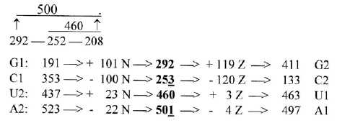

Note that the order U+A in the figure have been reversed, 2nd to 1st base order.

   U1 463 -  3 Z = 460, -  23 N = 437 = U2       
   A1 497 + 4 Z = 501, + 22 N = 523 =A2

Adding displacements of pyrimidine and purine bases respectively, we find that they are exactly the same in N and Z = 123:

C1 + U1 →  C2 + U2 = **-  123 N, - 123 Z**.  
G1 + A1 → G2 + A2 = **+ 123 N, + 123 Z**

U-C-pair is divided in step 1 - 2: 100 - 23 (+/-1): 1 —|—2 ——  3  
A-G-pair is divided in step 2 - 3: 120 -   3 (-/+1): 1 ——2 —|— 3  
  
Displacements 220 and 26,:in G-C-groups 220, in A-U-groups 26.

Cf. a series 102 – 82 – 62 - 42 - 22:

100 – 64 – 36 – 16 – 4

N Z

Another way to get these numbers, abbreviated:

G-C: 54/3 - 44/3 , x 100 = 220. A-U: (5+3)4/3 - (4+3)4/3, x 10 = 26.

Could the exponent 4/3 represent an underlying level?

**√3/2:**

√3/2 gives the total relation Z - N = 828**/**676 very closely, as it does in the separate G+C- and U+A-groups.

**~ 1/10**:    The number of H in these main groups is circa 1/10 of totals 544 and 960, 55+**/**-1 in G+C-groups, 97 -**/**+1 in U+A-groups.

**7.4. Interval 49 in ES in the middle step: 3' - 2'**

The interval in step 3' - 2' (208 - 159) at the middle of the ES-chain = 49. Divisions of sums 544 and 960 -/+ 49 (+/-1) give approximately the N-Z-division between main codon groups G+C, A+U:

**Fig 7-2:** *N-Z-division approximately from -/+ middle interval 49:*

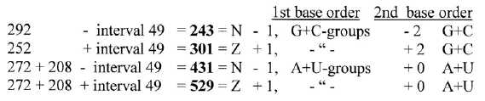

Here we could associate to a d-degree step 3 - 2 as a relation mass versus charge: neutrons n polarized by weak interaction into charges, protons and electrons:   
   n → p+ + e- + antineutrino.

**7.5. H-atoms:**

Total number of H-atoms in 24 ams R-chains = 152 = 8 x 19.  
It is rather precisely distributed on the individual codon groups as 1**/**8 - 2**/**8 in G-C-groups, 2**/**8 - 3**/**8 in U-A-groups with exchange of the numbers from 1st to 2nd base sums:  
  
   G1 1**/**8, C1 2**/**8, G2 2**/**8, C1 1**/**8.    U1 2/8, A1 3/8, U2 3/8, A2 2/8.  
  
This makes it possible to closely derive the N- and Z-numbers of the individual codon base groups -**/**+ 1-2 units. Examples:

G1 = 191 A, - 19 = 172, x ½ = 86 = N, + 19 = 105 = Z  
A1 = 497 A, - 57 = 440, x ½ = 220 = N+1, + 57 = 277 = Z -1.

**7.6. A special observation** **regarding 3rd base groups:**  
The figure shows ams with differentiating 3rd base, to the left from glycolysis, to the right from the citrate cycle.

**Fig.** *17 files, 02-10 a, b:*

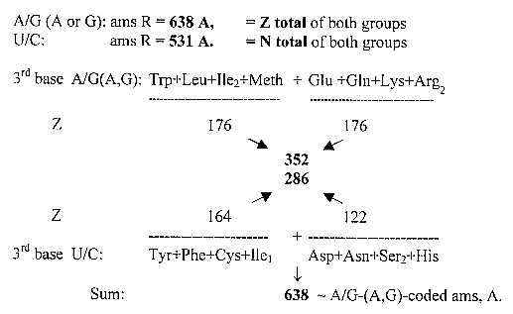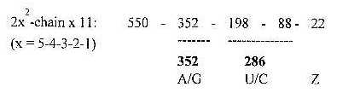

This is still another example of equal number divisions along different "property axes".

(In numbers of the ES-chain:  
     272 + 367 = 638 +1. 272 + 259 = 531  
or 584 +/- 54, half the interval 3'- 1' 108 = 531 -1 and 638.)

\***8.  Geometries**

**- Golden section - Special arithmetical operations, e. g.**

**π + √2, - ES-series and Cheops pyramid - √1/3 and √2/3**

Hopefully some advanced mathematicians will find this file on the web and get provoked enough to search for explanations!

**8.1. Geometrical relations in the two 12-groups:**

385 x √2 is ~ 544. Through this factor √2 and inversions (/\ ) the codon groups 385 and 367 in the ES-series become related, figure 8-1 below.. How to interpret such relations? They are very likely only one example among many similar dimensional relations on a deeper underlying level that remains to investigate. (√2 should probably not be regarded as a relation diagonal/side in a square, sooner in its serial development?)

**Fig 8-1:** *Geometrical relations through √2:*

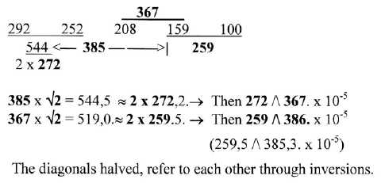

Two notes:   
1) A right-angled triangle with the sides 176 and 209 (the number division of 385 within mixed codon groups) gives the hypotenuse 273.23.; 273 the mean number of two ams R + B unbound.

2) Cf. perhaps the relations between Z-numbers of ATP and NADPH(+H) around 258-387, a 2/3-relation, 6 x 43 ⎯ 9 x 43, see Biochemistry.

**8.2. Intervals in the ES-chain with exponents 3/2 and 4/3:**

Intervals 40-44-84 in the ES-chain with exponent 3/2 gives numbers 253 292, and 770, as a kind of feed back (?) or mutual references , re-establishing the ES-numbers 5' and 4' (+1):

   403/2 = 252.98. = 253.  
   443/2 = 291.86. = 292. ........Sum 544 +1.  
  
(Third number 208?: 84 - 49 = 35, → 353/2 = 207.06. = 208 -1)

   843/2 = [292 - 208]3/2 = 770. = Cross- plus Form-coded ams.  
  
Compare with 42, 1/2 times the interval 84, divided and whole number:

**Fig. 8-1-b**

Intervals in the three middle steps of the ES-chain, sum 152:  
     
   **443/2** = 291.9.     **493/2** = 343     **593/2** = 453.2.......sum 1088.15. ≈ **2 x 544**.  
  
  
**8.3. Exponent 4/3 ?**  
Testing this exponent - as related to a higher d-degree step 4 - 3 (?) - shows up to be another way to re-establish the starting number 292:   
  
   404/3 **+** 444/3  →  292.13. (Cf. 52/3 = 2.924.)

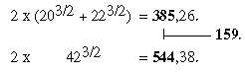

Note that 404**/**3 is about 136 +1 and 444**/**3 about 156 -1: 136 mass of Inosine, 156 mass of Orotate, the parents of the bases in the codons

**844/3 = 367.9**. = 208 + 159, +1;     x 2 = 736. = RNA- + Pair-coded ams +2.

**8.4. The golden section:**  
The golden section (gs) as Fibonacci series appears also in this ES-chain and mass relations within groups of ams. Following series, figure 8-2, leads from 2' in the ES-series to total sum R + B of the 24 bound ams through steps as times gs:   
    The ES-numbers  208 and 367 gives for instance the groups  G+C 544 and U+A 960 approximately.

**Fig 8-2:** *Golden section (gs) steps in the ES-series*:

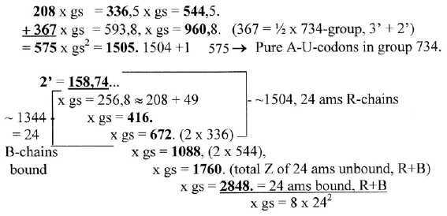

Higher numbers abridged. Number 257. = 208 + middle interval 49. In 7th step we get 2848, x gs = 2 x 2304 = 2 x 482.(24 = number of codons, ams.)

**8.5. Forms of R-chains:**

Elementary structure of R-chains as basis for grouping of ams may give three elementary groups: vary roughly ring-formed, "straight" and "branched":

Ring-formed ams 292 + 159 (a loop 5' - 2'.) = **451**,  
three aromatic ams 328, + His + Pro 123.  
  
"Straight" ams = 2 x 159 (2') = **318**,  
Ala, 2 Ser, Thr, Cys, Lys, Meth = 317, + Gly 1.  
  
   Ring-formed + "straight" = **770 -1**.   
  
Branched = **734 +1** (as at middle of the ES-chain):   
CHx-groups = 271; O-OH + O-NHx = 262; 2 Arg NHx-NHx = 202.

**8.6. π and √2 , an arithmetical curiosity:**

Reading and adding 2 x 5 two-figure-numbers (31 + 41 + 59..., 14 + 15 + 92...) from first eleven figures in these transcendent celebrities gives both whole and partial sums of the codon grouped amino acids as well as vertically numbers from the exponent series, see the figure below.  
   No motivation for the operation is offered here. Should there exist any sense in the operation, it's left to more advanced mathematicians to find it.

**Fig 8-3**: *π and √2:*

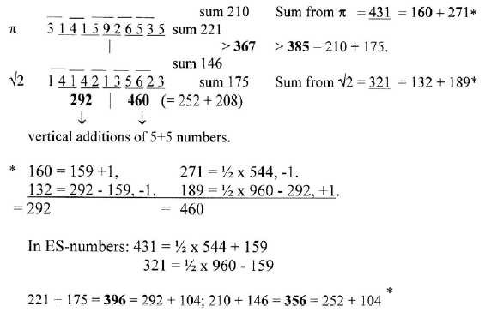

*Cf. fig. 4-1.  
Sums of numbers from π = 431 and from √2 = 321; cf. triplet numbers 432-321.

If √2 is seen connected to d-degree step 2-1 and π to step 3-2, the number 321 from √2 could be thought of as displaced, here one 10-power step:

**Fig. 8-3-x**. *Sum 431 + 321 with displaced 321 number*

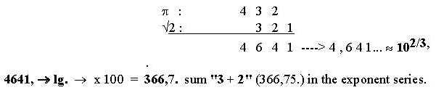

[**Cheops pyramid:**

½ x 292 = 146 ~ the height of this pyramid - in meters!

½ x 460 = 230 ~ side of this pyramid - in meters!

If the old Egyptians were acquainted with cubic roots and exponents 2/3 is probably uncertain. The Pharaoh measure "ell" is said to have been about half a meter.   
    That the circumference of the base is approximately 2π times its height is a well- known fact.]

*π* and √ 2 in figure 8-3*:* the 2-figure numbers summed in another way:    
  
*One example:*

*π*   31 14 41 15    59  92 26 65   53 35   
*√ 2*   14 41 14 42    21  13 35 56   62 23  
            210+2              367            175-2  
                 |                                      |    
                                    385

[212 x 173 = 366,76 x 10^2. 3' + 2' = 366,74.)

What kind of relation could exist, which closely couples *π* and *√ 2*?  
*π* represents 1/2 of a unity circle, but *√ 2* only 1/4, if illustrated as in the figure   
below? Could we interpret it in terms of a step or displacement in dimension   
degree 3 to 2: (4-3-1 → 3-2-1 as sums of the 2-figure numbers above)? *π* related to a 3-dimensional world, *√ 2* to a 2-dimensional one.

**Fig. 8-4** *Bell's theorem*

a.       b.

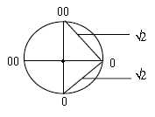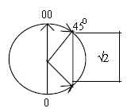

Assuming the definition of a dimension as characterized by two complementary “end-poles” (0 - 00 in figure a), the shortest step between the poles in an 1-dimensional world would be 2 r and the shortest step in a 2-dimensisonal world could be only *√*2. In a 3-dimensional world, the shortest way could be the circular one (with reference to Einstein)?

(There is an association here to Bell's theorem and Aspect's experiments with photons in quantum physics: measurements in two dimensions (directions) as φ a branched way for two possible outcomes. If there were no coupling between the photons, the maximum result of Bell’s formula should be +/- 2. But the experiments showed on a maximum of +/- 2*√*2  showing that the photons were entangled.   
    The question arises: what would be the result if such measurements were carried out in three dimensions?)

**8.7. *√*2 representing the tangent of an angle, a direction?**  
Arc tan *√*2 = φ 54.736.  
Sin φ = *√*2/3,   
Cos φ = *√*1/3  
  
Treating these numbers sin - cos in the same way as *π* and *√*2 above gives these results:

**Fig. 8-5.** *Sin - Cos for arc tan √2*

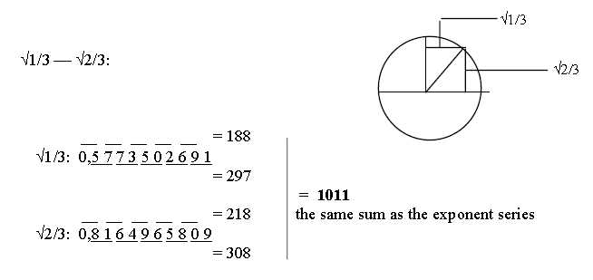

Taking each other 2-figure number from the cosine series and each other from sine numbers, the upper ten first, gives sums of the ES-chain:

**Fig. 8-6.** *Sin-Cos-series with sum 1011 of the ES-series*

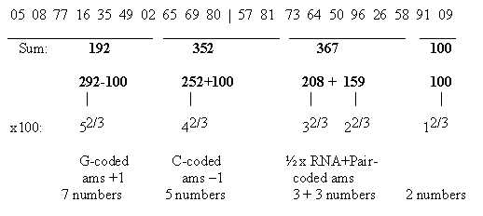

\***9.  Glycolysis - Citrate cycle**

**Codon grouped amino acids on the basis of their origin.**

**9.1. Division of ams from Glycolysis and citrate cycle**

Sum of ams with **U-base** in 1st and/or 2nd position of codons is **752**, exactly half the total = 292 + 252 + 208 in the ES-series. It's division between the two 12-groups 770 and 734:

Group 770: Cross- and Form-coded: **208 + 100 = 308**   
Group 734: RNA- and Pair-coded: **544 - 100 = 444**

All these ams derive from stations in glycolysis, no one from citrate cycle.   
    (It's suggested here that this is connected with the fact that U as coenzyme UTP-UMP is the one engaged in bonds and breaking of glycogen.)   
  
Hence, we could imagine that the two groups or number chains à 752 also represent the two sides outside**/**inside mitochondria membranes. This under following conditions:  
   Ala is regarded as derived from oxaloacetate (may also derive from pyruvate). Ser2, AG-coded, likewise, as along the outer loop from oxaloacetate via homoserine back to 3-P-glycerate. Gly (one unit) from Ser1 or 2? Meth as connected with Cys (?).  
   With these assumptions we get ams derived from the different stations in the processes as shown in table 6: Note the approximate ES-number divisions

**Table 6:** *Amino acids from stations in glycolysis - citrate cycle*

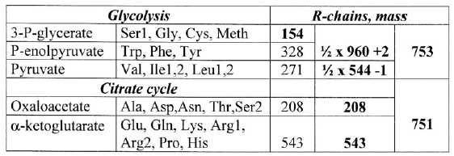

**9..2 Mixed and non-mixed coded ams from the stations:.**

The divisions in codon type groups 770 and 734 on the both sides of mitochondria membrane is shown in figure 9-1 below. Included in the figure is an observation from files about number-base systems that these groups -/+1 seem to refer to each other through transformations between nb-10 and nb-8 and in opposite directions:

**Fig 9-1:** *Codon type groups, division on Glycolysis and Citrate cycle:*  
(The codon type groups defined in file 2.)

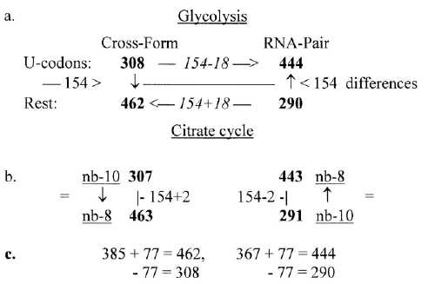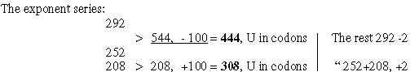

Differences, cf. interpretation of number 77:  
    308 - 444 = 136 = 4 x **34**  
    462 - 290 = 172 = 4 x **43**             (Cf. A1 - U1 = 1 x 34, A2 - U2 = 2 x 43)

43 to 34: 9 ~ OH- Z

Also the rest, not U-contenting codon groups, are divided +/-2 in numbers of the ES-chain, a division in step 5 - 4, while U-groups represent a number division in step 4 - 3.   
  
In the figure above we have for instance 18 as differences 308-290, 444-462 and +/-2 in the transformations. We have perhaps (?) here a correlation among ams to the general theme in the processes, secretion of 2H and processing of H2O (18). If so, what about +/- 154?    Could it eventually express the same as the loop, outside the main steps, from oxaloacetate via homoserine (and homocysteine) back to 3-P-glycerate where sum of ams = 154?

Codons and ams in the four groups are shown in figure 9-2 below:

**Fig 9-2:** *Amino acids in the 4 codon type groups:*

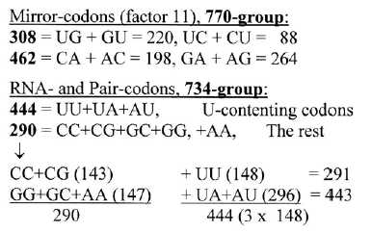

**9.3. Division in G+C- and A+U-coded ams:**

This division shows notable agreement with divisions in the ES-chain (+**/**-1).

**Fig 9-3:** *Division on groups G+C, A + U from stations in Glycolysis - Citrate cycle:*

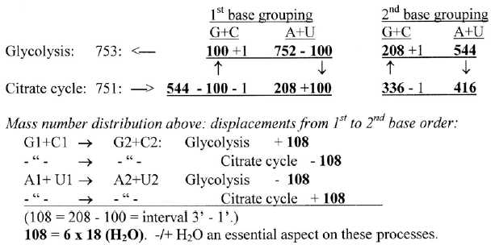

**9.4. Division on atom kinds:**

**Atoms** on ams from Glycolysis and from Citrate cycle become the same for C-atoms as between U1+C1-coded and G1+A1-coded ams (cf. file 4, figure 4-1):

   Glycolysis 47 C = **564** = 460 + 104, other atoms 292 - 104 +1.  
   Citrate cycle 33 C = **396** = 292 + 104, other atoms 252 + 104 -1.

**Fig. 9-4:** *Division on atom kinds*

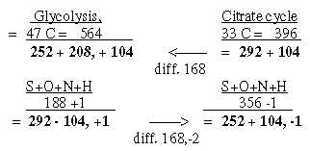

**9.5. Sums of stations in the two processes compared with groups of ams**:

a) bound, b) with +1 for charge and bonds to S- or P-enzymes:

Glycolysis, 8 C3-stations: a) 736, b) 750.   
Citrate cycle, 10 stations*: a) 2 x 736, b) 2 x 748

*Malate, Oxaloacetate, Citrate, Cisaconitate, Isocitrate, Oxalosuccinate, α-ketoglutarate, Succinyl(~Coa), Succinate, Fumarate.

That the sums approximate numbers as 752 and 734 among ams in the ES-series is not so natural as it perhaps may seem.

**Table 7:** *Molecules in the citrate cycle* 1496 = 11 x 136 (~ Inosine) = 44 x 34.  
Molecules with 5 C and 4 C = 748 - 12 (6 x 2) for charges, bond = 736;   
molecules with 6 C =:748, - 12 (4 x 3) = 736. .  
736 = **32 x 23**.   
    Sum of substances = 1496, x 2 (turns) = 2992 = 11 x **272** (half the number 544)  
  
**Eight of the stations in Citrate cycle** as uncharged, compared with the ES-chain:  
  
101 = Succinyl →  
→ 2 x 59 = Succinate →  
→ → 2 x 58 = Fumarate →  
→ → → 2 x 133 +/-1 (== 292 - 159) Malate + Oxaloacetate →  
→ → → → 2 x 192 (292 - 100) = Citrate + Isocitrate →   
→ → → → → 146 (½ x 292) = α-ketoglutarate, → (→ Succinyl...101)   
(Two substances excluded here, Cisaconitate  174 and Oxalosuccinate 190.)

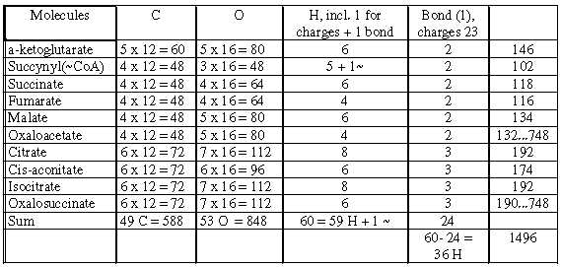

**9.6.   44 - 59, intervals in the ES-chain:**  
It is worth noting the intervals 44 (4' →>3') and 59 (2' ← 1') in the ES-chain, steps that correspond to each other in the background model. See figure 9-4. It is numbers equivalent with main molecules incorporated into the citrate cycle: CO2 in step from Pyruvate (88) to Malate (133+1) and of acetyl-(CoA) + O(H) = 59 (60) in step from Oxaloacetate (133 -1) to Citrate 192 (132 + 60 (~ 133 -1 and 59 +1):

**Fig 9-5:** *Intervals 44 and 59 in ES-chain as additions into Citrate cycle:*

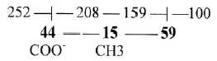

**9.7. Orotate <———> Inosine; codons U/C → A/G in 3rd position:**

There is a trend from ams with 3rd base U/C to ams with 3rd base A/G like a coordinate axis through the processes, in ams codons from first stations in the glycolysis to Glu in the citrate cycle, illustrated by following examples:

**Fig 9-6:** *Orotate - Inosine, a coordinate axes through the processes*

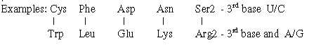

**9.8. Anti-codons:**

Most codons of ams from Glycolysis have anti-codons that are codons for ams from the Citrate cycle - as a kind of "complementary poles". Is it perhaps possible to imagine that the two series of codons once originated from opposite strands of DNA (via tRNAs)? One such variant is shown in table 7:

**Table 8:** *Anti-codons:*

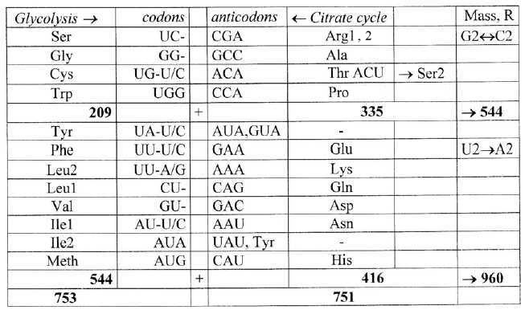

Among ams from Citrate cycle the AG-codons of double-coded Ser and Arg can only be derived in a second step through a change between optional U and C in 3rd base as from Thr and Pro.   
   Exchanges within group 416 in the table are possible

*

**10.  The coding bases - some annotations**

**Codon bases G, C, U, A in RNA; T instead of U in DNA:**Some material from fileBiochemistry 04**:**  
**10.1. Complementarities and inversions:**At least in actual cells of today the bases are synthesized in complementary ways: the purine type from the amino acid Gly as centre, the pyrimidine type from the amino acid    
Asp together with carbamoyl phosphate.   
   In both cases molecules of circa 60 A are added: Gly 75 + 60 = A-base 135, Asp 133 + carbamyl ~ 60 A, - 2 x 18 at condensation, to Orotate); cf. interval 159 - 100 in the ES-chain.     
   Both mass numbers of Gly and Asp are found in the ES-chain as intervals:

Gly 75 A = 292 - 367   
Asp 133 A = 292 - 159...Sum **208** = 3'

It could also be observed that these numbers are inversions of each other:

**75 /\ 133**... x 10x, = 3/4 - 4/3 x 100

Approximate inversions are also the mass sums of purine versus pyrimidine bases:

G 151+ A 135 = **286**. U 112 + C 111 + T 126 = **349**:  
 **286 /\ 349**.65 x 10-5

**10.2. Exponent 2/3:**

Pairs of the RNA-bases - with exponent 2/3 appear to be inversions of their complementary ones:

**Fig 10-1**: *Pairs of bases as each other's inversions through exponent 2/3*

**Another relation to the ES-chain:**The single bases as bound (= -1) with exponent 2/3, (figure 10-2 below), times 10, give the sums G + A≈544, U + C ≈ 460, sums 5'+4' and 4+3´ in the ES-chain. With exponent 2/3 applied again on the four obtained numbers the sum becomes ≈ 159 = 2' in the ES-chain. First obtained four numbers without times 10 are ≈100 = 1':

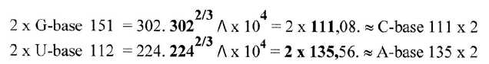

**Fig 10-2:** *Bases bound with exponent 2/3:*

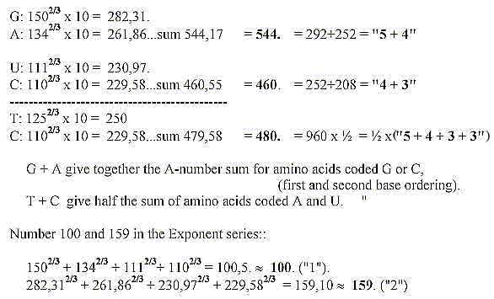

**10.3. ES-numbers, a few first notes:  
  
*Parents of the bases***(inosine 136 and orotate 156 ) **= 292 = 5'**

***N-Z-division in 4 DNA-bases:***4 DNA-bases, sum 523 A: N-Z compared with numbers in the ES-chain:

Z:  272 = 544 x½. G + C: 136, A + T 136 (- 8 in RNA with U-base = 128)  
N: 251 = 252, -1: G + C: 126, A + T 125 (- 6 in RNA = 119)

***Mean value of a base pair of DNA:***Mean value of a base pair of DNA happens to be a quotient from the ES-series:

544 **/** 208, x 100 = 261,5.

***Five bases***. including T = 635, circa 292**/**460  x 10^3 ( 634,7)

***A step of polarization*** outwards can be recognized from G + C-bases to U + A-bases, reminding of order of dominating groups in the ES-chain:  
   The bonds G ≡C are 3 versus 2 in U=A-pair and G + C include both N and O in the H-bridges, while these are "polarized" to only N in A-base, only O in U/T-bases.

**10.4. Atoms in the bases - a 2-dimensional table**

Number of atoms in 24 codons, 1st and 2nd bases, figure 10-3:

**Fig. 10-3:** *Atoms in the bases - a 2-dimensional table*

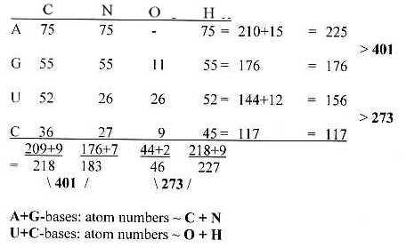

Number of atoms in 24 codons, 1st and 2nd bases:

For  23 ams, without AUA-codon for Ile2, the sums become

   horizontally 401 - 15 = **386**, 273 - 12 = **261**,  
   vertically     401 - 16 = **385**, 273 - 11 = **262**

(The division of 385 on N and C vertically in 209 - 176, is the same as in the table of mixed codons.)

Sum of atoms in 24 coding bases for 24 ams = 674, 2 x 337 . Assuming an equal distribution of bases in 3rd position we get the sum  1011 = sum of the ES- series:

292 - 252 - 208 - 159 - 100 - 0      Sum 1011  
    **544                 467**

Number of atoms in the bases and adding equal number in 3rd base:

13 U with 12 atoms = 156, + 6 x 12 = 228  
15 A with 15 atoms = 225, + 6 x 15 = 315...**Sum 544 -1**  
11 G with 16 atoms = 176, + 6 x 16 = 272  
  9 C with 13 atoms = 117, + 6 x 13 = 195...**Sum 467**

The equivalences could be connected with the function that the bases have as coenzymes in relation to the different classes of substances. Roughly:

U-base (UTP) with carbohydrates (with dominating atom O),  
C-base (CTP)- with lipids (characterizing atom may be said to be H)  
G-base (GTP) with proteins (with typical atom N).   
A-base: (ATP), main energy storage and with transporting function ? (C-skeleton?)

**10.5. Bases U, A, G from "phase waves":***(From index file, figure 01-1..)*   
  
Quotients between wavelengths (n = 2, m = 5, 4, 3) in the Balmer series times 102 happen to give the mass numbers of U- and A-bases too (112 and 135) andapproximately the G-base (151,2), which could awake some suspicions...* (Quotients as a kind of phase waves? Alleged not to carry any information!)

**Fig. 10-4:** *From Balmer series for spectral lines of hydrogen***:** (C-base eventually later developed to give two pairs? Eventually from a quotient between a spectral line of hydrogen and oxygen.  
    Or cf. last  term in c. = 1/9,  x 1000, = 111,1. C-base = 111 )

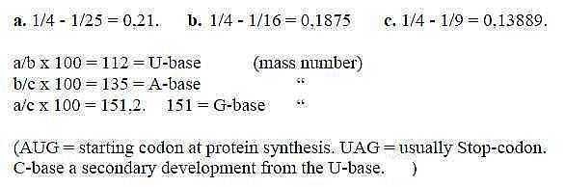

**10.6. Just some numbers. a selection of operations**

**a)** Sum of 1st and 2nd bases in 24 codons = 6141.   
   Quotient to sum of 24 ams R + B unbound 3276:

    6141 **/** 3276 = 1.8745 ~ 1.875. = 15**/**8 = 5 x 3 x 1 **/** 4 x 2, odd/even d-degrees.  
  
    (Cf. 0.1875, 2nd spectral line of hydrogen.

For number 6141 = number 1357 transformed to number base system (nb-x) 6,  
see file 19, fig. 19-3.

**b)** DNA-bases with +2 for double-bonds in the rings:

A = +8, G = +6, C = +4, T = +2 = **543.**

**c)** - 14 (A+T = 261), **/\**, x 107 = 2736.7   
    - 10 (G+C = 262), **/\**, x 107 = 3816.8   
                        Sum = 6553.5 = 2 x 3276.76. ~ 2 x 24 ams R + B unbound

                       [6 x 509 (24 baser RNA) = 3054, **/\**, x 107 = 3274.4 ]

**d)** 4 RNA-bases = 509 and number 32

25**/**2π, x 100 = 509 (509.3)  
(4th root of 32 x 100 ~ 752.12 x10-2, 752 half the sum of 24 ams R)

**e)** G**/**5 + A**/**4 + T**/**3 + U**/**2 + C**/**1 = **273** (272.95),   
273 the mean value of two ams R+B unbound

**f)** 4 DNA-bases = 523 A: 5232 = 273529 = ~2735. × 102   
2735 = sum of 20 amino acids, R+B-chains,   
        without the extra set of 4 ams with two codons.

**g)** G-base, mass number from the simple dimension chain:

1 **/** 543 + 1 **/** 210, **/\** = **151**.43. ~ G-base 151

**More material may be found in files about biochemistry:**The protein synthesis,    Synthesis of the bases, Numbers DNA/RNA

*

**11.  Transmitters and the ES-chain**

**Transmitters**  
Several transmitters show up to have halved mass numbers of the ES-series (-/+1):  
  
**Fig 11-1:** *Some transmitters:*

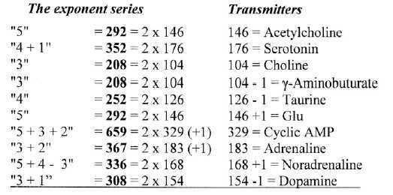

(Cf. opposite forces that cancel each other and only halved or polarized become active.)

**Fig 11-2:** *Example Acetylcholine:*

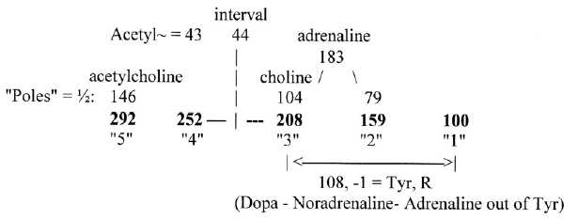

*To Section II: **Simpler chains - comparisons**.

A survey of sums of amino acids derived from the ES-chain on next page..

\**Table 9: Survey of mass sums of amino acids derived from the exponent series*

|  |  |  |  |  |  |  |  |  |  |  |  |
| --- | --- | --- | --- | --- | --- | --- | --- | --- | --- | --- | --- |
| The chain 5-4-3-2-1-0 with exponent 2/3, x 100, abbreviated numbers:  292 - 252 - 208 - 159 - 100 - 0  “5” - “4 ” - “3” - “2 ” - “1” - 0 | | | | | | | | | | | |
| 20 + 4 ams | | | | 1504 | 2 (5 + 4 + 3) * (See note) | | | | | in Exponent series = | |
| Pairs of codon groups | | | | | | | | | | | |
| G1 + C1 = G2 + C2 | | | | 544 | = 5 + 4 | | | | | 752 - 208 | |
| U1 + A1 = U2 + A2 | | | | 960 | = 5 + 4 + 3 + 3 | | | | | 752 + 208 | |
| C1 + U1 | | | | 816 | = 5 + 4, + ½ (5 + 4) = 2(4+3) - ½ x3 | | | | | 544 + 272 (½ x 544) | |
| G1 + A1 | | | | 688 | = 2 x 3, + ½( 5 + 4) = 2 x 5 + ½ x 3 | | | | | 416 + 272 “ | |
| C2 + U2 | | | | 570 | = 2(5 + 4 - 2 - 1) | | | | | 2(544 - ,259) | |
| G2 + A2 | | | | 934 | = 2 ( 3 + 2 + 1) | | | | | 2(208 + 259) | |
| Individual codon groups (-/+ one unit) | | | | | | | | | | | |
| G1 | | | | 191 | = 5 - 1 - 1 | | | | | 292 -101 (CG = 101) | |
| C1 | | | | 353 | = 4 + 1 + 1 | | | | | 252 +101 (CG =Arg) | |
| C2 | | | | 133 | = 5 - 2 | | | | | 292 - 159 | |
| G2 | | | | 411 | = 4 + 2 | | | | | 252 +159 | |
| U2 | | | | 437 | = 5 + 4 - (3 - 1) +1 | | | | | 544 - 107 (UA = 107) | |
| A2 | | | | 523 | = 2 x 3 + (3 - 1) - 1 | | | | | 416 +107 (UA =Tyr) | |
| U1  A1 | | | | 463  497 | = 4 + 3 + ½ x 3 - 1 - 1  = 5 + ½ x 3 + 1 +1 | | | | | 460 +104 - 101  292 +104 +101 | |
| A1  U1 | | | | 497  463 | = C1 + 2 x 3 - ½ (5 + 4)  = G1 + ½ (5 + 4) | | | | | 353 + 416 - 272  191 +272 | |
| Codon types | | | | | | | | | | | |
| Cross plus Form: | | | | 770 | = 2 (5 + 4 - 2) | | | | | 2(544 - 159) = 2 x 385 | |
| RNA plus Pair: | | | | 734 | = 2 (3 + 2) | | | | | 2(202 +159) = 2 x 367 | |
| Pure G-C-codons, pure A-U-codons in 1st and 2nd position (of RNA- + Pair-groups) | | | | | | | | | | | |
| GG+GC+CG + CC | | | | 159 | = 2 | | | | | 159 | |
| UU+UA+AU+AA | | | | 575 | = 2 x 3 + 2 | | | | | 416 + 159 | |
| 3rd base grouping (-/+ one unit) | | | | | | | | | | | |
| “2-base-coded” ams | | | | 335 | = 5 + 4, - 3 - 1 | | | | | 544 - 208, - 1 | |
| A/G (A or G) + U/C | | | | 1169 | = 5 + 4 + 2 x 3, + 3 = 4 x 5 +1 | | | | | 960 +208, +1 | |
| G1+A1 without  “2-base-coded” | | | | 688-104 | = 2 x 5 “2-base-coded”  GG+GC+GU+AC | | | | | 584 = 2 x 292 | |
| C1 + U1 without  “2-base-coded” | | | | 816-231 | = 2 x 5 “2-base-coded” +1  CG+CC+CU+UC | | | | | 585 = 2 x 292, +1 | |
| G2 + A2 without  “2-base-coded” | | | | 934-102 | = 4 x 3 | | | | | 4 x 208 = 832 | |
| C2 + U2 without  “2-base-coded” | | | | 570-233 | = 5 + 4 - 3 +1 | | | | | 544 - 208, +1 | |
| Mass division on atoms in the 24 ams R-chains | | | | | | | | | | | |
| C-atoms 80 | | | | 960 | = 5 + 4 + 3 + 3, ~ A+U-coded ams | | | | | 80 C | |
| S+O+N+H | | | | 544 | = 5 + 4 , ~ G+C-coded ams | | | | |  | |
| H | | | | 152 | = 4 - 1 | | | | | 152 H | |
| S+O+N | | | | 392 | = 5 +1 | | | | | 2 S, 10 O, 12 N | |
| Ams, R-chains, grouped according to end atoms in R-chains | | | | | | | | | | | |
| a)R with only CHx,H | | | | 420 |  | | | | | including Gly | |
| b) R with S, O, no N | | | | 468 | a)+b) = 888 = 2 (544 - 100) | | | | |  | |
| c) R with N | | | | 616 | = 2 208 + 100) | | | | | including Gln,Asn | |
| Ams (mass) divided in groups according to number of C-atoms in R-chains | | | | | | | | | | | |
| 4 C | | 7 C | | 3 C | | 0 C | 2 C | 1 C | 9 C | | See page 21 on  7C (Phe. Tyr)  9 C (Trp) |
| 584 | 198 | | 305 | | | 1 | 162 | 124 | 130 | |
| 2 x 5 | 2 x 4 | | | | | | 2 x 3 | | | |

* Reference numbers 5-4-3-2-1 written without quotation marks.

## **The Genetic code: Section II**

**Simpler numeral series**

#### **Åsa Wohlin**

**www.u5d.net**

**2015-03-23**

CONTENT *Page*

12. Simpler numeral series: comparisons with the ES-series.

Some first notes 55

13. The 2x2-chain 57

14. Halved orbitals as a superposed chain 66

15. x1 – The triplet series. ⎯ The x4-series 69

16. An x3 series 73

**12.  Simpler numeral series**

**- Comparisons with the ES-series - some first notes -**

**12.1. Some simple quotients:**  
  
The simple quotients 7**/**24, 6**/**24, 5**/**24 times 103 approximate first three numbers of the ES-chain, since total sum of ams R is nearly 1500 (particularly if we count on Lys and the two Arg uncharged), Note the sum of the series 5 - 4 - 3 - 2 - 1 - 0 = 15.  
   However, the lower numbers in the ES-chain are not given through simple quotients.  
     
**Fig 12-1:** *7,6, 5 parts of 24, decimals ~ ES-numbers:*

Cf. numbers 7, 6, 5 with halved numbers of electrons in orbitals *f, s + d,* and *d*, see below and file 13 about the periodic system.

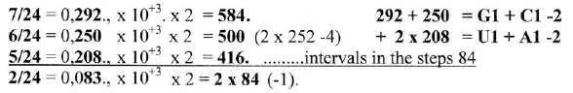

A division 10-8-6 of the total 24 ams times 1504 in agreement with number of ams, 10 (2 x 5) in G1 and C1, 8 in A1, 6 in U1, gives sums that through a displacement of **84** (~ 2/24 = 292 - 208 in the ES-chain) gives the G+C- and U+A-groups, figure 12-2 below..   
   Applying exponent 2**/**3 to these 10-8-6-parts of the total, gives abbreviated times 4 the appropriate numbers of the ES-chain.   
  
**Fig 12-2:** *10, 8, 6 parts of 24, transformed to ES-numbers:*

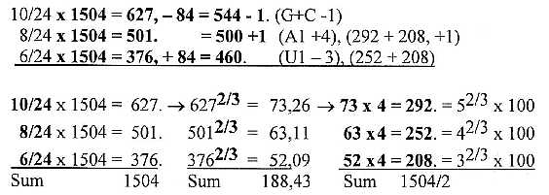

**63 x 52** happen to give the whole sum of 24 ams R + B unbound = **3276**.

A note:  
Numbers 7**/**24 and 5**/**24 above = 0,292 – (1/3×10-3) and 0.208 + (1/3×10-3).   
Times 2 x 103  gives orbital numbers with reference to file 13:  
    [14 – 2**/**3]**/**24 = 0,5555…  
    [10 + 2**/**3]**/**24 = 0,4444…  
      8        **/**24 = 0,3333…   
 [2 + 2**/**3] **/**24 = 0,1111...

**12.2. Survey of different numeral series on x = 5 - 0:**

a) **x1: 5 - 4 - 3 - 2 - 1 - 0** read as triplets:

    543 - 432 - 321 - 210

b) **2x2:** **50 - 32 - 18 - 8 - 2 - 0**: the chain behind the periodic system.  
            Intervals in the steps as orbitals in electronic shells.

c) Halved orbital numbers **½(18 - 14 - 10 - 6 - 2)** as a superposed chain:

**Fig 12-3:** *Halved orbitals as a superposed chain:*

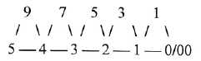  
  
d) **x3:** 125 - 64 - **27 - 8** - 1 - 0.

e) **x4:** **625 - 256 - 81** - 16 - 1 - 0.

*

**13.  The 2x2-chain**

**13.1. The 2x2-chain behind the periodic system:**

It is one rather natural hypothesis that the genetic code could originate from a similar number chain as for instance the 2x2-chain behind the Periodic system, figure 13-1 below. The ES-chain is the cubic roots out of numbers in this chain halved. Is there anything pointing to a more direct connection?   
  
(In the figure is pointed to the fact that reading these numbers in decreasing number-base systems (nb-x) 10-8-6-4-2 and translating them to nb-10 gives the very simple chain 50 - 40 - 30 - 20 - 10.)  
  
**Fig 13-1:** *The 2x2-chain behind the periodic system:*

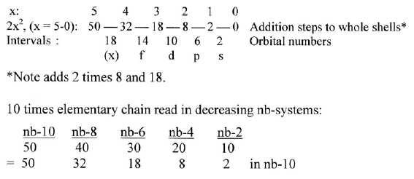

**13.2. G+C and U+A-groups:**

First observations is that numbers in the chain times a factor 16 gives mass of the main groups of G + C- and U + A (R), fig.13-2], total sum 94 x 16= 1504.   
    (Simultaneously we have that sum of the whole chain 110, times 16, = 1760, e. g the total sum of Z in the 24 ams unbound. About Z, see Para 6 below.)

**Fig 13-2:** *2x2-chain, main codon groups 544, 960 through a factor 16:*



With reference to the dimension model behind this site (cf. the "loop model", figure 1-2) three polarizations of dimension degree 5 (the whole): 5 → 0 + 00, 5 → 4 + 1, 5 → 3 → 3 + 2

## **Fig 13-3.** *Three polarizations of 5:*

|  |  |
| --- | --- |
|  | The G+C-coded ams as a polarization of 5 to 4 + 1  (before 5 to 3 + 2) may be regarded as a deeper level  when dimensional aspects are applied, as this group  of ams comes first in the ES-chain. |

However, number 544 appears also "linearly" as a sum:   
(32 - 8) x 16 = 384  
(18 - 8) x 16 = 160  
Sum:               544

It may be noted that first three numbers 50 - 32 - 18 in the 2x2-chain times a factor ~ 30 (2 times the elementary series 5-0) roughly approximate the sum and division on U+A and G+C groups: 1500 - 960 - 540.  
  
  
**13.3. Some general observations:**

Both 208-numbers in the ES-chain and here 416 goes to the U+A-group of ams. Cf. perhaps that additions 8 and 18 are repeated two times to whole shells in the periodic system (through displacement of *d*-orbitals; *s*-orbitals of next shell first filled).   
  
262 = 676, the middle number 18 + 8 in this 2x2-chain squared, times 2 = 1352, sum of all ams R without H-atoms; this factor 26 also something to remember. Total number of ams, R + B = 3276 = 26 x 126.

Number 94, 60 + 34; and Selenocysteine:  
Number 94 (times 16 = 1504, total of ams R) is also the R-chain of the so-called 21st ams *Selenocysteine*, 34 Z, with isotope 79 of Selenium: A (R) = 94 = 2 x 47, the R-chain of Cys with its special role in protein folding. Se-Cys is encoded in a special way and could be an example of how Nature elaborates to fill arithmetical patterns?   
   About numbers 94, 47, 34 and the division of number 128, see Subpages II, file 04. para. 6

Total number of atoms in R + B-chains of the 24 ams without H-atoms = 224 =

= 14 x 16. (14 the interval in step 4 - 3 in the 2x2-series.).  
  
  
**13.4. All integers 1 - 110 = 6105:**  
Another curious connection is that the sum of all integers 1 - 110 of the whole 2x2-chain = 111 x 55 = 6105, inverted = half the total sum 3276 of 24 unbound ams 1638 as a periodic number.

**Fig 13-4.** *6105, total sum of numbers 1-110:*

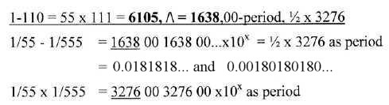

* Numbers 18 and 180 as decimal periods are equivalent with masses of H2O and glucose, fructose, essential starts for ams!

**13.5. Mass numbers, other groups:**

**Fig. 13-5.** ***16 times the 2x2-chain:***

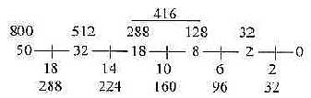

a) The two 12-groups of ams, 770: and 734, -/+2 = 768 and 736:   
  
12-group 770, ams with the mixed codons, -2 = 768, 2 x 384:  
       384 = 800 - 416 (or 512 - 128 or 416 - 32),  
       an interval here as in the ES-chain.   
     
      384 divided in numbers 208 and 176;  
      - 208 = 1/2 x 416, = 3' in the ES-chain.  
      - 176 = 1/2 interval 512 to 160 (128 + 32)

12-group 734, non-mixed codons, +2 = 736 (= 32 x 23):  
  
        2 x 288 + 160 = 734 +2. (160 interval 288 - 128 or 128 +32)  
        G1 + C1 = 160, -1

        U1 + A1 in this 12-group = 2 x 288 -1= 416 + 160, = 576, -1.  
        - U1 = 288 - 32 = 256, -1.   
        - A1 = 288 +32 = 320.

Note the similarity in derivations with the ES-chain: in these groups:  
384 +1 is an interval of the type 52/3 —— 22/3 (x102) in the ES-chain.,  
and the other 12-group (734 + 2) appear in the middle step as in that chain,  
both 288-nuumbers belonging to the 734-group.   
   Cf. below Pyramid numbers.

**b) Purine - Pyrimidine pairs:**

**Fig. 13-6.** *Sums of ams R in codon groups:*

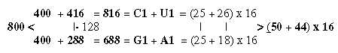

**c) B-chains:**

B-chains bound = 1344:  
Orbital numbers (18 - 14 -10), x 16 = 288 + 224 + 160 = 672, x 2 = 1344  
= 6 x 224.

**Why a factor 16?**  
Factor 16 happens to appear in all single base groups in 1 1st base order -/+1:   
  G1: 192 -1, C: 352 +1, U1 464 -1, A1 496 +1.  
Why, however this factor 16 here, if pointing to a real connection between this 2x2--chain behind the periodic system and codon-grouped mass in the genetic code?   
- As 24, an expression for d-degree 4, four polarizations inwards?   
(16 also the inversion of 54, x 104.)   
- And / or the factor biochemically related to mass of oxygen 16O, 4 alpha - or Z of 32S in a first energy source?   
- Or somehow connected with the unexplained "octet rule" with a doubled expression for mass in the atomic nucleus?  
   It must be left here as an open question.

**13.6. Atomic mass expressed in the levels of electron orbitals and shells?**

It is natural that the distances of electron orbitals and intervals between them around an atom are expressions for atomic mass, e.g. number of charged nucleons in the nucleus and thus circa half the atomic mass of ordinary isotopes of C, N, O and S in ams.

1760 was factor 16 times the sum of the 2x2-chain and the total Z of 24 unbound ams R+B, i. e. sum of all electrons.   
   The number of atoms C, N, O, S in these unbound ams R+B is 224.   
  
Reducing 1760 with this number 224 in steps - as a kind of activation in electron shells, as suppressing of deeper orbital levels, with one electron in each step until those of C-atoms are zero, gives 6 "phases". It gives stepwise mass of bound ams R+B and disintegration of R-chains doubled.

**Fig 13-7.** *Reducing 1760 with 224 per step:*

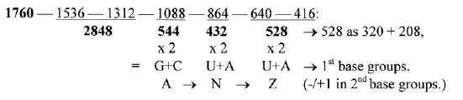

**2848** is the mass sum of the 24 bound ams, R+B, here from phases representing suppression of electrons in the K-shell.   
- 1536 is the sum of all 128 C-atoms, **1312** sum of all other atoms.   
  
Whole interval 1760 — 416 = **1344,** sum of 24 bound B-chains, 4 x 56 in each step.   
  
544 is also the mass sum of all other atoms N, O, S, H in R-chains,   
960 = 432 + 528,  the mass sum of the 80 C-atoms in R-chains.   
    432 = 36 C-atoms in C2 + U2, 528 = 44 C-atoms in G2 + A2.

Sum of whole chain = **14 x 544**.

*Series of phases for R- and B-chains taken separately:*   
   R-chains: 104 atoms C, N, O, S gives minus 104 per step. (H = 152)  
   B-chains: 120 atoms C, N, O gives minus 120 per step. (H =   92)  
Z -sum R-chains 828.  
Z-sum B-chains 932.... Difference 104.

   B: 932 - 812 - 692 - 572 - 452 - 332 - 212  
                  **1504**

   R: 828 - 724 - 620 - 516 - 412 - 308 - 204  
                  **1344**

Thus, the B-chains give in first numbers the atomic mass sum of the 24 R-chains,  
the R-chains in first numbers the sum of the atomic mass sum of 24 B-chains bound.

**13.7. Z-numbers:**

**13.7.1**. ***Z-numbers total and its divisions:***  
**Fig 13-8.** *Division of total Z 1760 in the 2x2-chain times 16:*

The total 1760 divided 800 and 960: 800 = 512 + 288, numbers from 4 and 3.

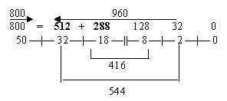

Sum of whole chain = 110, times 16 = 1760 = total Z-sum of 24 ams (R + B) unbound.  
960 = 24 x 40, Z-sum for B-chain of Gly with only 1 H as "R-chain".  
  
Displacements of H-atoms between R- and B-chains:  
 If in B-chains one H is added as replacement for R-chains, and the 4 H, reduced in B-chains of Arg 1, 2, Lys and Pro, are filled from R-chains, all B-chains become NH2-CH2-COOH = 40 Z: It gives a division of the chain in step 5 - 4:

   R-chains: 800 Z = 50 x 16  
   B-chains: 960 Z = (32 + 18 + 8 + 2) x 16 = 24 x 40 Z  
   (32 + 18) x 16 = 20 B-chains. The 4 extra B-chains = (8 + 2) x 16.

R-chains, number 800 Z get divided:

   A1+U1: 512 = 32 x 16. (528 Z - 14 H - 2H in Arg AG and Lys AA)  
   G1+C1: 288 = 18 x 16. (300 Z - 10 H - 2H (in Arg CG and Pro*)  
   * (Has sooner to be added + H in Pro, compensated with - 2H in Glu and Asp?)

These resulting numbers 512 and 288 could give more support for a hypothesis that the 2x2-chain influenced the code on one level and for the thought that the B-chains may have "come first" in the evolution, followed by a stepwise construction of the side chains R as substitution of H.  
  
**L-T-waves:**The backbone chains (B) of proteins may be regarded as a kind of L-waves, (assumed in fields of gravity), when unbound expressed as dipoles in terms of the electromagnetic force. Perhaps they preceded the evolution of the side chains (R), these implying a dimensional step to T-waves, characterizing electromagnetic waves.   
    (Cf. perhaps a hypothesis by Copley et al (2005) that ams may have been constructed at the inner OH-group of ribose between nucleotide pairs.)  
  
(Total number of atoms R + B without H = 512 - 288 = 224.)

Note that interval 800 - 512, also 288, may be connected with G1 + C1 too.

**13.7.2.** ***Z-division on atom kinds when 24 + 4 H are moved to the B-chains:***

Z - B-chains as 960:  
  
     C: = 288  
     N + H (120) = 288...Sum 576, 3 x 192  
     O = 384 = 2 x 192

Z - R-chains as 800:  
  
     C = 480 = 512 - 32,   
     N + O + H (124) + 2 S = 288 + 32 = 320  
A division 3/2 between C-skeleton and " substituents".

Z - total. R+B 1760:  
  
     C = 2 x 384 = 800 - 32  
     S = 32  
     N + O + H (244) = 960

**13.8. Pyramids on the 2x2-chain:**

Building figure pyramids (as Pascal's triangles) on the 2x2-chain leads of unknown reasons to numbers from the ES-chain (-1 in some of them). A couple of examples are shown in Fig.13-9:   
   

**Fig 13-9.** *Pyramids on 2x2-chain, 176, 384 and 158, 574:*

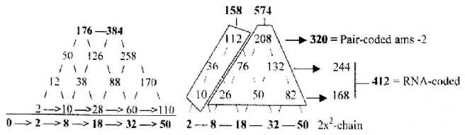

The left pyramid is built on the cumulative sum of the chain and gives on level 3 the top numbers 176 and 385-1, interval 208, to compare with the 770-group of ams as intervals in the ES-chain.  
   The right pyramid is built directly on the 2x2-chain and shows the 734-group and its codon divisions when figures are added in orthogonal directions, -1 in the G+C- and U+A-sums. 574 - 158, interval 416.   
   Note e. g. A1 = 497 = 176+1 in group 770 plus 320 in group 734 = 496 +1.

"2-base-coded" ams = 336-1 is the sum of 176 in the 12-group 770 (GU+CU+UC+AC) and 158 + 1 in 12-group 734 (GG+GC+CC+CG). These numbers appear to the left, built from lowest "dimension degrees" in the 2x2-.chain. (160 in figure 13-8 below).

Another way to see the right 574-pyramid above , 2 x 208 = 416, + 158 in accordance with the ES-chain.  To the left the isolated 544-pyramid below.

**Fig 13-10a, 10b**.:

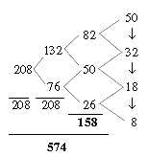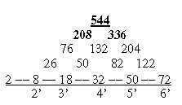

Extending the 2x2-chain with x = 6 - 0 in Fig. 13-11,( top of pyramid to the right), and with an orbital 22 gives e. g. the sums 292 for level 1, 460 on level 2, first sums in the ES-chain, and sum 1638 on levels 0 to 4. half the total of 24 unbound ams.

**Fig 13-11.** *Pyramid 1638, the top of it to the right:*

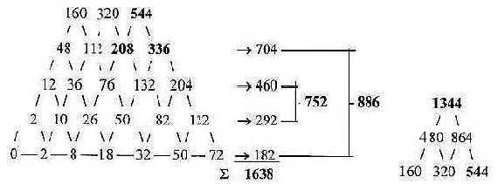

- **752** = ½ x R-chains, **886** = ½ x B-chains of ams.  
  
- On level 3 and 4 we get the numbers 336 - 208, sum 544.   
- Top number becomes 1344, sum of 24 *bound* B-chains.

Do we have to count on a 6th dimension or rather rely on Einstein that the relation between two bodies is 6-dimensional?! Only for a total 544. Note: G+C 544 = 384 in left figure 13-7, the cumulative pyramid, +1, + 160 - 1 in figure 13-8.

**13.9. About 3rd-base groups of ams:**

Number of ams in the G+C- and U+A-groups are possible to associate to orbital numbers, as in figure 13-12 below. U+A: 14 ams, 2 with indifferent 3rd base; G+C: 10 ams, 6 with indifferent 3rd base.   
  
**Fig 13-12:** *Codon groups after 3rd base compared with orbital numbers:*

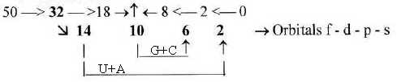

A note:   
Ams with 3rd base A/G (+ A or G) = 638  
   638 = 352 + 286 = 11 x 32 + 11 (18 + 8), orbital numbers

Together with all "debranched " 2-base-coded ams 335 we get the sum = 973.  
   973 = figures 1/2 x (18 + 14 + 10), -2.   
3rd base U/C = 531  
   531 = 1/2 x figures 10 - 6 - 2.

**13.10. Two more special annotations:**

**a) Numbers 110 and 26:**  
Two numbers in the 2x2-chain, 110 as the sum of the whole chain and 26 as the sum of middle two numbers 18 + 8, give associations to the displacements between single base groups of ams from 1st to 2nd base order: +/- 2 x 110 in the G- and C-groups and -/+ 26 in the U- and A-groups. An eventual connection?  
    It should imply a two-way direction aspect on the G+C-groups versus one-way direction in the U+A-groups.

Compare the numbers in these differences:  
  
To purine - pyrimidine group:

U+A = 960, – 26 = 934 = G2 + A2; from U + A, ~ U → G  
G+C = 544, + 26 = 570 = C2 +´U2; from C + G, ~ G → U  
To keto- / amino groups:  
U+A = 960, – 110 = 850 = C1 + A1; from U + A, ~ U → C  
G+C = 544, + 110 = 654 = G1 + U1; from G + C, ~ C → U

**b) Some numbers of the 2x2-chain, orbitals, cumulative ones as 28 etc. read in opposite directions:**

28 + 82 = 110, x 2 = 220 = UG + GU  
26 + 62 = 88, x 2 = 176   
18 + 81 = 99, x 2 = 198 = CA + AC  
14 + 41 = 55, x 2 = 110  
10 + 01 = 11, x 2 = 22  
08 + 80 = 88, x 2 = 176 = CU + UC + GU + AC  
06 + 60 = 66, x 2 = 132 = GA, AG  
02 + 20 = 22, x 2 = 44 (CO2)

*

**14.  Halved orbitals as a superposed chain**

**14.1. Sum of triplets read in the halved orbital chain:**Intervals in the 2x2-chain in preceding file 13 give the orbital numbers in the periodic system. Halved these numbers, 9 - 7 - 5 - 3 - 1, may be regarded as a superposed chain to steps in the most elementary chain 5-0: 5-4, 4-3, 3-2, 2-1, 1-0:  
  
**Fig 14-1:** *Halved orbital numbers 9-7-5-3-1 as superposed level:*

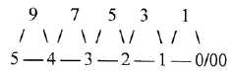

975 + 531 = **1506** = mass of 24 ams R, +2.  
  
Cf. 975**/**531 x 103 = 1836,158 ~ mass quotient proton**/**electron (p**/**e)

**14.2. Classes of tRNA synthetases:**We may note here that the triplets 975 and 531 approximate sums of ams in the two classes I and II of tRNA syntethases - if the different codons for Arg, Leu, Ile and Ser with two codons don't split their affiliation:  
    Class I: Leu, Ile, Met, Cys, Val,  
       Glu, Gln Arg, Tyr, Trp: Sum **975 +2** (with 2 sets of Leu, Ile, Arg)  
    Class II: Pro, Ala, Gly, Ser, Thr,   
       His, Lys, Asp, Asn, Phe. Sum **531 -4** with two Ser  
  
**14.3. Wavy, horizontal reading:**  
  
The two-level chain in figure 14-1 above may be regarded as a kind of "wave function". and a first observation is that the square root out of 6-figure numbers, from lower 5 to upper 5 in the middle, outwards and inwards, gives the sums of ams in the 12-groups 770 and 734, -**/**+1, total 1504 of 24 ams:   
  
**Fig 14-2:** *Square roots out of 6-figure numbers:*



Note that 734 -1 is derived from the middle of the chain where we had this 734-group of ams in the ES-chain 2(208 + 159).   
  
Next step from lower 4 to upper 3 gives the sum of 20 ams (R) = 1258 without the four double-coded ones and these divided in Z and N -/+1 outwards - inwards **688** and **570**, also numbers for G1 + A1 and C2 + U2 among the 24 ams.

**14..4. Vertical readings in halved orbitals. - An illustration of fusion processes:**  
Another way of reading in the chain is downwards, adding numbers 95+94, 94 + 74, 74 + 73 etc. as in figure 14-3 below. This gives sums that may be called **"A-Z"--**numbers of first elements in K- and L-shells, 16O, 14N, 12C etc.

**Fig 14-3:** *"A-Z"-numbers of elements - an illustration to fusion processes:*

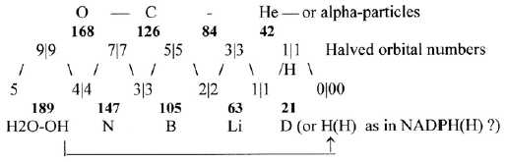

The figure could illustrate fusion:   
- the right part first elementary steps from H and Deuterium via Tritium and 3He2 to 4He2, then e. g. to 6Li3 to 2 alpha 8-4;   
- the left part illustrating **the carbon-nitrogen cycle** in the sun, O 16-8, N 14-7 C, 12-6, intermediate steps neglected here. (10Boron, 5 Z, in the middle.) Interpretation of first and last step, see the figure.  
  
The close, inner relations C-N-O in the fusion of the sun could be regarded as "outsourced" to a planet and translated to external relations on the higher molecular level, forming the bases and amino acids and the situation when their B-chains bind to each other in the protein synthesis;.[- O=CO- → ← +H2NH -].

***Comparison with numbers in the ES-chain:***

Sums of numbers from 168:

168 147 126 105         84 63 42 21  
       **544 + 2**                   **208 +2**  
                                                         The role of boron?

2 times numbers 147 - 126 - 105 gives sums near the first three numbers in the ES-chain:    
 2 x 189 = 378 (½ x 752 + 2, 2 x 168 = 336 = 544 - 208 or here 546 - 210.   
 2 x 147 = **294 ~ 5’** +2, 2 x 126 = **252 ~ 4’**; 2 x 105 = **210 ~ 3’ +2**.189 –1 = 1/4 x (292 + 252 + 208) = **1/4  x 752**  
168 = **1/2** x **336** (544 – 208)  
147 –1 = **1/2** x **292**  
126 = **1/2** x **252** - steps 4-3-2 here ~ 5 – 4 - 3 in the exponent series   
105 - 1 = **1/2** x **208**  
84 = 292 – 208, etc.

Nitrogen - Carbon:  
"A-Z"-numbers of C and N, characterizing both codon bases and ams, gives the sum**273**, the mean value of two ams unbound.   
   12 x 273 = 3276, total sum R + B

**3276** is also "A-Z"-number of C, 126, x 26 (= 18 + 8 in the 2x2-chain).   
First six "A-Z"-numbers, including 84, give the sum 819, times 4 = 3276. Sum of left part: 189 + 168 + 147 + 126 = **630**, to compare with mean value of side chains of an ams,  nearly 63.   
 There is the relation too that four last numbers, 84-63-42-21, regarded as debranched from higher steps and representing 4, 3, 2, 1 steps à 21, raised with **exponent 3/2** give the sum = 1638, 2 x 819 and half of total sum of unbound ams.

84**3/2** ≈ 770;  63**3/2** ≈ 500;  42**3/2** ≈ 272;  21**3/2** ≈ 96. **Sum = 1638.**

**14.5. The p/e-quotient, π-mesons and μ-leptons:**  
In figure 42 above we had the halved orbital numbers 9-7-5-3-1 as a superposed chain to the elementary one. Quotient between this chain as two triplets gives the p/e-relation, inverted about the same 544-number as above:

**975 / 531** x 103 = 1836,158 ≈ mass quotient p**/**e . *  
**531 / 975** x 103 = **544**,6. x 10-3; [~ (2**/**3)3**/**2 = 544.33.]

*(About middle figure 5 as last and first number in the two triplets we should perhaps remember that the inner electron is said to sometimes exist inside the nucleus of an atom.)

Wavy reading of 2-figure numbers in figure 14-4 below, 59 + 94 + 47 + 73 in two steps, gives sum **273**, ~ the quotient π +-meson **/** electron as parts of the proton. π-mesons appear at disintegration of protons in *p*-anti-*p*-annihilations. Next two steps 47 + 73 + 35 + 52 give **207**, ~ the μ-lepton in *e*-units, released in the further disintegration of π-mesons.  
   2 times these numbers = 544 + 2, 416 - 2, with reference to the ES-series.   
  
**Fig 14-4:** *273 and 207 from addition of 2-figure-numbers in the two-level chain:*

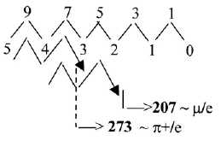

**2 x 273  = 546 = G + C, +2  
2(273 + 207) = 960** = **U + A**

It was noted before that 273 is the mean value of two unbound ams (and sum of what here was called "A-Z"-numbers of N- and C-atoms 14-7 and 12-6).  
   The correspondence with numbers for charged π-mesons and μ-leptons, the same quotients on levels of different units (e- versus u), invites the not unreasonable view on amino acids and proteins as having a corresponding role in the very superposed unit of a cell as these elementary quanta in the nucleus of an atom.

**14.6. Reading 2-figure numbers in the superposed chain:**  
A two-way directed reading of such numbers can give the 4 codon type groups of ams, Cross- and Form-coded, Pair- and RNA-coded, as shown in Genetic code II: “17 short files”, number 17.

**15.  x1 - The triplet series   
The x4 series**

**I. The triplet series, x1:**

**15.1.1. *Reading triplet numbers in the elementary chain 5 - 0:*** *(Most of this file from "17 short files", 05*.*)*

The most elementary chain 5-4-3-2-1-0 read as triplets approximates the sum of R-chains of ams read as two triplets: 2(543 + 210) = 1504 +2, or read as 4 triplets as in figure 15-1.  
  
Expanded with triplets from 987 - 876 etc. the chain gives the approximate whole mass of 24 ams. Intervals in each step = 111 sum up to 24 times B-chains à 74.

**Fig 15-1.** *Triplets from elementary chain 5 to 0 and the same chain expanded:*

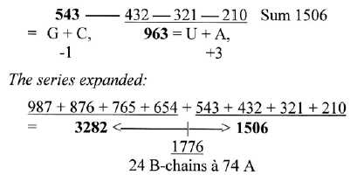

A note about number 3282:

Number 3282 is also the difference between products of base pair numbers:  
G 151, C 111, U 112, A 135:

2 x G x C = 33522  
                    |------- 3282  
2 x U x A = 30240

3282 = 6 x 547. 5 x 547 = 2735 = 20 ams, without the double-coded ams.

(½ x 3282 = 1641 is said to have something to do with a formula for first amount of prime numbers.)

A "condensed" or undeveloped elementary chain 5 - 0, dimensionally, written:

5 - 4 -3 - 2 - 1 - 0, ~ 5433 ~ **546**   ("before disintegration") =2 x 273.  
                 = 3

546 x 6 = 3276, the sum of 24 ams R+B unbound.

**15.1.2.** ***A-N-Z-numbers of ams approximating the triplets:***

**Fig 15-2.** *A-N-Z- as triplets in codon groups:*

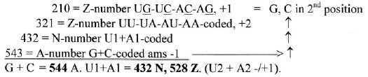

The chain A→> N→>Z implies polarization steps from mass to charge as assumed in the background model.

Cf. figure 13-7, file 13, approximate the same numbers halved.

[A connection wirg the ES-chaib and its first number 5’?

1/543 – 1/210 = -292.03 x 10-5 .]

**15.1.3.** ***B-chains:***  
  
In a peptide bond between ams their side-chains come to point in opposite directions.  
For the triplets 543 and 210 arranged in such a way, see figure 15-3 below,. When read in opposite directions, we get the B-chains of 12 ams á 74 A = 888 as divided 543 + 345.

**Fig 15-3:**. *Triplets 543, 210 written as neighbor R-chains in opposite directions:*

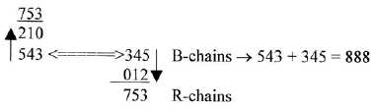

888 = 12 B-chains à 74.. A division on numbers 543 and 345 gives:

543 / 12 = 45,25 ~ 45 A = COOH  
  
345 / 12 = 28,75 ~ 29 A = H2N-CH  
  
The B-chain gets approximately divided in the COOH-part 45 and H2N-CH-part 29.  
Cf. the similar division in the ES-series.

345 —|— 210   
        135 = mass of the A-base

135 is also mass of Meth, R+B, when losing its end group CH2 = -14 at start of protein synthesis.

012 + 345 = 357 = sum of A+C+C, the common ends of tRNA.

Sum of a triplet chain "inwards" 012-123-234-345 = 2 x 357.  
A-base 012+123 = 135, plus first two intervals = + 2 C-bases 111 = 357.

***B-chains as periodic numbers:***

**Fig 15-4.**

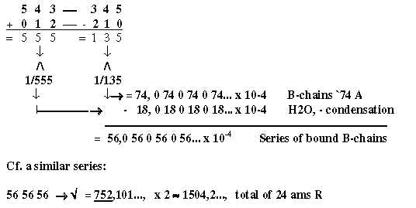

A note:

543/3 = 181 = Tyr, R + B  
321/3 = 107 = Tyr R.

Two steps in the triplet series = -222 = 3 x 74, the normal B-chains unbound

Two more numbers from the elementary chain 5 - 0:

4/5 + 3/4 + 2/3 + 1/2 = 1/2 x 5,433333

[1/5 + 1/4 + 1/3]4 = 376,5. x 10-3; x 2 x 103 = 753,037.

About the elementary series as exponents to 2 as a binary language and Serine, see file

17.16.point 6.

**II.  The x4 series:**

**15.2. The x4 series as an underlying chain?**  
It would agree with the general thoughts behind this research that chains as x4 and x3 (x = 5 - 0) could underlie the ES-chain on deeper levels.

In the chain, figure 15-5 below, we have that 625 - 81 = 544, the G+C-coded ams and 625 + 256, + 81 = 962, the U+A-coded ams +2. The operation -/+ 81 in this series x4 is comparable with the similar operation -/+ 208 in the ES-chain.

**Fig 15-5.** *An x4-chain, some codon groups of ams:*

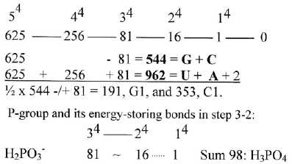

Number 81 is both a charged molecule H2PO3 but also the R-chain of His (the only ams that not derives from Glycolysis-Citrate cycle but from the A-base).   
   It could be observed that -/+ 81 gives the individual codon base groups in 1st order in the ES-chain:

½ x 544 -/+ 81 = G1 191, C1 353,   
544 -  81 = U1 463   
416 + 81 = A1 497.     (An eventual influence of phosphorus groups,                                          P-group H2PO3~ = 81 or of His, R 81?)

Sum 44 + 34 = 337 is 1**/**3 of the total sum of the ES-chain..

* **16. An x3- series**

**16.1. Middle numbers 27 and 8:**

In an x3-series, (x = 5 - 0), the numbers 27 and 8 appear around the middle step 3 - 2. They are the factors in the astonishing regular table of ams with mixed codons below, where the ams with differentiating 3rd base in their codons amount to 594.

An x3-chain and factor 35 in the 12-group 770:

                      33                  23  
125 — 64 — 27 —- (19 ) — 8 — 1 — 0. (x = 5 - 0)

Table 2:



Sums of rows in the table:

385:   27 + 8 = 35, → x 11 = 385   
209:   27 - 8  = 19; → x 11 = 209... Sum 594 = 27 x 11 x 2.  
176:             =   8,  → x 11 x 2

One 27 number disintegrates into interval 19 and 8 into rows two and three..  
    (The factor 11 in this group of ams with mixed codons gets no special explanation in this x3-chain.)

A note:   
About factor 11 among ams with mixed codons as an expression for double-direction in steps (file I-05): 01 + 10 = 11, the last step in the elementary chain 5-0. Cf. steps in the half orbital chain 9-7-5-3-1 read as 97 - 75 - 53 - 31 = - 2 x 11 in each step.   
    (Are there eventually any 11-factor in quark computers?)

Compare also the atomic mass of bases A and U and interval 27 - 8 = 19 divided 5 - 14, (interval 9 as in a simple reading of the step in opposite directions 32 - 23)

A-base 5 x 27 = 135, U-base 14 x 8 = 112

Cf. these numbers 112 and 135 from quotients between spectral lines of hydrogen (end of Introduction  
    About some other numbers in the x3-chain compared with the ES-chain, see below.

**16.2. A root in physics of number 544?**  
Numbers 27 and 8 have appeared in group theories of elementary particle physics (Gell-Mann M in *The Eightfold Way* 1964)), this mentioned with nothing of a closer knowledge in that field.  
    A suggested connection here seems supported by following relations in figure 16-1 below, which could imply that number 544 for the G+C-group of ams had its root in the the mass quotient between the electron (e) and the proton (p) of a single H-atom - or rather (e + p) / e ≈ 1837.117 x10-6.*   
  
* p/e ≈ 1836.12, /\ = 544,623 x 10-6. If p/e = 975 x 103 / 531 (a quotient in the middle in the chain of halved orbital numbers = 1836.158, the inverse becomes 544.615 x10-6. (Two similar or equivalent numbers may of course have very different origins as similar words in languages.)

The square root of 8/27, x 10-3 = [2/3]3/2 = 544.331... x 10-3 is a similar number, however not exactly the same.

A suggested connection here seems supported by following relations in figure 16-1 below, which could imply that number 544 for G+C-group of ams may have its root in the p/e-quotient of a single H-atom:   
  
**Fig 16-1.** *Square roots of 27/8, and inversions of 27 and 8:*

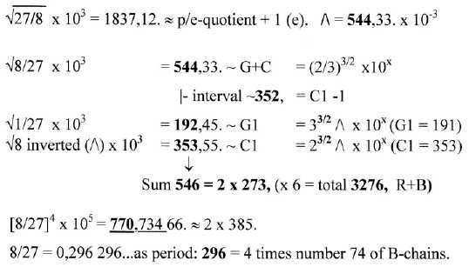

1/4 of the period 296 = 2/27 = 740740740... (x10x) is the inversion of A-base number 135.

Inversions may be regarded as one kind of references between units or energy levels in complementary fields outside - inside number 1 as a ring around the origin in a coordinate system.   
    The numbers 1836 and 544 among ams as quotients, however, concern units on different levels, referring to number of e and number of u (~ shell versus nucleus in the atom). If we could assume that quotients as such reappear on different levels, already a single H-atom in some way could include resonances in the future development of life.   
   More reasonably expressed, the same underlying elementary number series in its development gives such number relations on different levels through the evolution.

A bit curiously the "same" number 544,33..as from √8/27 is given out of a "factor chain", 1 to 5 times 2-figure numbers of steps in the elementary chain:   
(8/27 → √ = 544,3310540 x 10-3, →/\ = 1,837117307.)

A "factor chain:"  
  1 x 54   
  2 x 43  
  3 x 32  
  4 x 21  
+5 x 10 ---> 54 86 96 84 50 → √ = 74074,074074... → √ = 272,165...  
=    370  
    5 x 74 x 2 = 544,3310540*

*The numbers differ after the 11th digit!?

( A factor chain in opposite direction, 1 x 45, 2 x 34 etc.. gives the sum 5 x 47, the factor in total ams R 1504 and the mass of Cys.)

To summarize, the numbers 27 and 8 may through simple operations join approximate numbers of the inverted p/e-quotient , the masses structuring ams masses (R) of mixed codons, the sum 544 of G1 + C1 and its division on these codon groups and the A-base with its inversion of a periodic 74, the mass of unbound B-chains of ams..

If the numbers 27 and 8 in group theory for elementary particles has been connected with the e/p-quotient is left unknown here. Perhaps it is two different hypothesis that are involved in the figure above for the origin of the number 544?   
    The number 385 gets its simple explanation directly from 27 and 8, apart from factor 11, and 544 was shown as ≈ √2 times 385, through inversions and halving connected with approximate number 367, the sum of the 12-group of ams with non-mixed codons (in file I-8, fig 8-1).   
  
The e/p-quotient, or e/(e+p) as a deeper root for number 544 seems to concern a more fundamental issue about inversions and conjugates in higher dimensions; inversions as a property of steps towards higher levels of complexity and the biochemistry of life.   
    Cells are in some respects the inversions of an atom, especially in the relation of charges, with dominating negative charge inside, mostly carried by the proteins, and positive charge outside. The hydrophobic bonds in P-lipids of cell membranes could be imagined as one expression for an inversion (center to anti-center) of the strong force (Fst) on this higher level. (The mentioned group theories are also used in analysis of the electroweak and strong forces.)

**16.3. Some numbers in the x3-chain times 3 compared with the ES-chain:**  
Besides the middle numbers 27 and 8 here, the x3-chain as a whole doesn't show any simple correlations with elementary codon groups of ams in similar ways as in the x4, x1 and x2-chains (files II: 13, 15, 16).   
   Some numbers could or should eventually be noted. With a factor 3 times the series we have 375 - 192 - 81 as first three numbers:   
- 375 =1/2 x 750, 1/8 of a total sum 1500, approximating the total of R of 24 ams.  
- 192 is a returning factor in 385-1, 770 -2, 575 +1 (the U+A-group in 12-group 734), in  
    960 (U+A-groups R) and in 1344 (sum of bound B-chains)   
- 81, 3rd number in the x4-chain (file 15).  
- 192 + 81 = 273, the mean value of 2 unbound B-chains.  
- Interval 111, (cf. reference Scherbak) is the number for steps in the triplet series x1  
(file 15). (111 in a hexagonal system = 273 in a decimal system.)

6 times numbers in the x3-chain gives a series that have some similarities with the ES-series:

**Fig. 16-2:**

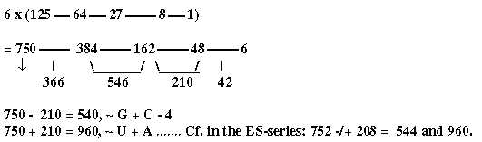

- 750 divided in ams with mixed (385) - non-mixed (367) codons (the first interval here),   -1 in each group.

- 162 ~the difference G1 - C1.

- 384 + 162 =385 + 159 + 2 = 546, 2 x 273, (4' + 3').  
  the mean value of 2 unbound ams.

- 384 + 210 = 4' + 3' + 2' in this chain = 594 = 385 + 209 in the table above   
  
- Interval 4' - 2' = 384 - 48 = 336, 6 B-chains bound.

The sum of the whole series 225 times 6 = 1350.   
1350 → √ = 367.42 x10-1, → /\ =272.1655 x10-4 , x 2 = 544.331054 . 10-4 =   
= 1/10 of √8/27.  
  
However, if there is a deeper relation between the factors 27 and 8 here and the ES-chain remains an open question. It is possible that these numbers should not be associated with a whole x3-series at all but represent a transformation of exponents in step 3 → ← 2 of the ES-chain, with the background model (fig 03-3) in mind



and the double-directed processes, meeting in the middle step, somehow implying a change of the exponent 2/3 to 3/2 and including an inversion... Cf. the assumption in the background model of new levels developing through step 3 → ← 2.

x4 → 3x3 → x3/2 → ↑↑← x2/3 ← 2x2 ← x1

There is a similar pattern of two-way direction in the protein synthesis, where tRNAs as from opposite strands of DNA meet mRNA "the other way around" at ribosomes in the "middle" of the process.

**16.4. Number of codons:**This x3-chain as basis for number of codons?  
  
- 5 bases T/U-A-G-C become   
- 4 inwards DNA and 4 outwards in RNA, which, become.  
- 3 bases in codons, as 3 positions on ribosomes. Third position indifferent gives  
- 2 bases relevant in one 3rd of codons. Then leads to  
- 1 base in nucleotides, becoming active coenzymes in–MP, -DP, -Taprooms.

4 bases gives 64 possible codons but leads to  
3 bases in actual codons = 27 differentiating ones including 3 stop codons,  
2 bases relevant in 8 codons.   
  
Rest 19, 27 - 8 codons with more or less halfway defined 3rd base in step 3 - 2:   
- 8 ams with 3rd base U/C,   
- 8 ams with A/G, A or G, (5 A/G-coded, 3 ams "3-base-coded"),  
- plus 3, usually stop codons (or 2 if we count UA-A/G as one).  
   We could possibly imagine that it's the interval step 5' → 4' = 61 (125 - 64) that decides this reduction and appears in later numbers as potential "pre-codons" ?

(With this view it's possible to imagine that the not ams coding parts of DNA-strands, should be divided in quadruplets for the interpretation? Cf. perhaps how strands are cut, giving sticky ends?)

Number of codons as halvings:  
  
    64 → 32: 32 = "2-base-coded", x 4: 8 ams = 335  
            32 → 16: 16 = U/C-coded, x 2: 8 ams = 531  
                    16 → 8: A/G-coded, x 2: 5 ams = 376, + 3 ams x 1, A or G = 262  
+ 3x1, usually stop codons.

*

## **The Genetic code:** **Section III**

**Tranformations between number–base systems**

#### Åsa Wohlin

**www.u5d.net**

**2015-03-23**

CONTENT *Page*

17. Transformations beteen number-base systems 81

18. More on totals and other notable transformations 91

19. P – phosphorous groups – Coenzymes – Nucleotides 101

Met AUG - tRNA-end ACC

20. Additions to files 17-18 107

21. I. The triplet series. – II. An alternative series 112

22 Other substances 117

Discussion 120

References 122

**17.  Transformations between number-base systems (nb-x)**

**Bases - totals of ams − 5 x ES- numbers − Generative production of the 12-groups**

**17.1. Transformations of the codon-bases to the 12-groups of ams:**  
  
All geometrical dimensions should naturally be regarded as present in the cell simultaneously, on different levels, and interdependent through transformations into one another. One simple example is the geometries of proteins, forming linear threads (~ D1), sheets (~ D2) and globular forms (~ D3).   
  
The thought that different d-degrees could be associated with different number base systems (nb-x), as nb-10, nb-8, nb-6 for x = 5, 4, 3, led to a first test on mass of codon bases with remarkable results, figure 17-1 below. Further investigation showed also several connections with the ES-series. (Nb-x in text below often written as "-index figures. Figures in nb-8 and nb-6 are often rewritten with figures from nb-10.)   
  
**Fig 17-1:** *From mass of codon bases to the two 12-groups of ams:*

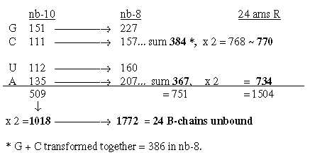

Hence, 4 sets of the 4 bases give the total sum of 24 unbound ams.

We find also that 2 x G+C-bases in nb-8 as 768 gives total sum 3276 in nb-6:

nb-10      nb-6  
768 —> **3276**    24 ams R + B, unbound (rewritten from 3320)

The sum of the 4 bases in nb-8 = 752 -**/**+1:

nb-10      nb-6  
752 —>  **2848**    24 ams R + B. bound (rewritten from 3252)

**ES-numbers 292 - 252 - 2 -/+ 100 might also give the total of bound ams in nb-6, figure 17-2:08**

**Fig 17-2*.****From 752 as sum of ES-numbers 5', 4' and 3' to 2848 in nb-6:*

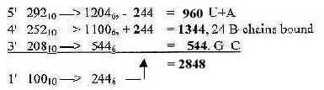

**2848 = 24 ams R + B bound**

**17.1.2  *Some general annotations:***  
However strange the idea surely may seem for scientific "common sense", the many   
astonishing results here and below are rather difficult to dismiss as only haphazard. If they are not, if they reveal some connections on deep energy levels, they should represent one kind of references, one kind of guiding operators for potential growth - or just what is sometimes in the biochemical field is referred to as "affinities"?   
  
All derived numbers shall naturally be regarded as nb-10-numbers, hence transformations as nb-10 →> nb-8 may be repeated, illustrated for instance in the carbon-nitrogen cycle in the sun, from 12C to 14N to 16O, intermediate steps showing one way to perform such transformations.

It follows that all operations as multiplications are performed in nb-10. Indexes for x in nb-x are often used below to shorten the text. As mentioned above numbers in nb-8 and nb-6 are often rewritten with figures from nb-10.   
   A question is of course if such rewritings could be expressed in biochemical processes as for instance 20 equivalent with (~) 18 in nb-8 as -2H or 120 in nb-6 ~ 76 as - 44 (CO2)?

Another question is how to interpret nb-16 in many examples below If keeping to the thought of x in nb-x as first three numbers in the elementary chain 5' →> 4' →>3' doubled, should nb-16 be regarded as 2 x 4 doubled or 2(5 + 3) doubled?

**Fig Ti-1**



A general feature may be noted: transformation of sums or whole units give larger numbers in lower nb-systems than their parts transformed and summed afterwards.

**17.1.3   *Halves of the 12-groups 770 and 734, -/+1 = 384 and 368:***

**Fatty acids*,*** a first annotation here:   
Cell membranes are an equally essential part of life as the genetic code. Two of the most common fatty acids give transformed to nb-6 three times these numbers 367 and 385, +/-1, a relation to R-chains of the 24 ams = 3/2 and simultaneously a relation d-degree 3 to 4(nb-6 to nb-8) with the assumed view above.

C16H32O2: 256-**10 →** 1104-6 = **3 x 368**  
C18H36O2: 284-**10 →** 1152**-6** = **3 x 384**, (Note: 1152 = 752 rewritten)

Cf. the hexagonal pattern in Table 0: fatty acids as a third way to read such a pattern.

From the numbers **384** and **368** in nb-10 transformed in two steps to nb-8 we get 2 sets of bases G and A in nb-8, as in opposite direction to the figure above and without C and U:

384 x **½** = 192**-10** **→** 300**-8** **/** 300-**10** **→** 454**-8** = 2 x 227 = 2 G**-8**   
368 x **½** = 184**-10** **→** 268**-8 /** 268-**10** **→** 414**-8** = 2 x 207 = 2 A**-8**

**17.1.4 . *Bases → totals:***

**Four times G+U and A+C to ~ B- and R-chains of total 3276:**

Sums of R+B-chains together in **nb-10**:  
  
   G1 + U1 = C2 + A2 = **1468**  
   C1 + A1 = G2 + U2 = **1808**... Sums of coded amino acids (R + B)  
  
With exchanged partners these sums are given from 4 times the bases:

**Fig.** **17-3**

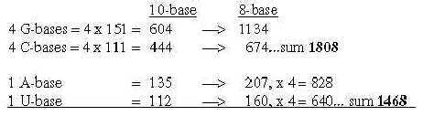

In nb-10 we have groups of ams paired in keto-/amino types:   
Here G- and A-bases have exchanged partners and bases A and U must be multiplied with 4 after transformation.

**Fig. 17-4**

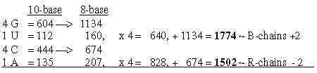

Rewriting 640 to 638 and 828 to 830 gives the right sums B 1772 and R 1504.

**Two sets of bases from ES-numbers 5', 4' and 3':Fig. 17-5**

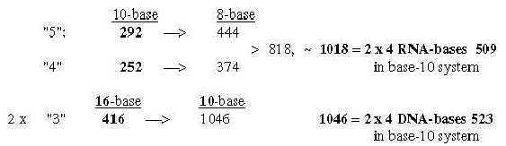

Number 416 (2 x 3', 208) is the one which added to 544 gives the A-U-group of ams. Cf. that U-base gets replaced by T-base in DNA, a CH2-group added for inward direction to DNA. (It could perhaps be compared with the interpretation of nb-16 as 2 x (3' + 5'), a step backwards from 3' to 5', equivalent with inwards?

**17.2. The bases in the ES-chain:**

**Fig. 17-6**

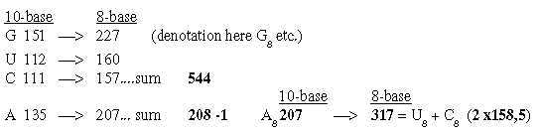

U 160 + C 157 in nb-8 approximate number 2' = 159 in the ES-series, together 317.   
   In nb-10 number 385 is the interval 544 to 159. Here G-8 becomes the same interval to both bases U**-8 + C-8**. Cf. that G-base can bind to both:

**Fig 17-7:** *The bases in nb-8 in the ES-chain:*

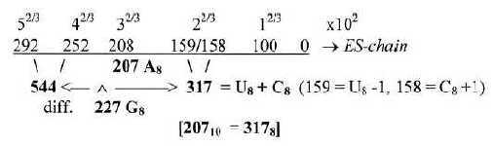

These relations could be a reason why G+C-bases get connected with the 12-group 770 of ams in spite of all bases equally represented in this group.

**17.3.  Five times ES-numbers:**   
 **17.3.1 *The transformations between nb-10 and nb-8 of main codon groups of ams and 5 times the ES-chain numbers 5' - 4' - 3' are among the most astonishing:***

**Fig 17-8*:*** *Main codon groups of ams from 5 times ES-numbers:*

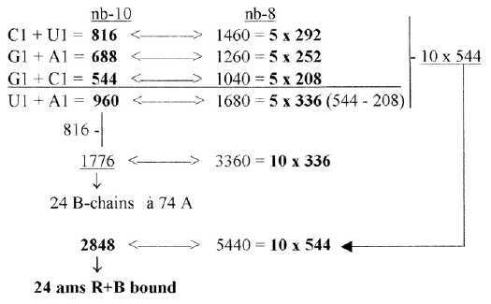

816 and 688 is the division of **R**-chains of total sum 1504 of 24 ams, a division between purine and pyrimidine codon groups, As a division in step 5 - 4 here it precedes the one between complementary pairs G-C and U-A, which are attained from the secondary division of 544 in 336 and 208, a division in step 4 - 3.

Note also about 1344, the 24 B-chains bound, included in sum 2848:

**1344** in nb-10 = 2500 in nb-8 = ES-numbers **5(292 + 208)**

These relations seem to support the relevance of both the ES-chain and the thought that nb-transformations could be part of the reference system.

**Fig 17-9** *5 x half of 752, number 688 as an interval:*

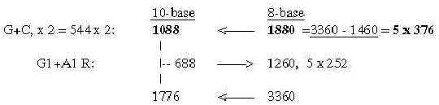

There is also the feature that divisions stepwise as polarizations of numbers 816 in U1 + C1, separately transformed to nb-8 give 1260, next lower level, and this back to nb-10 and divided G1 and A1 gives 1040 in nb-8:

**Fig 17-10.** *Stepwise polarization giving next number x5 in Es-chain:*

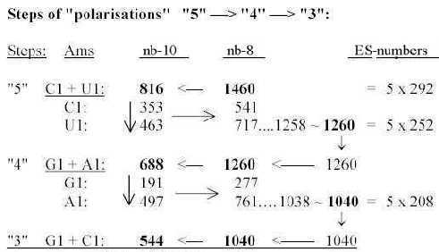

**17.3.2. *About the interval 84***:

292 →> 208 in the ES-chain = 84. Wwe have that n x 84 (n = 1, 2, 4) times 10 (1040 ~ 840, 1680 and 3360) in nb-8 gives the groups 544, 960 and 1776 in nb-10:.   
  
**Fig 17-11.** *n x interval 84:*

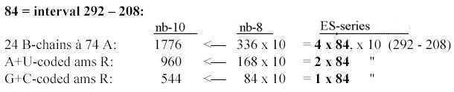

**17.3.3.  *5 times intervals in the exponent series in nb-8 give ams-groups -/+1:***

**Fig. 17-12** *5 x interval in the ES-chain:*

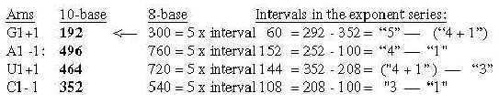

**17.3.4. *Nb-6:  5 times the ES-numbers 5', 4' 3' in nb-6:***

It gives the sum of U- plus A-coded ams R and also all C-atoms in R-chains in nb-10, divided on G1 + A1 = 396 and U1 + C1 = 564:

**Fig**..**17-13**   *5 times ES-numbers in nb-6 to 396-564.*

:

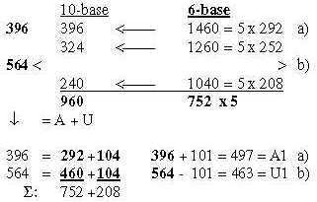

**17.3.5. *G1+A1-domains = Cs 396 + Re 292. With 2nd base G or A = 396, with 2nd bse U or C = 292:***

**Fig** **17-14**

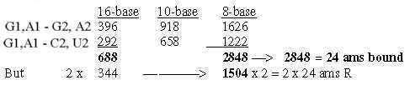

**17.3.6.**  ***The numbers  U1 + C1 = 816 and G1+ A1 = 688 read in nb-8 rewritten, give in two steps total 24 ams, R + B unbound in nb-8:***

nb-8   
816 ~ 1016  
688 ~   710 ... Sum 1726-8.**/** 1726-10 → **3276**-8

**17.4. Generation of the two 12-groups of ams with mixed and non-mixed codons:**

**17.4.1** ***Generative production of sums within 12-groups of ams:***

**Fig. 17-15a*.*** *The ES-chain, numbers 177 and 208:*

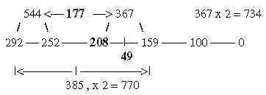

Cf Table 2,3 in file 02.

Numbers 770 and 734 generated from 177 and 208:  
- From **177** we get 385 in two steps nb-10 to nb-8:   
- From 208 we get 734 in three such steps:

**Fig. 17-15b**

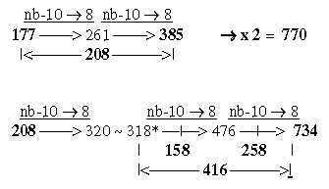

* 318 = 2 x 2', 159, from there only two steps:

**Fig 17-15c:**



**In group 734 U+A-coded ams =** **575**, a number given through two steps nb-10 to nb-8, either as sum of 500 + Meth 75 or from 208 + interval 49: Meth that starts the protein synthesis are attained from the middle interval in the ES-chain:

**Fig 17-15-d*:***

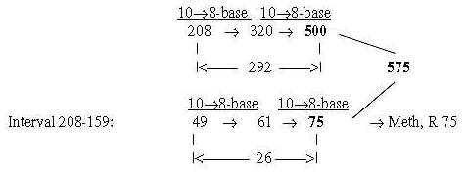

Note too that Meth leaves its outer CH3-goup at start of synthesis, (= -15 +1), which gives R-chain = 61, the intermediate number in the figure above.

575 directly from 208 + 49 = 257 in only two steps:  
  
**Fig 17-15e:**

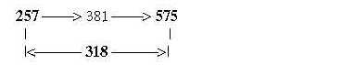

**Number 75**, R-chain of Meth:  
In the ES-chain in nb-10 the number 75 = interval 292 - 367 (the sum in the middle of the chain). Transformed in two steps nb-10 to nb-8 it gives the number 159:

**75** → 113 → **159**(161 rewritten)

**17.4.2.  *A- and T-bases give the sum 575 of ams with non-mixed codons:***Starting numbers 177 and 208 in transformations, minus 1 in each, are the T- and A-bases in nb-8. With DNA-base T we get the sum **575** in two steps nb-10→>8: *(Cf. file 02.)*

**Fig. 17-16:** *A+T*

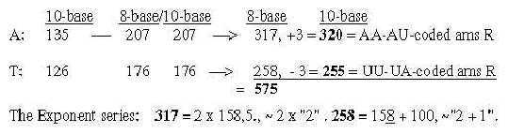

How explain the T-base here, a DNA-base giving A in RNA?

**17.4.3. *770-group from 4':***  
It can be added that 2 x 252 (= 4' in the ES-chain) in nb-10 leads directly to 770 in nb-8:

2 x 4' (252) = **504**-**10** →**770-8**

**17.4.4. *Parts of 12-group 770 from halved ES-chain:***  
The division of group 770 in Cross- and Form-coded ams, **418** and **352**, may be derived by dividing the whole ES-chain in step 4'-3' and halving these numbers:

**Fig 17-17:** *From halved ES-parts to mixed codon groups*

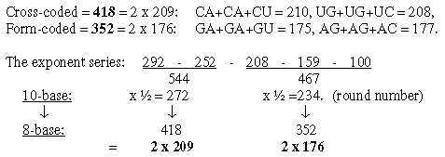

**17.4.5. *Derivation of N- and Z-numbers within the two 12-groups of ams:***

**Fig. 17-18:**

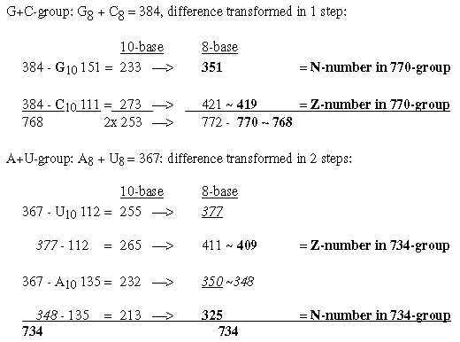

*

**18.  More on totals and other notable transformations**

**CCC − Why 24 ams? - H-atoms - N-numbers - C-atoms in R - B-chains - 1st to-2nd base**

**18.1.  Total sum R+B-chains of 24 ams unbound = 3276**:  
  
3276 is about 1**/**10 of 215. In nb-16 it's CCC, which may be transcribed as   
12.12.12 = 3072 (3 x 322 = 4 x 768) + 192 + 12:

**Fig 18-1***: Total sum of 24 ams R+B:*

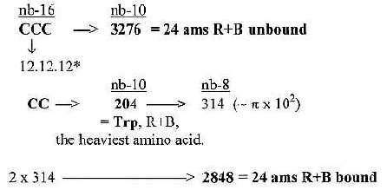

(2 π x 100: the bound 24 ams as a closed circle!)  
  
12.12.12: An association goes to carbon 12C and the 3C-molecules from halved fructose in glycolysis from which first group of ams derives. Could we eventually read positions of the carbon atoms as decided and guided by oxygen 16O in some way?! Much of the process in glycolysis seems to be about a stepwise displacement of oxygen along the C-C-C-chain.

**18.2.  Why 24 ams?**One reason to suspect nb-transformations could be the 4 double-coded ams, If 20 ams have to be 24, then 4 ams must be repeated (!).

20**-10** → 24**-8**

**18.3.  H-atoms, 152 in R-chains: and the total of R 1504:**  
Number of hydrogen atoms in R-chains was 152 = interval 4'- 1' in the ES-series.

292 — 252 —208 —— 159 — 100 — 0  
———**-|**<-44->**|<**——108——>**|**

This interval is divided 4'-3' = 44 and 3'-1' = 108: Transformed from nb-16 to nb-6 they give total Z-numbers of R-chains and N-numbers separately:

**Fig 18-2:** *H-atoms:*

Steps 44 → 152 = + **108**  
Step 108 → 676 = + 568...This sum is also = 676 = Z (or N) of atoms C, N. O, S.   
Cf. 676 = 262 and the 2x2-chain,file 13.

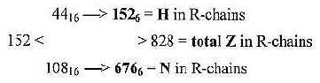

**18.4.  N-numbers in codon-groups of ams may lead to totals of ams:**

**Fig. 18-3:**  *Neutron numbers to totals*

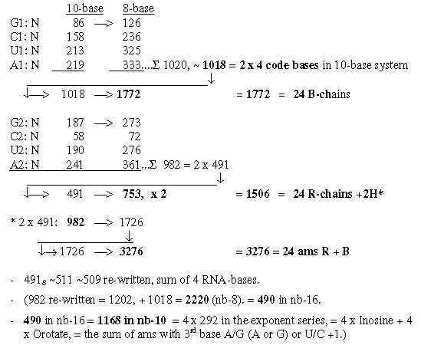

**18.5.  Number of C-atoms in R-chains as basis for divisions:**

In file 04, para. 3, the ams were ordered after number of C-atoms in their R-chains and their mass summed. This division did not concern codon distribution but seemed related to the ES-series with certain assumptions. Here C for carbon. (8 ams with 4 C in R-chains got the sum 584 2 x 292.)   
   Phe and Tyr are synthesized as 3C- plus 4C-molecules, hence positioned between 4C- and 3C-.groups. Trp as 3C + 4C + 5C - 1C. Trp gets its B-chain from Ser, shares codon with Cys and can brake down to Ala, hence here regarded as "meeting the other way around", added to the l C group.

**Fig. 18-4a:** *Transformations along the ES-chain as a nxC-chain:*

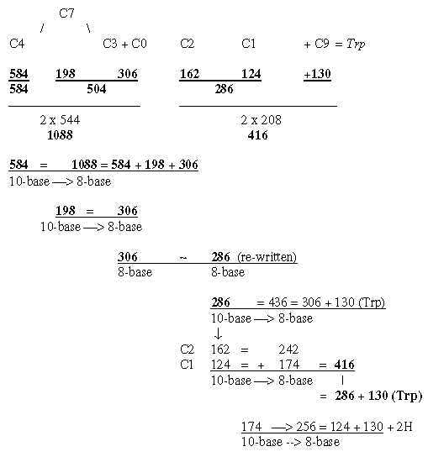

**Fig. 18-4b*:*** *Cf. triplet sums, file 15, numbers 714 and 792:*

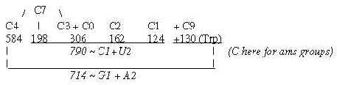

**Fig. 18-4c*:*** *nxC-atoms - three more details:*

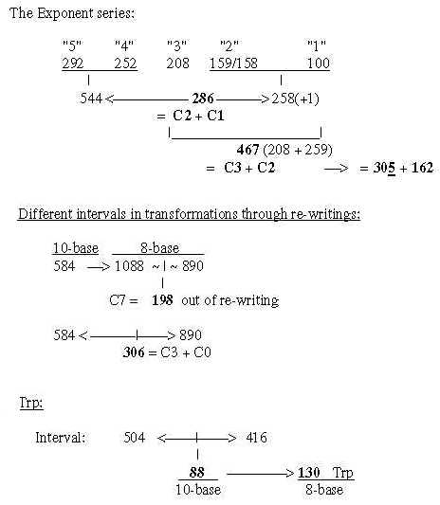

**18.6.  B-chains:**

**18.6.1.  *Number 752, sum of first 3 numbers in the ES-chain:***  
a) 752 from nb-**16** to nb-**10** gives the total **1772** of 24 B-chains unbound:

**292**-**16** → 658-**10**   
**252**-**16** → 594-**10**  
**208**-**16 →** 520-**10**... sum **1772**, 24 B-chains unbound

Cf. that 752: nb-**10** gave **2848** in nb-**6**, i.e., R+B-chains of 24 ams bound:

**Fig. 18-5:**



**18.6.2.  *A single, unbound B-chain = 74:***  
Two sets of the 4 RNA-bases, sum 1018, gave in nb-8 the sum of 24 B-chains unbound = 1772. A single unbound B-chain à 74 gives the sum of 2 bound B-chains.

**Fig 18-6:***From one unbound B-chain to two bound ones:*

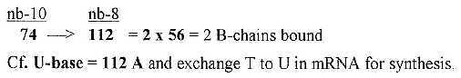

**18.6.3.   *Halvings of 2 x 5' 584 transformed to unbound and bound B-chains:***

**Fig. 18-7*:*** *From number 5´ in the ES-chain to B-chains in groups of 6:*

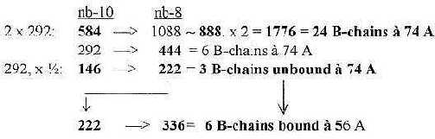

**18.6.4.  *Total B-chains unbound times 2 from the 4 bases:***

**Fig. 18-8:**

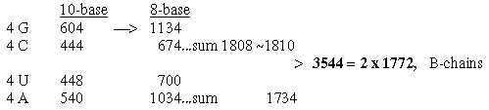

**18.6.5.  *Total of bound B-chains = 1344 from the bases:***

**Fig. 18-9:**

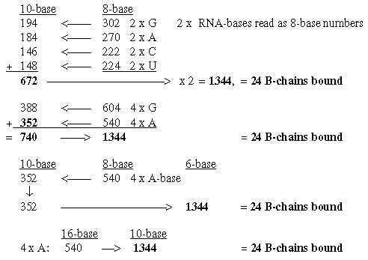

**18.6.6.  *Inosine 136 in repeated steps gives B-chains bound or unbound:***

Inosine or Hypoxanthine 136 A (1**/**4 x 544) may give both B-chain numbers 1344 and 1772 bound and unbound through 4 steps of transformations:

**Fig. 18-10:**

*Note that without rewritings 530 ~ 528 and 1020 ~ 1018 we get 1776 (24 x 74 A).

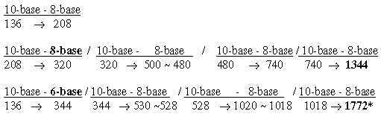

**18.7. Displacements between 1st and 2nd base order: Numbers 220 - 26:**

**18.7.1. *Relations between displacements 220 and*** *26:*

**Fig. 18-11:**

*(Correction in fig.18-11: (A1-G1) → (U1-C1) = 194 + 2.)*

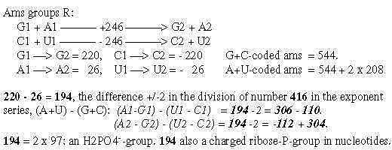

**Fig 18-12:**

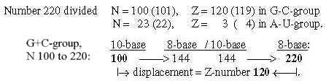

The relations between displacement 220 in the G+C-group and 26 in the U+A-group could be explained through only a minus 1 in N- and Z parts and the results in nb-8 through transformations.  
    Regard number 144 in figure 18-12 above divided in 64 and 80:

**Fig. 18-13:** *How the displacement 220 and 26 could be explained through -1:*

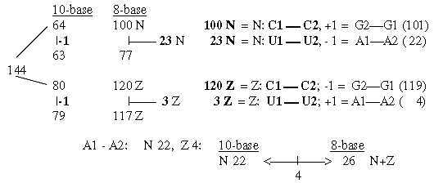

**Fig. 18-14:**



**18.7.2.  *The number 220 in displacements in group G+C:***

**Fig. 18-15:**

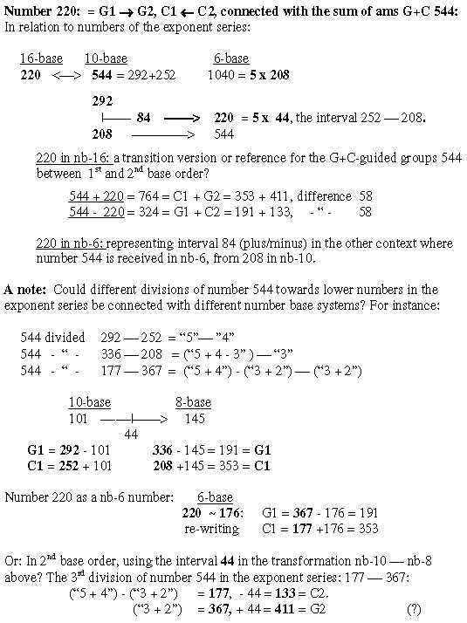

**18.8.  The 4 double-coded ams, sum = 246**

The sum of R-chains of the 4 ams with two different codons are “also” 246,  
i.e., the sum of displacements 220 and 26 above.   
   All 4 may become 37 in different nb-systems.

**Fig. 18-16:**

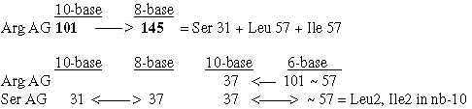

**19. Phosphorus groups - Co-enzymes - Nucleotides - Met AUG**

**19.1. P-groups**

**Fig 19-1*:*** *P-groups:*

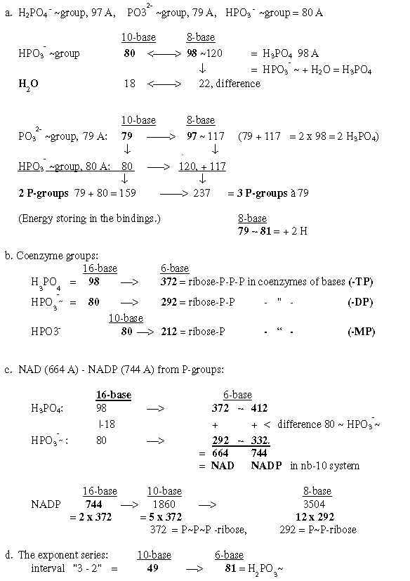

A form of life was found some years ago, said to use arsenic instead of phosphorus (P), i. e. next higher element in the phosphorus group of elements in the periodic system. If so, it could of course lead to the conclusion that all such transformations between masses including phosphorus are irrelevant and in any case no necessary condition for life as an eventual part of a reference system.  
   Yet, phosphorus could have had a decisive role at the very creation of the genetic code, while this not excludes further evolution?

**19.2. Coenzymes of the bases, -MP, -DP, -TP**:  
  
**19.2.1. *Tables of masses of the coenzymes***

**Fig. 19-2:** *Survey*

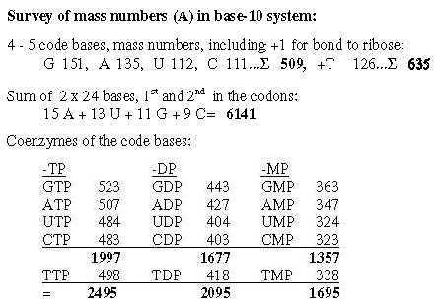

**19.2.2. *From 4 bases to their mass as coenzymes***

**Fig 19-3*:*** *509 - 1357, 4 coenzymes -MP:*

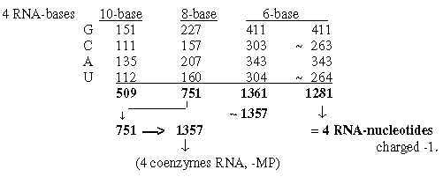

**19..2.3. *Expansion of bases nb-10 to nb-8 adds the Px-ribose groups:***

Some transformations from sums of the bases to sums of their appearance as coenzymes are shown in figures below. Note expansions where 212-292-372 correspond to the P(P(P)-ribose groups:

**Fig. 19-4:** *From the bases to coenzymes -MP, -DP, -TP*

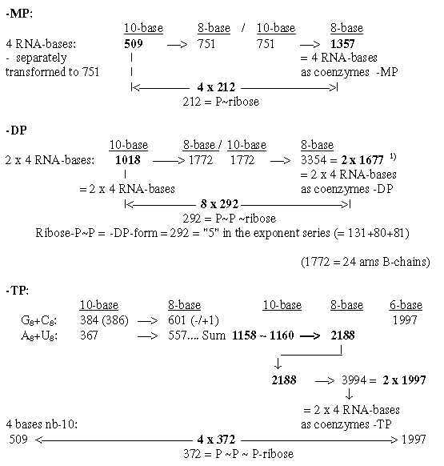

**19.2.4.   *5 bases to 5 coenzymes -TP:*Fig. 19-5:**

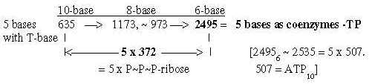

**19.2.5.**   ***4 RNA-bases giving 5 coenzymes -DP-MP in nb-6:***

**Fig. 19-6:**

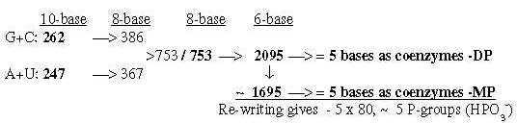

**19.2.6.  *From 751, the sum of 4 bases in nb-8,* *to 5 bases as coenzymes -TP and to 6141, the sum of 48 codon bases:***

**Fig. 19-7:**

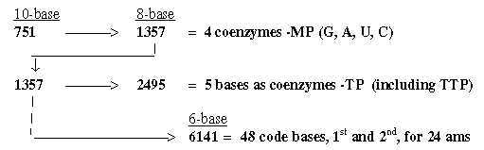

6141 == 15 A + 13 U + 11 G + 9 C :

**19.3. Nucleotides:**

**19.3.1.  *Survey of nucleotides in chain binding:***

**Fig 19-8:**

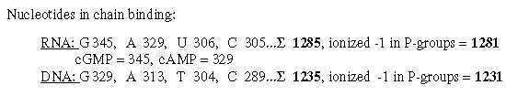

**19.3,2  *Two sets of the nucleotides from 2 sets of the bases*** *(from file 17)***:**  
The four RNA-nucleotides in chain-binding and uncharged = 345, 329, 306 and 305 =**1285**.   
The four DNA-nucleotides (= 1285 - 4 x 16 + 14 in T-base) = **1235**.

Two sets of RNA-nucleotides are given from 2 ¨times G- and C-bases in three steps nb-10 →>8, as two sets of DNA-nucleotides from 2 times A- and U-bases:  
  
2G + 2C = **768** in nb-8:   
                  **768**-**10**→> 1400-**8/** 1400-**10** →> 2570-**8** = **2 x 1285** ~ RNA-nucleotides  
  
2U + 2A = **734** in nb-8:   
    **734**-**10** →> 1336-**8 /** 1336-**10** →> 2470-**8**= **2 x 1235 ~** DNA-nucleotides

**19.3.3.  *ES-number 752 gives in two steps the sum of 4 nucleotides in DNA and RNA:***

**Fig 19-9:**

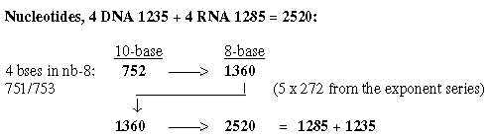

**19.3.4.  *The 4 bound RNA-bases in nb-16******gives the 4 RNA-nucleotides in nb-10:***

**Fig.  19-10:**

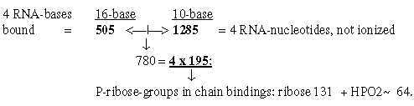

**19.3.5.  *Bases read as nb-8-numbers, giving cGMP and cAMP in nb-10:***

**Fig. 19-11:** *cGMP - cAMP:*

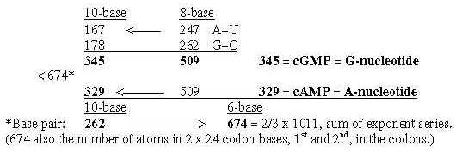

**19.4. Met - codon AUG and tRNA-ends ACC:  
  
AUG**, the codon for Meth, leads the string at transcriptions from DNA. Chain-bound nucleotides AUG, transformed from nb-10 to nb-8 give the whole sum of 24 ams R, 1504. There is also the equivalence between the 4 bases 509 in nb-8, the A-nucleotide 329 in nb-10 and Meth 149 (R+B) in nb-16,

**Fig 19-12:** *AUG, codon for Meth:*

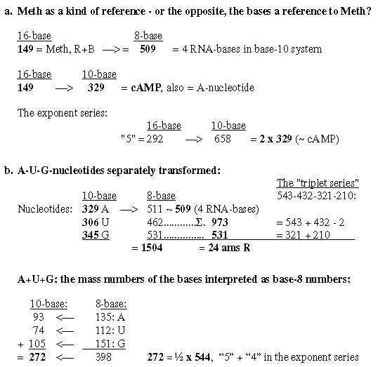

**19.5.  A-C-C - ends of tRNA:**  
A-C-Cmake up the common ends of tRNAs and one may ask why? The three bases (as unbound) give the sum 544 -/+1, the sum 5' + 4', 292 + 252 in the ES-series, when transformed in nb-8.

**Fig 19-13:** *tRNA-ends ACC:*

Cf. mass numbers for A and C from Triplets, file 21;

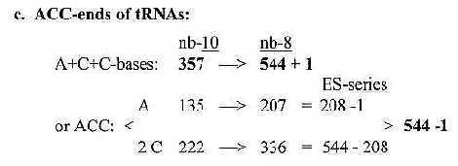

012 + 123 = 135 (A-base), + 234 = 357. Two of the intervals in the steps = 2 x 111 (2 x C-base.)

**\***

**20. Additions to files 17 - 18**

**20.1. Rewritings**

**20.1.1.   *Rewriting G - C:***

G- and C-bases transformed further to nb-6 becomes sums in later steps of the ES-chain, through rewritings, implying -44:

**Fig. 20-1:**

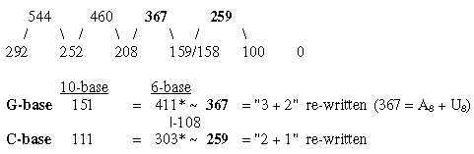

*411 = sum of G2-coded ams.  
  
Cf. 44 = the interval 252 - 208 = 4' - 3'. G1 + C1 = 544 divided 177 + 367:   
   C2 = 177 -  44 = 133  
   G2 = 367 + 44 = 411

**20.1.2.   *Number 65 - 101 - 81, bases and codon-grouped ams:***

**Fig. 20-2:**

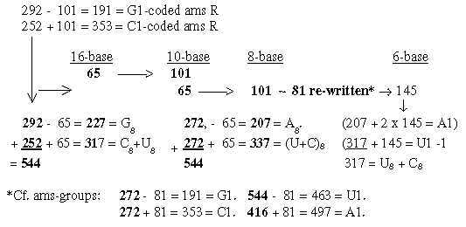

[U 112 and C 111 = 223, transformed together = 337-8.   
Further transformed to nb-6 = 1011= total sum of the ES-chain in nb-10..]

**20.1.3.  *Simple rewriting of 2 x 5', 4', 3' in the ES-chain, taken as nb-8 numbers:***

This rewriting gives closely the two sets of ams, sums of G1+G2, C1+C2 etc.  
  
   2 x 292-10: = 584.  584-8 ~ 604 = G1 + G2 +2;   → 604 + 416 = 1020 = A1 + A2  
   2 x 252-10  = 504,  504-8 ~ 484 = C1 + C2 - 2;   → 484 + 416 =   900 = U1 + U2

**Fig. 20-3:**

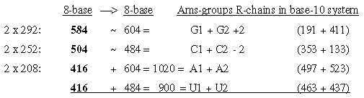

**20.1.4.  *From A-base to 273, mean value of 2 ams R+B:***

**Fig. 20-4:**

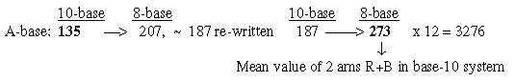

**20.2. Number 888 in different appearances:**

**Fig. 20-7:**

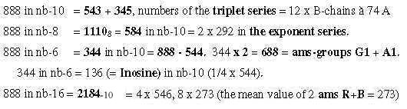

**20.3.  Difference of bases in nb-10 and nb-8, read in nb-16, gives 2 x 272 = 544;**

**Fig. 20-8:**

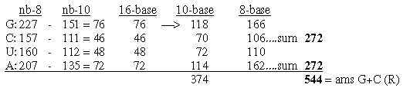

**20.4.  DNA-bases transformed give as intervals the G+C- and T+A-pairs and 752:**

**Fig. 20-9***:*

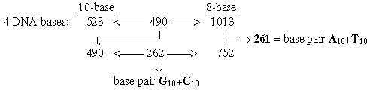

**20.5.  Sum of the whole ES-chain 1011:**

**20.5.1.  *N +3 and Z +3 from the ES-chain transformed separately and whole:***

**Fig. 20-10:**

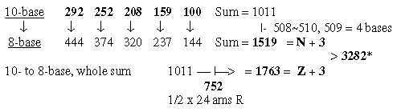

Cf. sum 3282 and sum of triplet series in

**20.5.2.  *DNA-bases as nb-6 numbers give the sum of the ES-chain:***

**Fig. 20-11:**

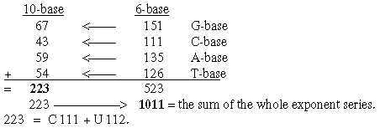

**20.6.  Totals, two mere operations**

**20.6.1.  *From ES-number 5' to 1/3  of the total 3276:***

**Fig. 20-12:**

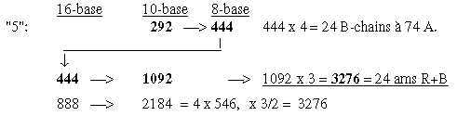

**20.6.2. *Two times total R from transformations of G+C-bases:***

**Fig. 20-13:**

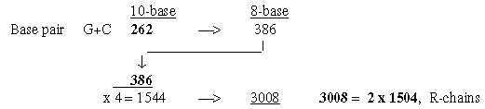

**20.7.   Individual R-chains of ams related through transformations ?**  
Transformations often imply additional numbers equivalent with molecules, as e. g. plus CH2. There are formally of course a lot of transformations possible between individual ams, only some of which may correspond to biochemical relations. Some examples are shown in the figure below, here regarding R-chains:  
 Fig. 20-14, next page:

It could be added that all four ams with double codons may transformed get the number 37: Ser AG 31-10 = 37-8, Arg AG 101-6 = 37-10, Ile and Leu 57-6 = 101-6 = 37-10, (file 18, para. 8).

**Fig 20-14:**

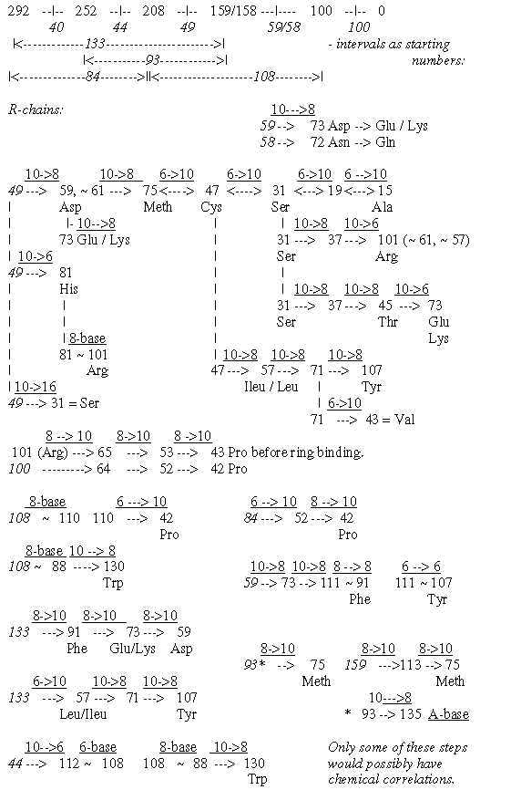

*

**21.  I.  Triplet series   
II.  An alternative series 151-111**

**I.**

**21.1.  Triplet series, read intervals outwards - inwards:**  
**211.1  Triplet chains in nb-8, transformed to nb-10:**

The triplets as 4 numbers in two series, outwards and inwards (as 543-345, 432-234 etc., treated as nb-8-numbers, give in pairs in nb-10 **sums 4 x 146, 3 x 146, 2 x 146, 1 x 146**, the total 5 times 292 =  5' in the ES-chain.  
   Intervals in nb-10 "outwards - inwards" = **126**, **½** x 252 ( 4').

**Fig. 21-1:**

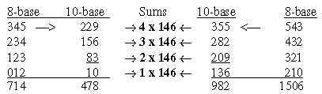

**982** = 2 x 491: 491-**10**→753-**8**   But 478-**10** →**736**-**8** .  
  
Triplets read "inwards" approximate the 734-group of ams in middle of the ES-chain, hypothetically representing an inward direction in relation to the 770-group as outward directed.   
*Cf. for 982 file 18, figure 18-3 and for directions file 14, para 3, figure 14-2.*

**Fig. 21-2:***Number 982:*

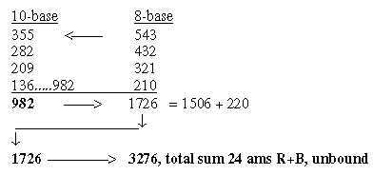

**21.1.2.   Codon bases read as nb-8-numbers give sums triplets in nb-10:**

**Fig. 21-3:**

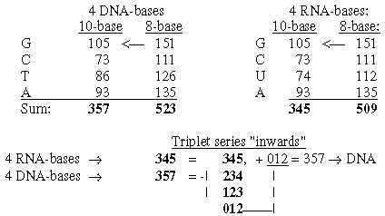

**21.2. Sums 1506 - 714 and intervals 792:**

**Fig. 21-4:**

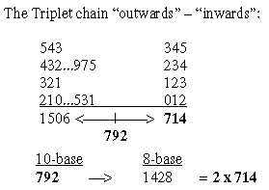

**Fig. 21-5:***Total sum of R for 24 ams, sum 1506 -2 from 2 x 4 bases:*

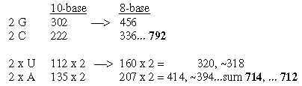

**21.3.  Number n x 273 from codon bases;, two other transformations:**  
  
273, the mean value of 2 ams R+B unbound:

 nb-**16**      nb-10

**C-base: 111**    —> **273**

The triplet chain with intervals **111**: 543 - 432 - 321 - 210:

**210-10** → **546-6 = 2 x 273.**

From file 20: Number n x 111, the intervals in the triplet steps:

**Fig. 21-6:**

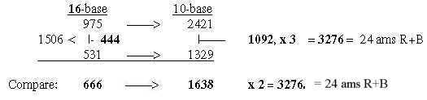

**21.4.  The triplet series and number 1875:**Pairs of the triplets = 753 transformed as a number in nb-16 gives 1875 in nb-10.  
   All 4 triplets separately transformed, see figure below, give n x 273 as the differences.

**Fig 21-7*:*** *Number 1875:*

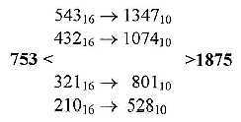

Intervals 1347 - 528 = 3 x 273 = **819, x 4 = 3276,** total R+B of 24 ams.  
  
The sums (pair wise added) reminds of the second spectral line of hydrogen from Balmer series, mentioned in *Introduction:* Formula **1/22 - 1/42 = 0,1875**. Cf. 210 and spectral line 0,21 (!).

Two other operations give relations between sums and intervals:

10**log** **1,875** ≈ 0,273 00...   
 **187,52/3** x 100 = 3275,93 ≈ 3276, total of 24 ams R+B

[1/4 × ES-chain numbers = 73 – 63 – 52 – 39.75 – 25,

with exponent 3/2 = 623.7. – 500. –375. – 250.6. – 125: sum ~1875 (1874.3..)

Note: 63 × 52 = 3276, total sum of 24 ams R+B. Cf “quark numbers” (in “17 short files”.)

15**/**8 = 5 × 3 × 1 **/** 4 × 2 = 1.875

24 ams R+B = 3276. = 409 × **8**.01.

48 codon bases (1st nd 2nd ) = 6141 = 409 × **15**.01.

**II.**

**21.5. An alternative numeral series**

Another series, from G- to C-base:, the series of integers 5 → 0 as within 1-dimenional poles.  
Such a series, not treated above, shows some interesting features:

**151** - 141 - 131 - 121 - **111**

First and last numbers = mass of G- and C-bases. The DNA-bases (+1 in A-base) are shown in figure below: 272 = 2 x 136 (~ Hypoxanthine), 252 = 2 x 126 = T-base:

**Fig 21-8:***An alternative series G - to C:*

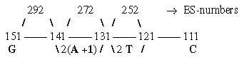

With last three numbers doubled the sum in nb-10 = 2 x RNA-bases = **1018**, in nb-8 = 1772, the 24 unbound B-chains.   
   All these numbers transformed to nb-8 give the triplet sums 975 (543 + 432) - 2 and 531 (321 + 210), sum 1504, 24 ams R:

**Fig. 21-~~9~~:**

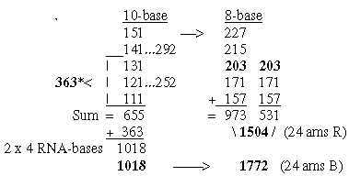

The 12-groups 770 and 734 of ams are shown in the figure below. Here it may be noted that we get the 734-group in the middle of the chain as in the ES-series, with 2 times 208 in that chain included, corresponding to both 203-groups here.

**Fig 21-10:**

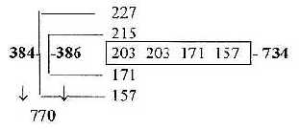

The ams groups 816 and 688 from -**/**+ last number 157:

973 -  157 = **816** = U1 + C1   
531 + 157 = **688** = G1 + A1.

**Some other paired groups of ams R from this alternative series:**

**Fig. 21-11:**

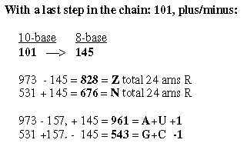

**Fig. 21-12:**

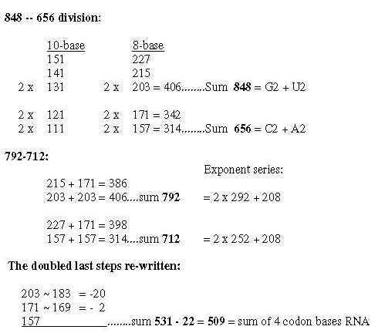

*

**22.  Other substances**

**Fatty acids — Sugar — Na-Cl, Na-K-pump**

**Some annotations about other substances:**  
  
  
**22.1.  Fatty acids**  
  
Two common fatty acids C18H36O2 = 284-**10** → 1152-**6** (~752 rewritten) = 3 x 384  
and C16H32O2 = 256-**10** → 1104-**6** = 3 x 368 are already mentioned in file 17-1:

**Fig. 22-1**: *Two comon fatty acids*

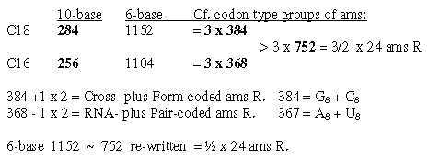

**22.2.  Carbohydrates:**

Carbohydrates, some examples, transformations nb-16 → 10 → 8 or → 6:  
- 12C → H2O → HCOH = 12-**16** → 18-**10** → 30-**6**, the building stone of sugar.  
  
- O2 16 A → H2CO3 62 A (built into ribose): 32-**16** → 50-**10** → 62-**8** = + 18, H2O, + 12, C.   
  
- Hexoses 180 in nb-10: In nb-16 180 = 384-**10** (= 2 citrate à 192 or e.g. G-**8** + C-**8**).  
- A fructose in P-P-bonds = 178: 178-**16** = 376-**10**= ½ x 752 in the ES-chain.   
  
- Ribose 150 as a number in nb-16 = 336 in nb-10, 544 - 208 in ES-chain.

- A disaccharide 342 or two hexoses 180 from ES-numbers as *intervals* in transformation   steps:

252-**16** → 594-**10** = + 342, a disaccharide.  
146-**16** → 326-**10** → 506-**8** (ATP charged -1) = + 180, + 180.

**Fig. 2-2:** *Sugar synthesis*

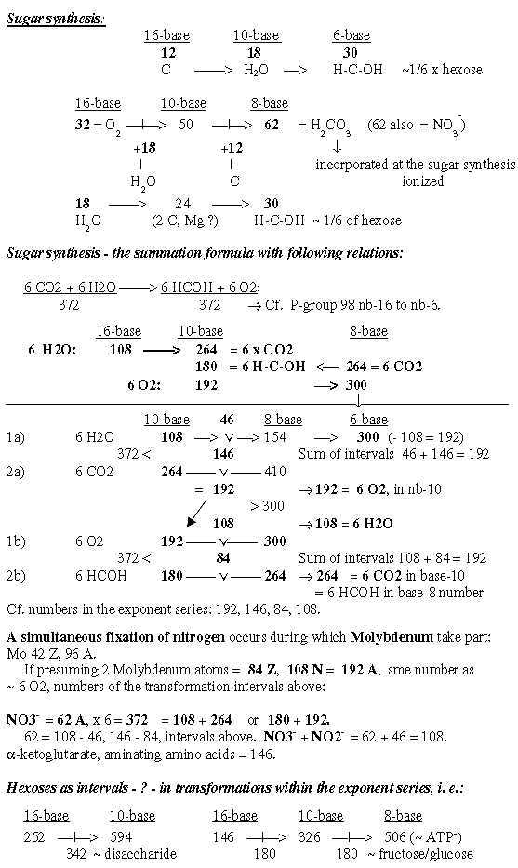

**22.3.  Na-Cl and the Na-K-pump:**

Na-Cl and Na-K-pump in the nervous system:  
    Na 11 Z→Cl 17 Z→K 19 Z: Na 11-**16** →Cl 17-**10** →K 19-**8**  
    Na 23 A, Cl 35 A (most common isotope): Na 23-**16**→> Cl 35-**10**  
  
   Cf. Na+, Cl**-**–, K**+** ionized, 10 e, 18 e: in nb-10 to nb-8 = +2, +4, numbers for the transport of H    through membranes.

**Fig. 22-3:**

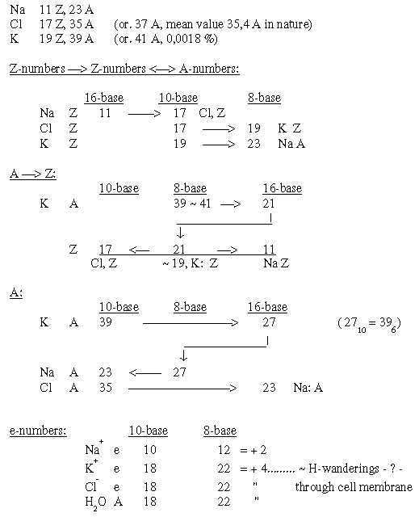

*

**Discussion**

**The amount of correlations** between the genetic code and numeral series is difficult to regard as only random ones.  
   A general problem is of course that it still doesn't seem to exist any known biochemically accepted mechanisms that could "explain" construction along such numeral series, however established facts in the other mentioned examples. It could however be questioned in which sense the 2x2-series behind the periodic system is "explained", or the formula for spectral lines of hydrogen.) Facts are there. Science has only its models, as far as possible congruent with the facts.

With the hypothesis here that they really reveal features in how Nature organized the genetic code, what should it imply? About the elementary series 5→> 0, the series of valences for atoms in the genetic code could be remembered: P - C - N - O,S - H = valences 5 - 4 - 3 - 2 - 1. ~~A~~ dimensional interpretation seems inevitable, with regard to exponents and to transformations between nb-systems.   
  
How should the exponent 2/3 be explained? We have squares in the 2x2-chain behind the periodic system and intervals between inverted squares behind the spectral lines of hydrogen. These formulas concern electron shells of atoms, i. e. the property charge. With mass and charge most elementary assumed as a mutual relation D3 to D2, cubes become natural. We have mass as the energy form concentrated in atomic nuclei, charge expressed in the atomic shell with released energy in kinetic form. Why then inverted cubes? They lead inwards to a deeper level, as does the inward direction toward nucleus in an atom.   
    It may be remembered too that there are a similar inverted relation between radii and mass in neutron stars.

**The many relations of disparate kinds to the 2x2-chain** and other simpler chains support the interpretation of the genetic code as built on an elementary chain x = 5 - 0 with exponents of different degrees. With a dimensional view on the exponents, it could imply, either that such chains preceded the more elaborated ES-chain when the coding system emerged or could be regarded as simultaneously existing on underlying levels. It's possible to imagine a dimensional development from both ends of the chain towards step 3 - 2 in the middle with increasing agreement of mass distribution in the genetic code:

x4 → x3 →[ x3**/**2 →← x2**/**3]← x2← x1.

The mass distribution as described in section I often implied minus**/**plus lower numbers in the ES-series, correlating with features in the background model. It points to a two-way direction in he chain of both disintegration and synthesis. This could seem to conflict with the common view on evolution as a stepwise synthesis towards more complex and bigger units. Yet, a double-direction is natural in Nature, if we think of macrocosm, Big Bang and both processes in celestial Hx-clouds. It could be mentioned that even among physicists this opposite view of disintegration, starting from a whole, has been proposed. (There is a similar pattern of two-way direction in the protein synthesis, where tRNAs as from opposite strands of DNA meet mRNA "the other way around" at ribosomes in the "middle" of the process.) See **figure here**, with dimensional interpretation of the forms from double direction (D4) in DNA to single-strnded RNA as vector (pole 4b) outwards to ribosomes (D3) - meeting tRNAs (as "clover leaves" D2) and ams.

**It's shown too that not only mass distribution on codon groups of ams** correlates with the ES-chain but also other bases for mass division, for instance with main groups of atom kinds and the not codon-dependant B-chains as well as with several features in the origin of ams from stations in glycolysis - citrate cycle. This suggests an interpretation where the same principle scheme is developed on different levels or as representing different axes in a coordinate system when the genetic code emerged.   
   The single fact that the mass division on C-skeleton and other atoms (960 and 544) is the same as between main codon groups (U+A, 960 and G+C, 544) supports in itself the general suggestion that the code is built on a numeral series.

In several ways the results seems to agree with the coevolution theory [6, 7]. There is the relation with biochemical origins of ams from glycolysis and citrate cycle. There is the view of codon domains as totals, differentiated in following steps, even if the "codon domains" here is related to mass sums of ams. There is also the fact that G1-coded ams "arrive first" in the number chain as 5 out of about 7 ams assumed first in that theory: GG-GC-GU-GA-GA besides Ser UC and Phe UU..

**Then about mass again**, rejected as irrelevant for codon assignments: In addition to arguments in the *Introduction* it's reasonable to ask for instance why precisely these ams have been selected for coding, not other ones? The selection seems rather random. Why just this number of ams with oxygen as end groups, that number of ams with nitrogen? (Besides that both types and polar and non-polar ams surely have been necessary.)   
    Further, when much research in this field has been focusing on the "most stable" configuration of the coding system, one could naturally ask what the background is for this stability? One aspect is of course that the most common isotopes have shown up to be most stable. (When calculating with common mix of isotopes today, atomic weights should change the sum of R- plus B-chains of ams from 3276 →> 3280 abbreviated, R-chains from 1504 →> 1506, no more than the deviations of single units (u) in this analysis.) In addition, the analysis here mostly concerns groups of ams, i. e. sums were an individual deviation in mass might have a rather small influence.  
   The fact that Ileu sometimes gets mixed with Leu by tRNAs could also be mentioned, differing in structure but having the same mass and atoms.

Does the proposal for a guiding numeral series exclude such an individual invention among certain organisms as Pyl, called the 22nd ams, occupying a stop codon? Pyl adds 108 to R-chain of Lys, i. e. the interval 3' to 1' in the ES-chain and could eventually be suspected as a "misreading" of the chain, leading to a compound, a new "word"?

**The examples of transformations** between nb-systems are astonishing and certainly provocative. They support however a general dimensional view in the creation of the code and actually too the relevance of the ES-chain. They seem to reveal a deep level in the reference system of a hitherto unknown kind, representing the very steps between dimensional degrees. In physical and biochemical terms they should imply something like mutual resonances between "mass fields" in different dimensional degrees, relations and fragmentation guided by geometrical and arithmetical rules. A problem is naturally the superfluity of such possible transformational relations.

If proposals in this paper are accepted as hypotheses, they will naturally raise many new questions and lead to secondary hypotheses, which in their turn could be possible to test. The dimensional aspects, mostly omitted here, should reasonably, if elaborated further, have implications for protein structures and their different functions in cells.  
   Whatever to believe about the arithmetic, something of that kind resembles life   
- in being very simple and very productive - and naturally multidimensional.

*

***References***

**References, referred to in the text within brackets [ ]:**

1. Chou KC: "Prediction of Protein Cellular Attributes Using Pseudo-Amino Acid     Composition." PROTEINS: Structure, Function and Genetics, 43, 246-255 (2001).  
2. shCherbak VI, "Arithmetic inside the universal genetic code," [Abstract],  
    Biosystems 70 (3), 187-209 (2003).  
3, Rakocevic MM, "A harmonic structure of the genetic code." J theor. Biol. 229, 221-234     (2004).  
4.Downes AM, Richardson J, "Relationships Between Genomic Base Content and    Distribution of Mass in Coded Proteins." J Mol Evol 55, 476-490 (2002).   
5. Perez JC, "Codon populations in single-stranded whole human genome DNA are fractal     and fine-tuned by the Golden Ratio 1.618." Interdiscip Sci 2(3), 228-240 (2010).  
6. Wong TF, "The evolution of a universal genetic code." Department of Biochemistry,     University of Toronto, Canada. Communicated by J. Tuzo Wilson. (1976)  
7. Wong JT, "Coevolution theory of the genetic code at age thirty." [Abstract], Bioessays,     27, 416-425 (2005).

**Since this research started in the beginning of 1980's, the main source used was:**   Karlson P., 1974. Biokemi (*Biochemisttry)*. Liber Läromedel, Lund, Swedish version of   
   Karlson, P. Introduction to Modern Biochemistry, forth edition, 1975, Academic Press Inc. with later, new editions.

**A few data taken from**a. Lindahl P E, Kihlström J E, Kiesling K-H, Sundell L-E: Zoofysiology *(Zoophysiology)* 1967, Almqvist & Wiksell, Uppsala.  
b. Nicholson D. F 1976. Metabolic Pathways. Koch-Light Laboratories, UK.[A map over main processes in biochemistry.]  
c. Wikipedia, the free encyclopedia, i.e. http://en.wikipedia.org/wiki/Histone#Classes.

**A selection of other articles dealing with the same topic:**

**Arquès DG, Michel CJ:** A Circular Code in the Protein Coding Genes of Mitochondria. J. theor. Biol. 1997, 189:273-290.  
**Arquès DG, Michel CJ**: A Complementary Circular Code in the Protein Coding Genes. J. theor Biol. 1996, 182:45-58.  
**Balázs A**: Some introductory formalizations on the affine Hilbert spaces model of the origin of life. I. On quantum mechanical measurement and the origin of the genetic code: A general physical framework theory. BioSystems 2006, 85:114-125.  
**Bedian V**: Self-description and the origin of the genetic code. BioSystems 2001, 60:39-47.  
**Berger G**: Deterministic hypotheses on the origin of life and of its reproduction. Med Hypotheses 2003, 61(5-6):586-592.  
**Biro J C, Benyó B, Sansom C, Szlávecs A, Fördös G, Micsik T, Benyò Z:** A common periodic table of codons and amino acids. BBRC 2003, 306:408-415.  
**Chechetkin V R**: Block structure and stability of the genetic code. J theor Biol. 2003, 222:177-188.  
**Chou, K-C:** Using amphiphilic pseudo amino acid composition to predict enzyme subfamily classes. Bioinformatics 2005, 21.1:10-19.  
**Copley S D**, Smith E, Morowitz H J: A mechanism for the association of amino acids with their codons and the origin of the genetic code. Proc. Natl. Acad. Sci. 2005, 102:4442-4447.  
**Damjanovic Z M, Rakocevic M M**: Genetic Code. An Alternative Model of Translation. Ann. N. Y. Acad. Sci. 2005, 1048:517-523.  
**Delarue M**: An asymmetric underlying rule in the assignment of codons: Possible clue to a quick early evolution of the genetic code via successive binary choices. RNA 2007, 13:161-169.

**Di Giulio M**: The origin of the genetic code: theories and their relationships, a review. BioSystems 2005, 80:175-184.  
**Hartman H**: Speculations on the Evolution of the Genetic Code. KIV. The Evolution of the Aminoacyl-tRNA Synthetases. Orig Life Evol Biosph. 1995, 25:265-269.  
**Heal J R, Roberts G W, Raynes J G, Bhakoo A, Miller A D**: Specific Interactions Between Sense and Complementary Peptides: The Bases for the Proteomic Code. ChemBioChem. 2002, 3:136-151.  
**Hobish M K, Wickramasinghe N S M D, Ponnamperuma C**: Direct Interaction between Amino Acids and Nucleotides as a possible physicochemical Basis for the Origin of the Genetic Code. Adv Space Res. 1995, 15:(3)365-(3)382.  
**Hoffmeyer J**: Life and reference. BioSystems 2001, 60:123-130.  
**Hornos J E M, Braggion L, Magini M, Forger M**: Symmetry Preservation in the Evolution of the Genetic Code. (Hypothesis Paper). IUBMB Life 2004, 56(3):125-130.  
**Ikehara K**: Origins of gene, genetic code, protein and life: comprehensive view of life systems from GNC-SNS primitive genetic code hypothesis. J. Biosci. 2002, 27:165-186.  
**Jiménez-Montaño M A**: Protein evolution drives the evolution of the genetic code and vice versa. BioSystems 1990, 54:47-64.  
**Johnson F Yan, Alexander K Yan, Benjamin C Yan**: Prime Numbers and the Amino Acid Code: Analogy in Coding Properties. J. theor. Biol. 1991, 151:333-341.  
**Judson O P, Haydon D**: The Genetic Code: What Is It Good For? An Analysis of the Effects of Selection Pressures on Genetic Codes. J Mol Evol. 1999, 49:539-550.   
**Karasev V A, Stefanov V E**: Topological Nature of the Genetic Code. J theor Biol. 2001, 209:303-317.  
**Knight R D, Landweber L F**: Rhyme or reason: RNA-arginine interactions and the genetic code. Chem Biol. 1998, 5:R215-R220.  
**Kohler H, Murali R, Kieber-Emmons T**: The hidden code in genomics: a tool for gene discovery. Review. J. Mol. Recognit. 2001, 14:269-272.  
**Lu Y, Freeland S**: On the evolution of the standard amino-acid alphabet. Genome Biol. 2006, 7:102:102.1-102.6.  
**Michel C J**: An Analytical Model of Gene Evolution with 9 Mutation Parameters: An Application to the Amino Acids Coded by the Common Circular Code. Bull Math Biol. 2007, 69:677-698.  
**Mussat M, Bégin M E, Bureau J P**: A constructionist model predicting the emergence, complementarity and classification of the nucleotide bases. Med Hypotheses 1998, 51:511-523.  
**Osawa S, Jukes TH**: Codon reassignment (codon capture) in evolution [abstract.  
J Mol Evol. 1989, Apr; 28(4):271-8.  
**Patel A**: The triplet genetic code had a doublet predecessor. J. theor. Biol. 2005, 233:527-532.  
**Ronneberg T A, Landweber L F, Freeland S J**: Testing a biosynthetic theory of the genetic code: Fact or artifact? Proc. Nat. Acad. Sci. 2000, 97:13690-13695.  
**Sanchez R, Grau R**: A genetic code Boolean structure. II. The genetic information system as a Boolean information system. Bull Math Biol. 2005, 67:1017-1029.  
**Schimmel P, Giegé R, Moras D, Yokoyama S**: An operational RNA code for amino acids and possible relationship to genetic code. Proc Natl Acad Sci. 1993, 90:8763-8768.  
**Sciarrino A**: A mathematical model accounting for the organization in multiplets of the genetic code. BioSystems 2003, 69:1-13.  
**Seligmann H, Amzallag G N**: Chemical interactions between amino acid and RNA: multiplicity of the levels of specificity explains origin of the genetic code. Naturwissenschaften 2002, 89:542-551.  
**shCherbak V I**: Twenty Canonical Amino Acids of the Genetic Code: The Arithmetical Regularities. Part I. J. theor. Biol. 1993, 162:399-401.  
**shCherbak V I**: Arithmetic inside the universal genetic code. BioSystems 2003, 70:187-209.  
**Shen N, Guo L, Yang B, Jin Y, Ding J**: Structure of human tryptophanyl-tRNA synthetase in complex with tRNATrp reveals the molecular basis of tRNA recognition and specificity. Nucleic Acid Res. 2006, 34:3246-3258.  
**Sitaramam V**: Genetic code preferentially conserves long-range interactions among the amino acids. FEBS Lett. 1989, 247:46-50.  
**Sowerby S J, Petersen G B, Holm N G**: Primordial Coding of Amino Acids by Adsorbed Purine Bases. Orig Life Evol Biosph 2002, 32:35-46.  
**Sukhodolets V. V**: The Genetic Code as a Clue to Understanding of Molecular Evolution. J. theor. Biol. 1989, 141:379-389.  
**Sungchul J**: The Linguistics of DNA: Words, Sentences, Grammar, Phonetics, and Semantics. Ann N Y Acad Sci 1999, 870:411-417.  
**Trevors J T, Abel D L**: Chance and necessity do not explain the origin of life. Cell Biol Int. 2004, 28:729-739.  
**Wilhelm T, Nikolajewa S**: A New Classification Scheme of the Genetic Code. J Mol Evol 2004, 59:598-605.Woese C R: A Proposal Concerning the Origin of Life on the Planet Earth. J Mol Evol. 1979, 13:95-101.  
**Wong J T-F**: Question 6: Coevolution Theory of the Genetic Code: A Proven Theory. Orig life Evol Biosph 2007, 37:403-408.  
**Wu H-L, Bagby S, van den Elsen J M H**: Evolution of the Genetic Triplet Code via Two Types of Doublet Codons. J Mol Evol. 2005, 61:54-64.  
**Yarus M**: Amino Acids as RNA Ligands: A DirectRNA-Template Theory for the Code's Origin. J Mol Evol. 1998, 47:109-117.  
**Yarus M, Caporaso J G, Knight R**: Origins of the Genetic Code: The Escaped Triplet Theory. Annu. Rev. Biochem. 2005, 74:179-198.  
**Yu J**: A Content-Centric Organization of the Genetic Code. Geno. Prot. Bioinfo. 2007, 5:No. 1 (1-6).

**END**